White Paper User Manual For –
Manual Invoice with Foreign Currency

Module – Account Receivables

Author : Ajinkya Patil
Creation Date : 06-Sep-2024
Last Updated : 06-Sep-2024
Version : 1.0

A receivables invoice is a financial document issued by a business (the seller) to a customer (the buyer) requesting payment for goods or services that have been provided. Here’s a more detailed look:

- Who:
  - Who issues the invoice? Typically, the business or individual that has provided goods or services issues the invoice.
  - Who receives the invoice? The invoice is received by the customer or client who has purchased the goods or services.

- What:
  - What is a receivables invoice? A receivables invoice is a document sent by a seller to a buyer requesting payment for goods or services that have been delivered. It details the amount due, payment terms, and a description of what was provided.

- When:
  - When is the invoice issued? The invoice is issued after the goods or services have been delivered, or according to the terms agreed upon between the seller and the buyer.

  - When should it be paid? The payment terms, including the due date, are specified on the invoice. Common terms include “net 30,” which means payment is due within 30 days from the invoice date.

- Where:
  - Where is the invoice sent? The invoice is typically sent to the billing address or email address provided by the customer or client. It may be sent physically or electronically.

- Why:
  - Why is a receivables invoice important? It serves as a formal request for payment and provides a record of the transaction for both parties. It ensures that the seller will receive payment for the goods or services provided and helps maintain accurate financial records for both the seller and the buyer.

In essence, a receivables invoice is a crucial component of the accounts receivable process, helping businesses manage their incoming payments and track outstanding debts.

Navigation – Account Receivables – Transaction – Receivable Invoice

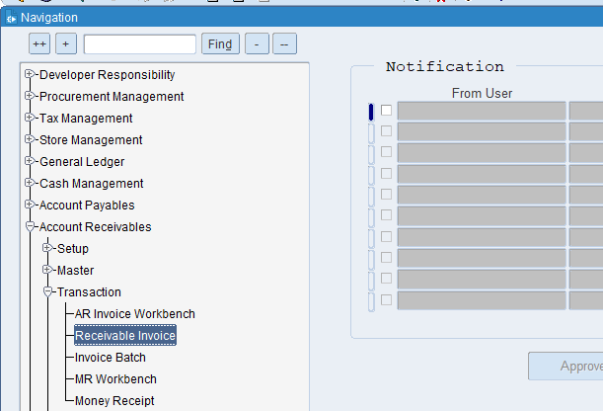

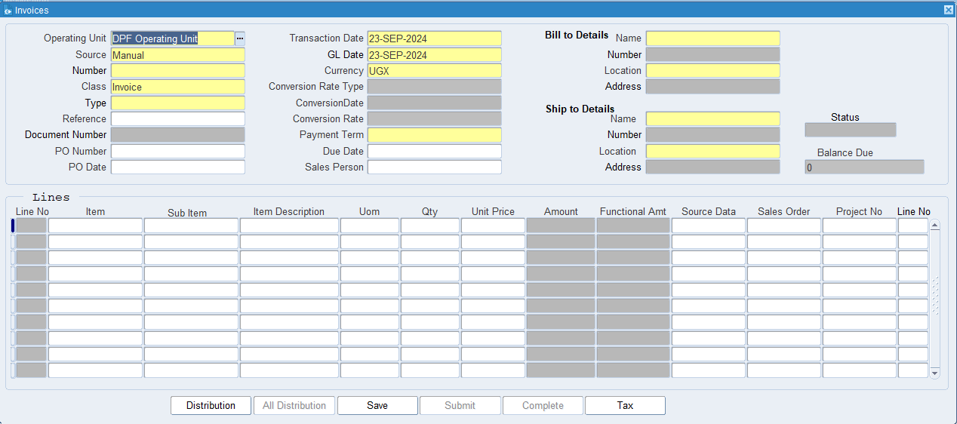
Put the required information.
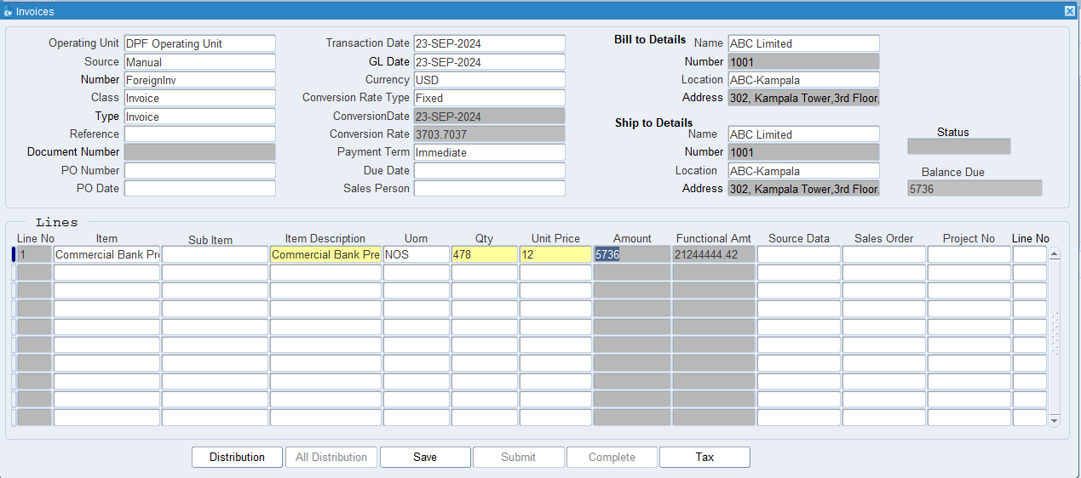
Select foreign currency USD

What is an Operating Unit?
An operating unit is a distinct segment or division within a company that manages a specific part of the company's operations. It can be thought of as a self-contained unit responsible for its own set of activities, resources, and objectives.

What is a source?
In the context of an Accounts Receivable (AR) invoice, the term "source" refers to the origin or point of creation of the invoice. It provides context for where the invoice originated or what triggered its issuance. Understanding the source can be crucial for tracking, verifying, and managing invoices efficiently.

What is the AR Invoice number?
A distinct, sequential number assigned to an invoice issued by a company to a customer. It is used to uniquely identify and track the invoice throughout the billing and payment cycle.

What is GL Date?
The GL date indicates the specific date on which a transaction is recorded in the General Ledger. This date determines the accounting period in which the transaction will be included for financial reporting and analysis.

What is Invoice Currency?
Invoice currency specifies the type of currency used to calculate and display the amounts due on an invoice. This could be the currency of the supplier, the customer, or a mutually agreed-upon currency.

What is class?
A categorization or grouping applied to an AR invoice to classify it based on specific criteria, such as the type of transaction, department, or product/service line.

What is Type?
The classification or category assigned to an AR invoice that indicates the nature of the invoice or the type of transaction it represents.

What is the Document Number?
A unique numerical or alphanumeric code assigned to an AR invoice to distinguish it from other invoices and provide a reference point for tracking and managing.

What is the Payment Term?
The specific conditions agreed upon by the buyer and seller regarding how and when payment for goods or services should be made. They are outlined in the invoice or contract and detail the payment schedule, due dates, and any discounts or penalties.

What is Bill-To Detail?
Bill To refers to the address and contact information of the party responsible for paying the invoice. This is the location where the invoice should be sent and where payment should be made.

What is Ship-To Detail?
Ship To refers to the address and contact information where the goods or services should be delivered. This is where the seller sends the physical products or where the service is to be provided.

Click on Tax (Tax is not Mandatory, impose tax only if necessary, otherwise ignore it)

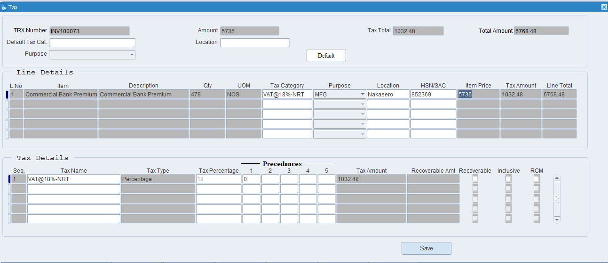
Put the Tax Category, Purpose, Location HSN/ SAC Code then click on Save.

What is Tax Category?
a tax category refers to a classification used to apply the correct tax rules and rates to transactions. This categorization ensures that taxes are calculated accurately based on the nature of the goods or services being provided and the applicable tax regulations.

What is HSN & SAC Code?
HSN (Harmonized System of Nomenclature Code) codes are used to classify goods in a standardized manner across international borders. They help in identifying products for trade and taxation purposes, ensuring uniformity in the classification of goods.

SAC (Services Accounting Code) codes are used to classify services in a standardized manner for taxation purposes. They help in identifying the type of service provided and determining the applicable GST rates.

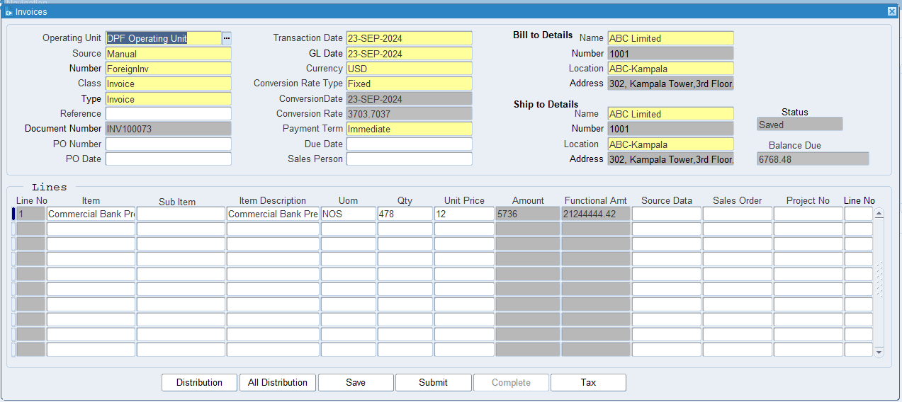
Click on Save.

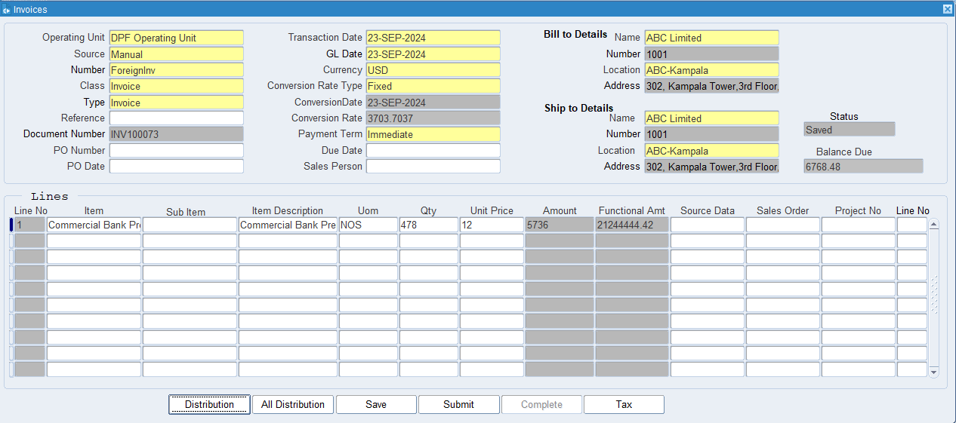
Click on Submit for Approval

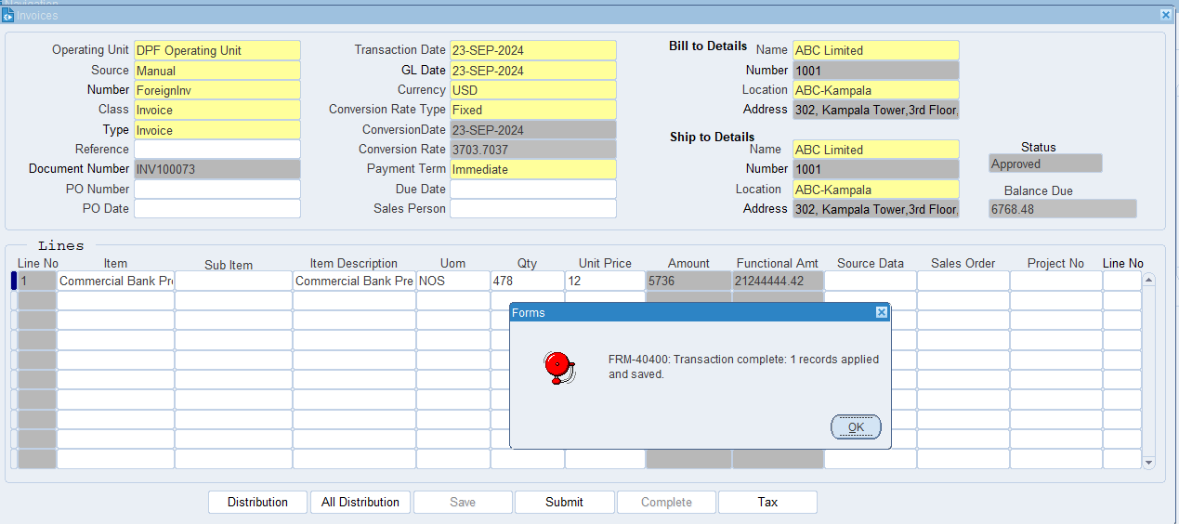
Once Approval done then Click Complete Button
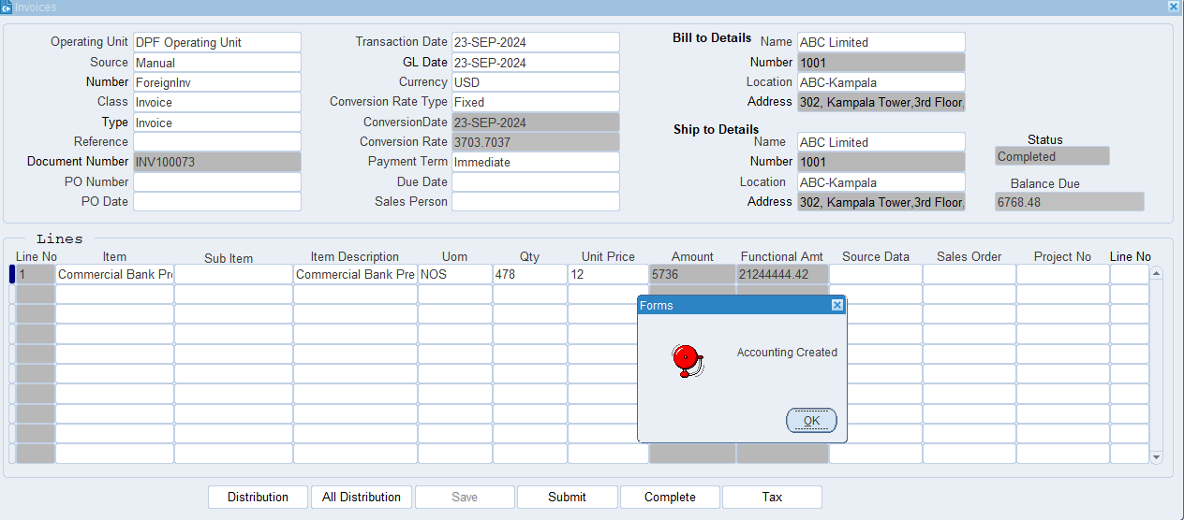
The AR invoice has been created and system will auto generate accounting entry.

XX END XX

