White Paper User Manual For –
Asset Workbench Searching Form

Module – Fixed Asset

Author : Niraj Chaurasia
Creation Date : 20-Jan-2025
Last Updated : 20-Jan-2025
Version : 1.0

Login from the User Credential to whom the functionality is provided
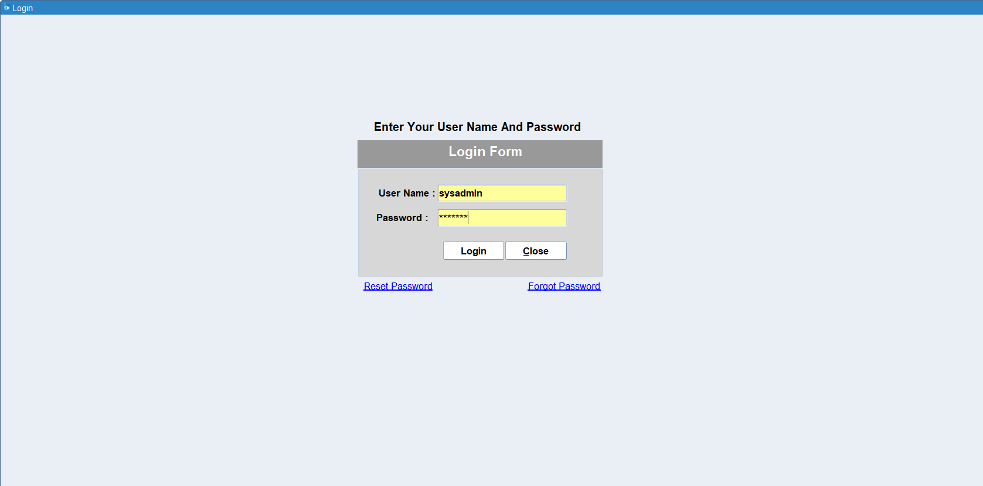

Navigation: Asset Management > Asset Workbench
Go to Asset Workbench form for viewing Asset
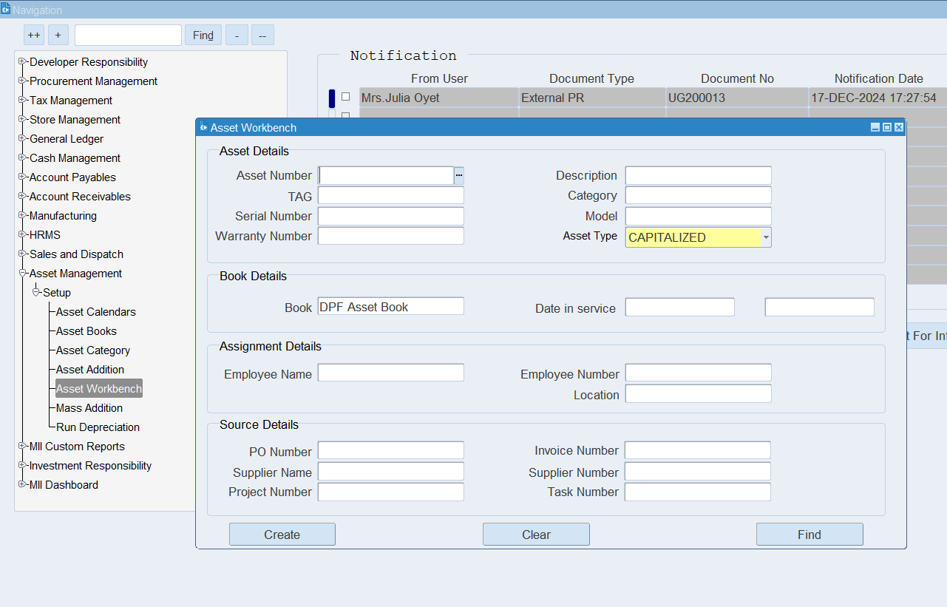

If you want to search CIP Asset then select Asset Type is CIP
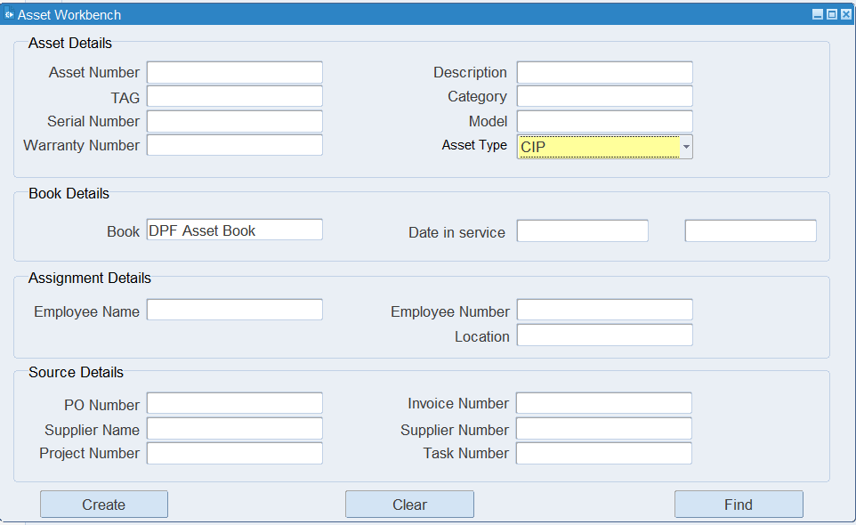
Only CIP Asset Number shown under LOV in Asset Number Field
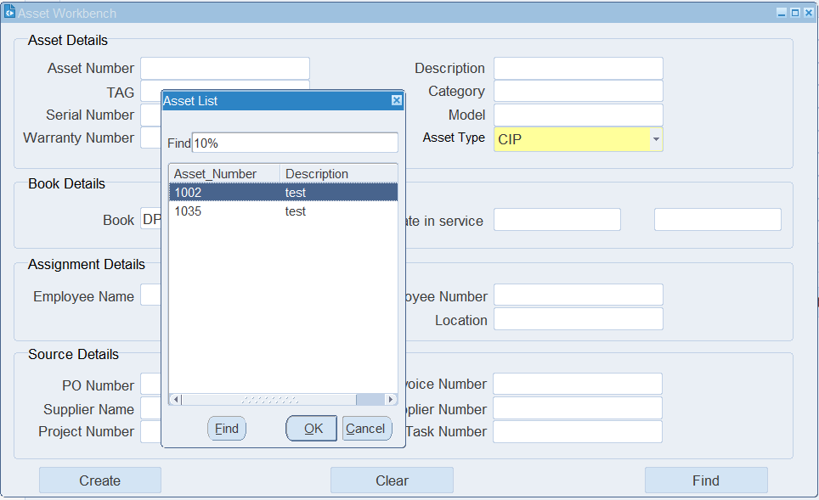

Click Find Button
Only CIP Asset Numbers are showing in Asset details Form
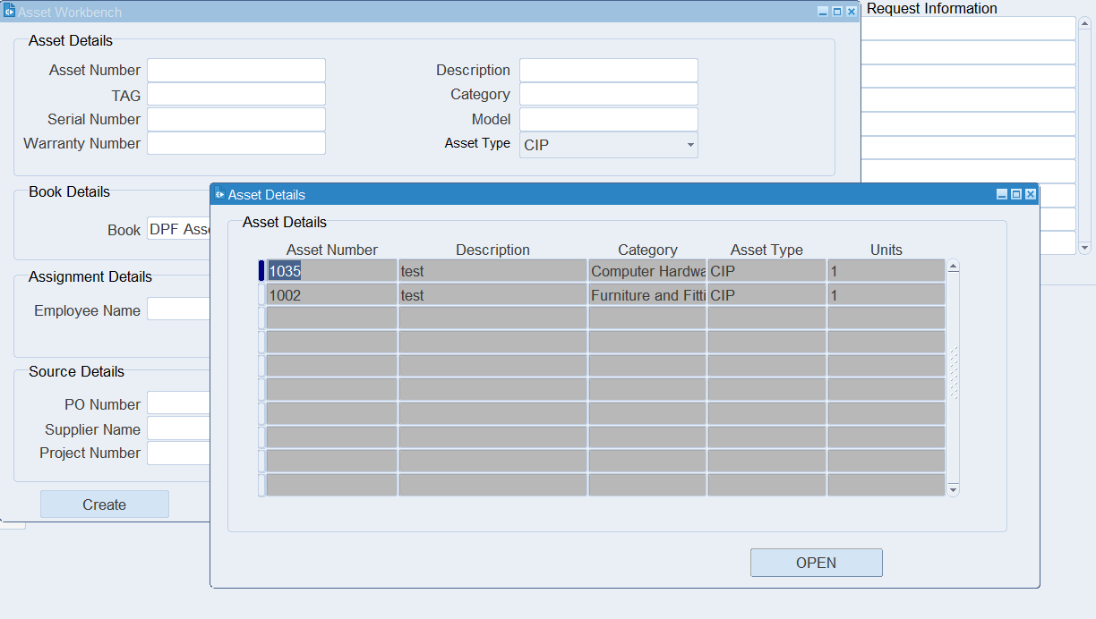
If you want to search Capitalized Asset then select Asset Type is CAPITALIZED
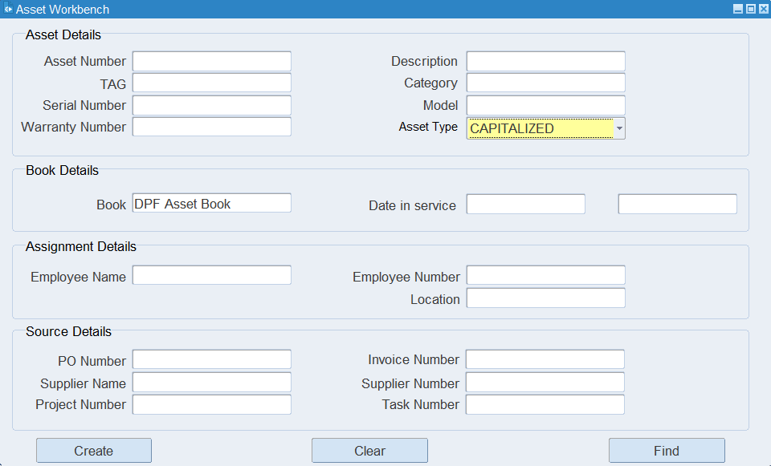

Only CAPITALIZED Asset Number shown under LOV in Asset Number Field
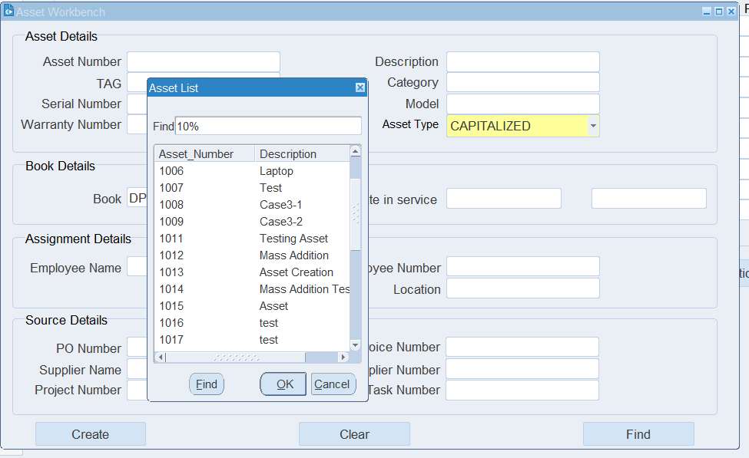
Click Find Button
Asset Detail forms will be open
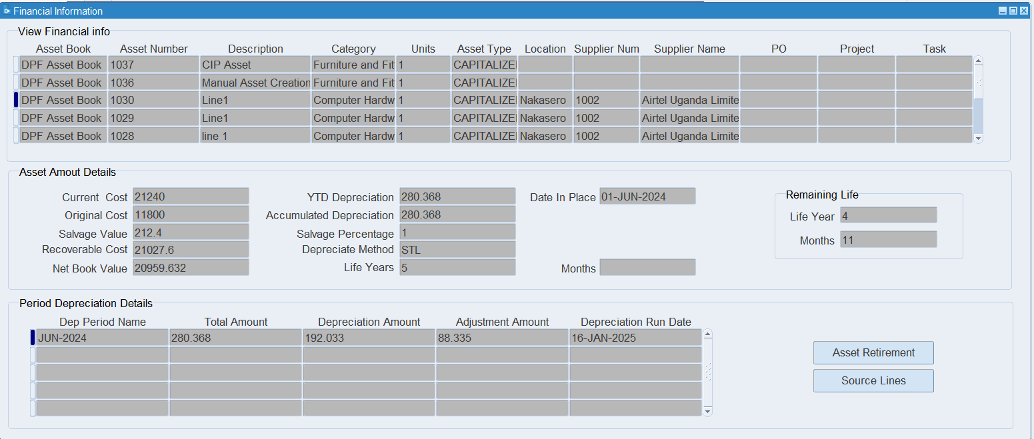
If Asset Comes from Purchases Order or Invoices, then click Source Lines for View transaction details

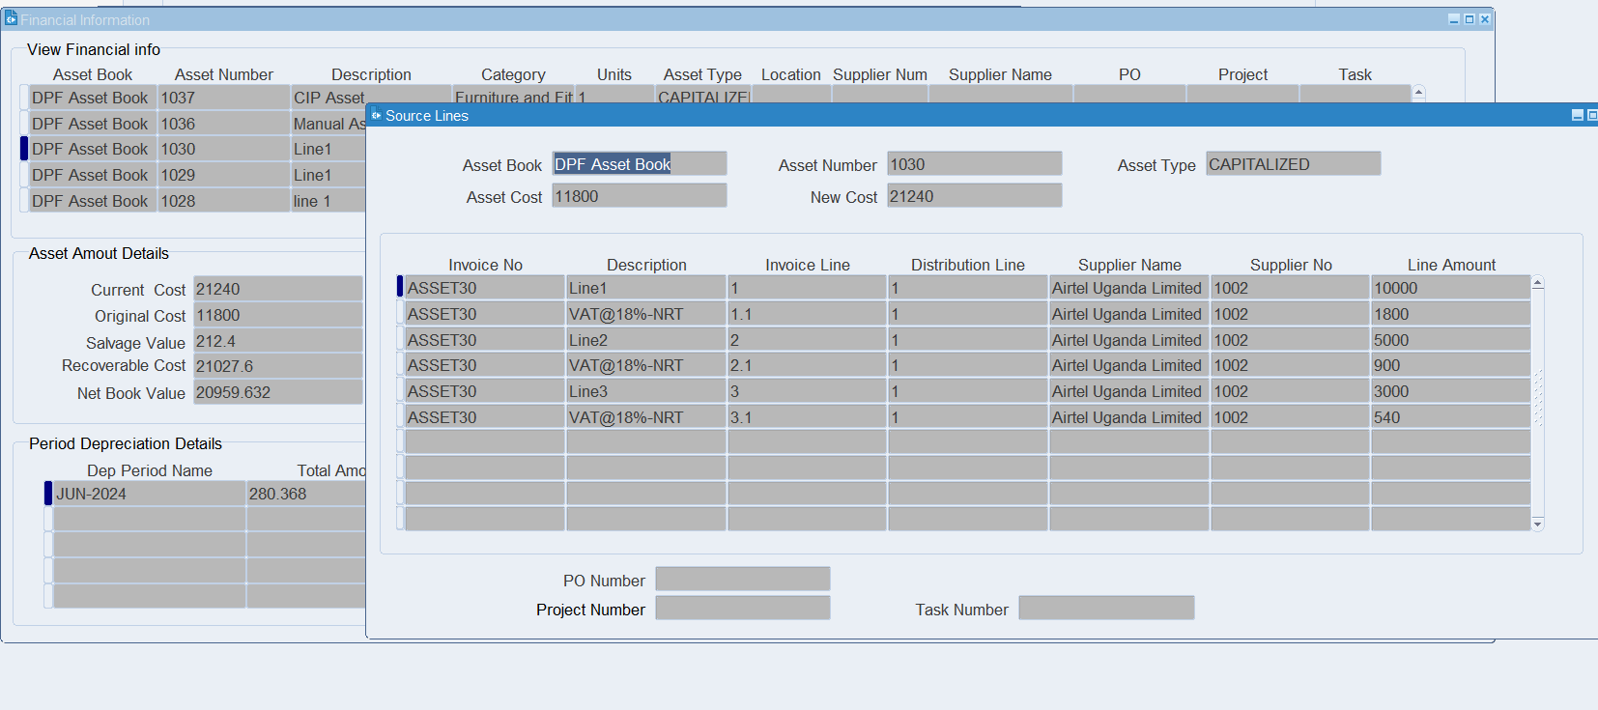

XX END XX

