White Paper User manual
Bank to Bank Transfer

Module – Cash Management

Author : Ajinkya Patil
Creation Date : 01-Oct-2024
Last Updated : 01-Oct-2024
Version : 1.0

Bank account transfers represent fund transfers between internal bank accounts. The process of getting funds from an account at Bank A to another at Bank B. Here’s a breakdown using the 5 W's:

Who
- Bank Employees: Initiate and oversee the transfer process.
- Finance Team: Ensures funds are allocated correctly and maintains records.
- IT Support: Provides technical assistance with Oracle systems.

What
- Bank-to-Bank Transfer: The process of moving funds from one bank account to another, either within the same financial institution or between different banks.
- Tools: Oracle Financials or Oracle Cash Management modules used for executing and tracking transfers.

When
- Timing: Transfers can be initiated on a scheduled basis (e.g., monthly, weekly) or on-demand, depending on business needs.
- Cut-off Times: Transfers may need to be completed by specific times to meet processing deadlines.

Where
- Location: Typically conducted within the finance department.
- Oracle System: The transfer is executed through the Oracle platform, where relevant accounts and transactions are recorded.

Why
- Cash Management: To optimize cash flow by reallocating funds between accounts.
- Operational Efficiency: Facilitates payments to suppliers, payroll, and other financial obligations.
- Financial Strategy: Supports strategic financial planning and investment activities.

Navigation – Cash Management – Transactions – Bank Transfer

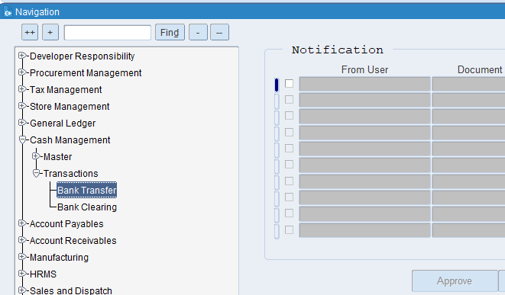

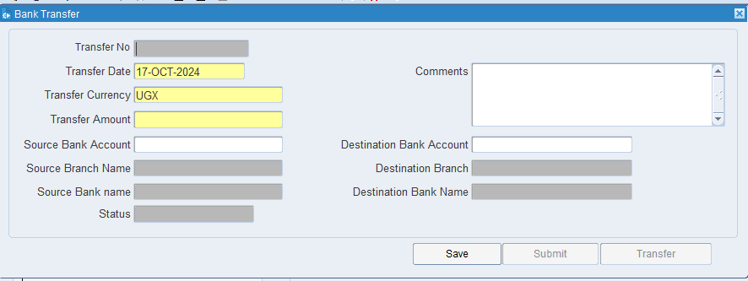

Put the required details like Date, Currency, Amount, Source and Destination Bank A/c Number then click on Save
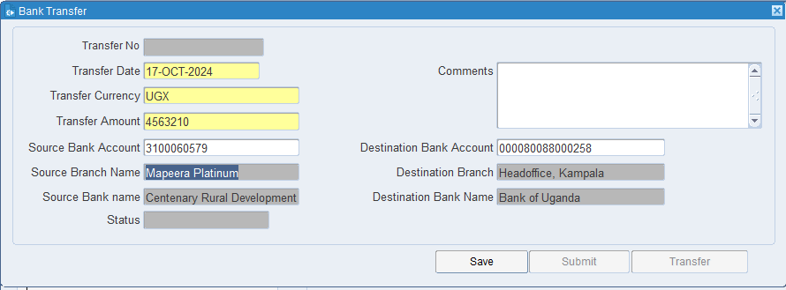

Click on Submit for Approval
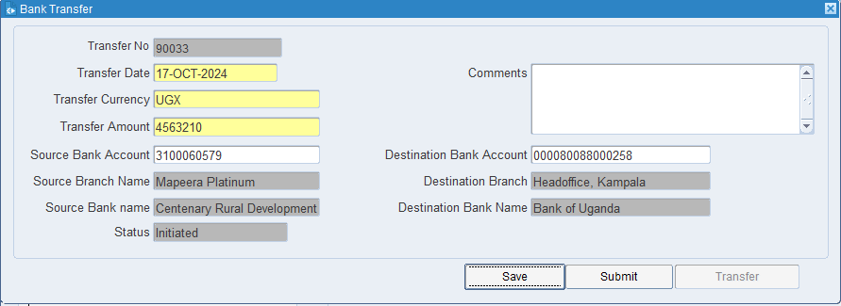

After Approval Click on Transfer Button
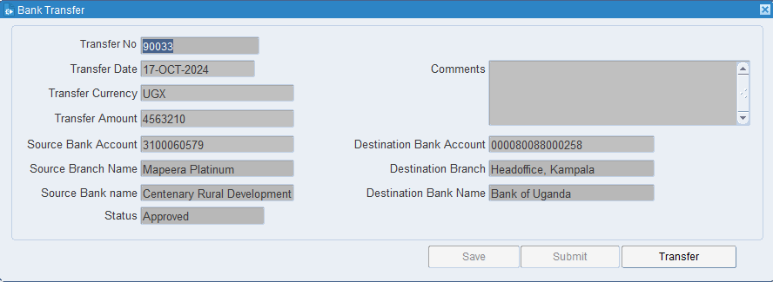

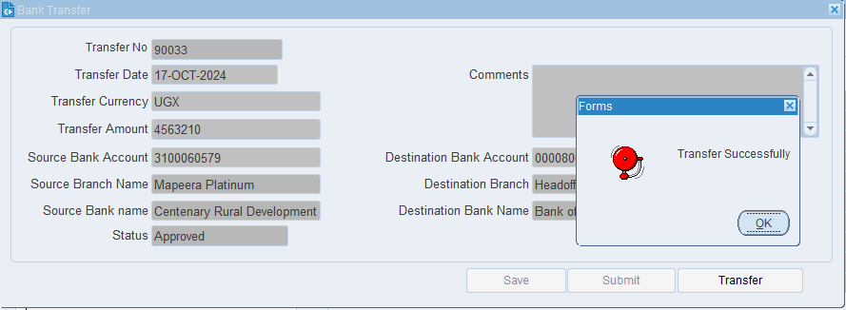

XX END XX

