White Paper User Manual For –
CIP Asset to Capitalized Asset

Module – Fixed Asset

Author : Niraj Chaurasia
Creation Date : 20-Jan-2025
Last Updated : 20-Jan-2025
Version : 1.0

Login from the User Credential to whom the functionality is provided
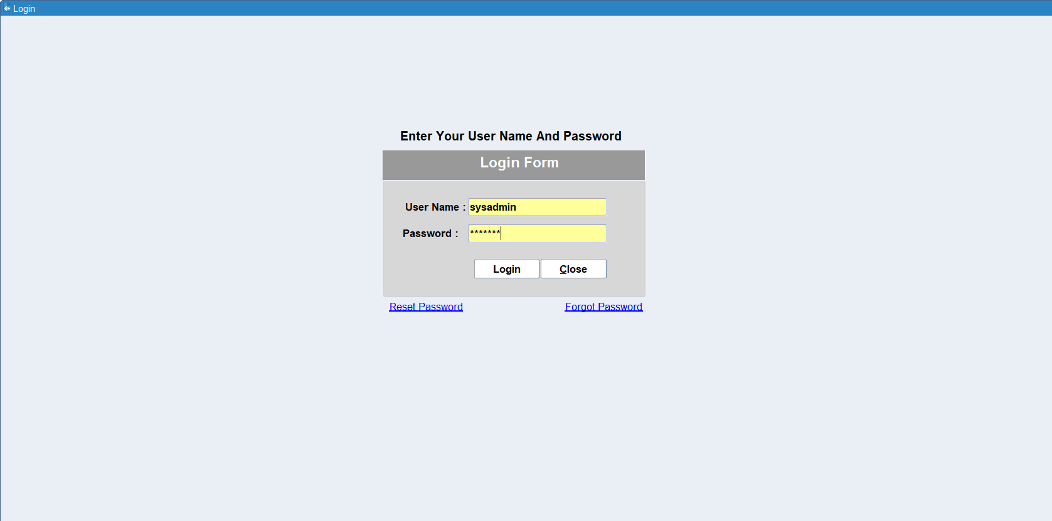
Go to Asset Workbench
Navigation: Asset Management > Asset Workbench
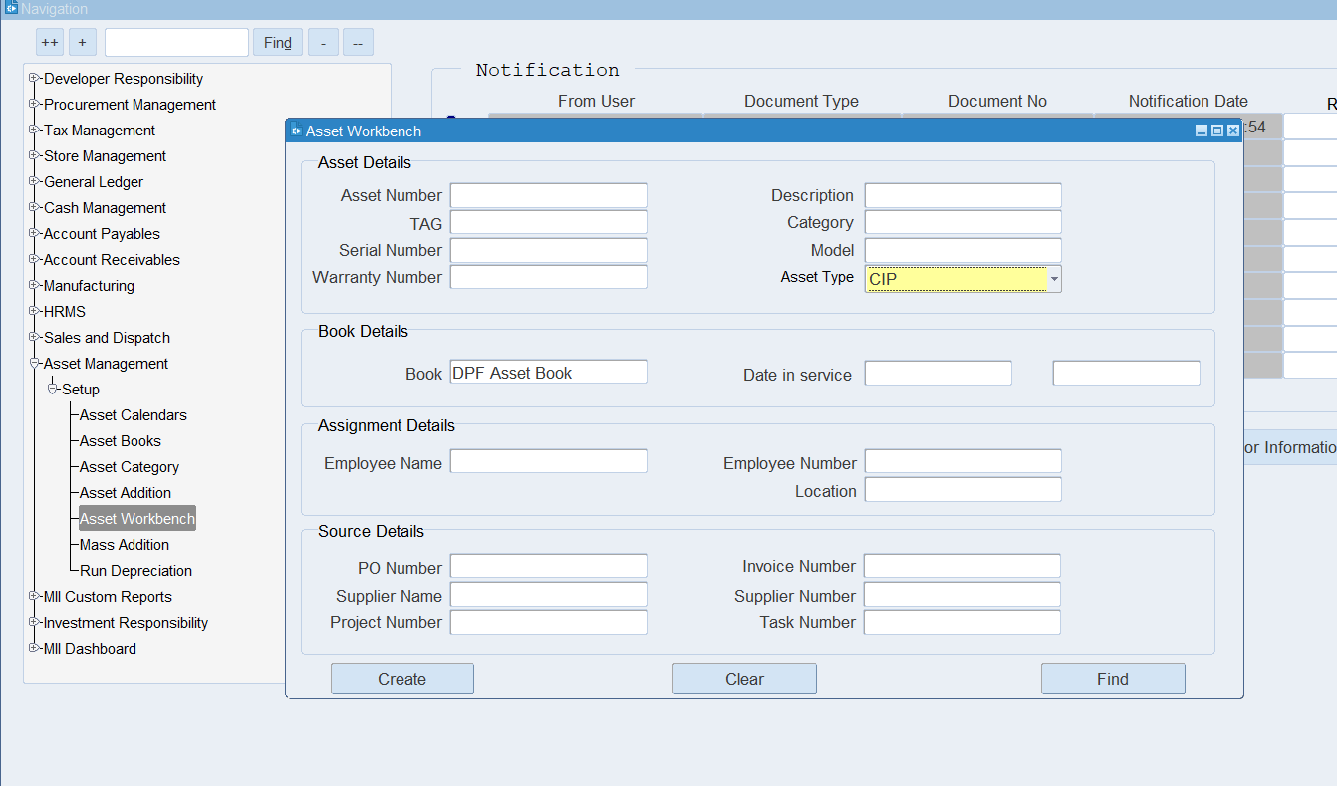

Asset Type should be CIP and Select CIP Asset Number from Asset Number Field
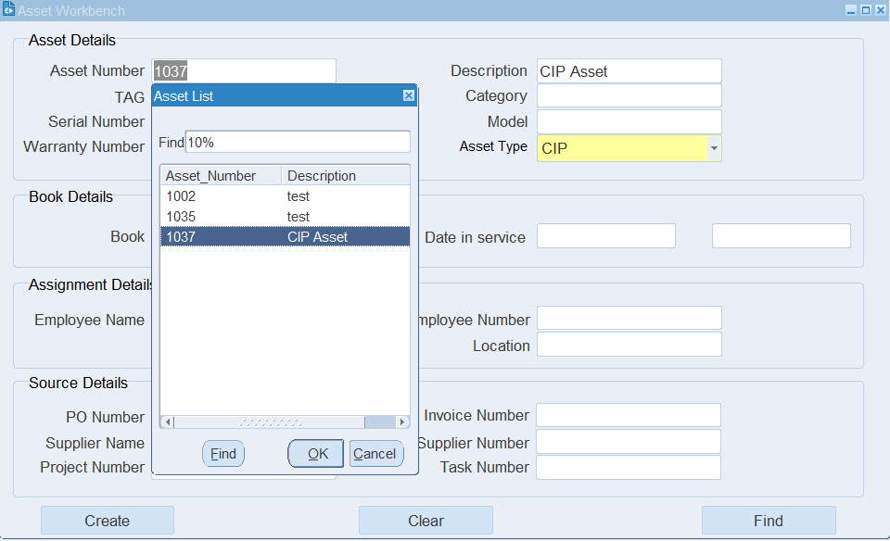
Click Find Button
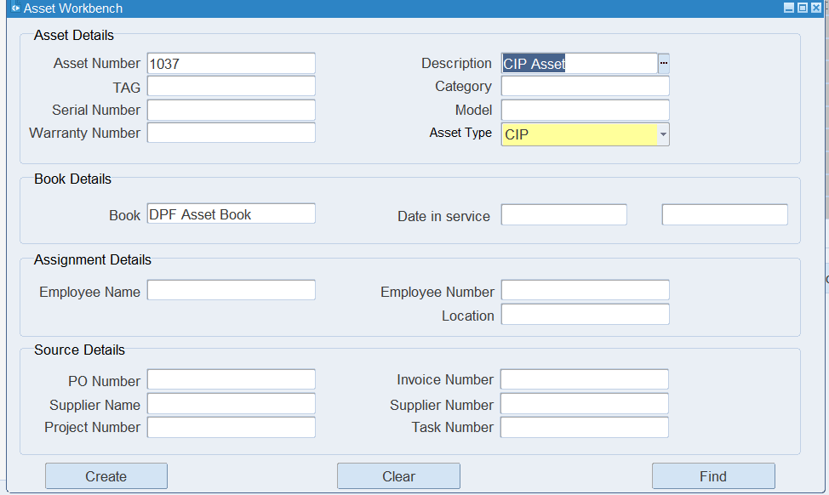

Asset Detail forms will be open
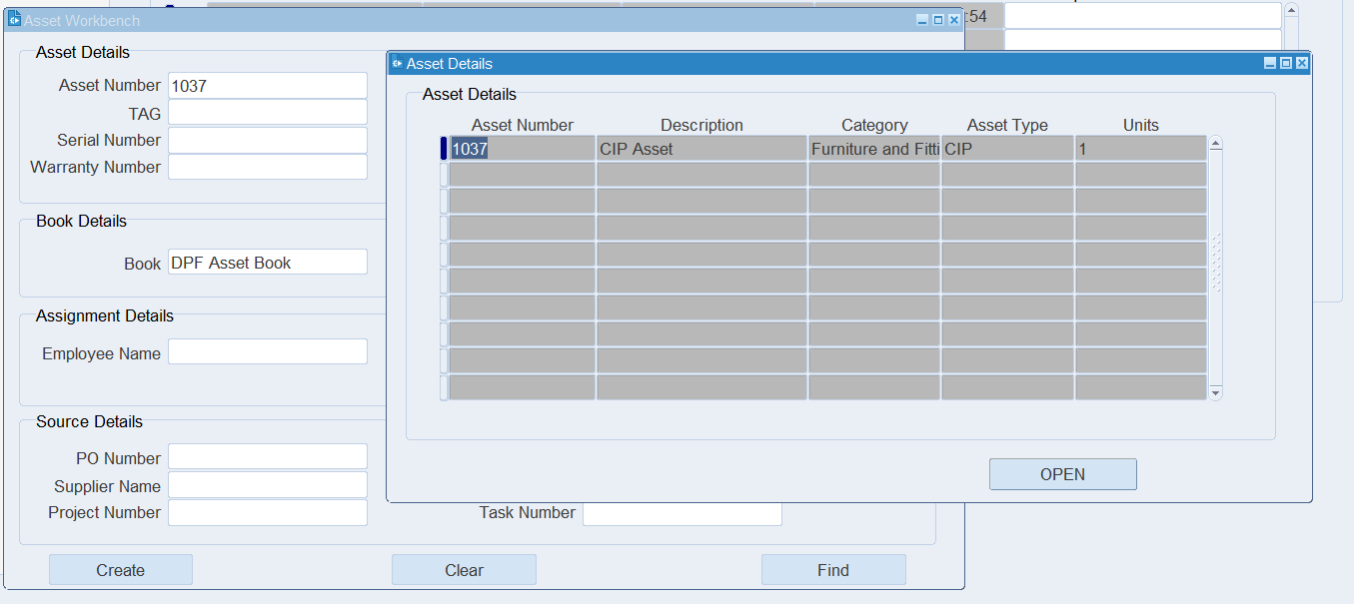
Click Open Button, Asset Addition Entry form will be open
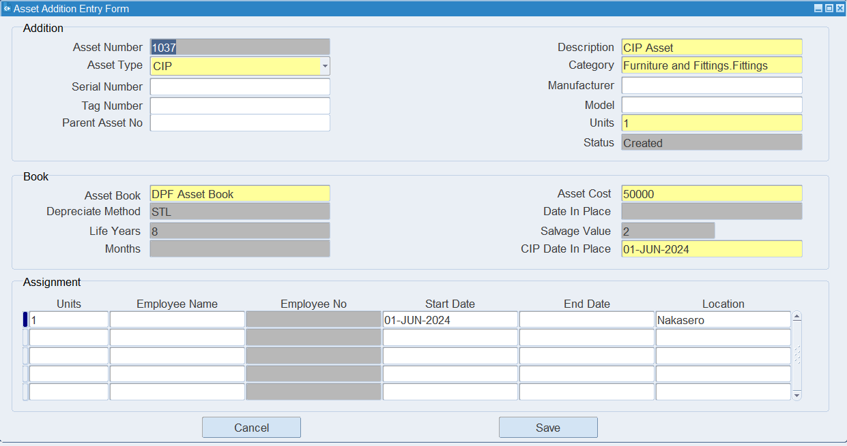

Change the Asset Type is CIP to Capitalized
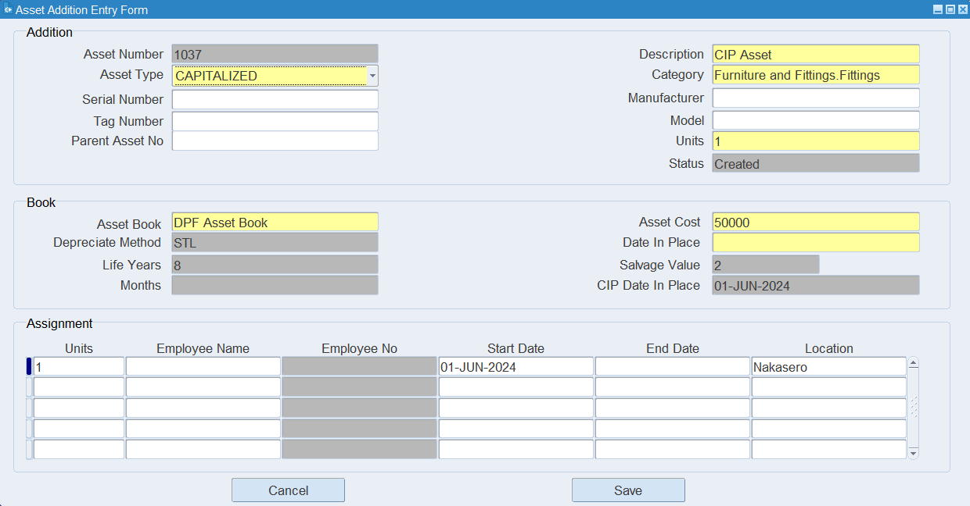
Now Date in Place field is Active, Enter the Asset Capitalization Date and save the entry
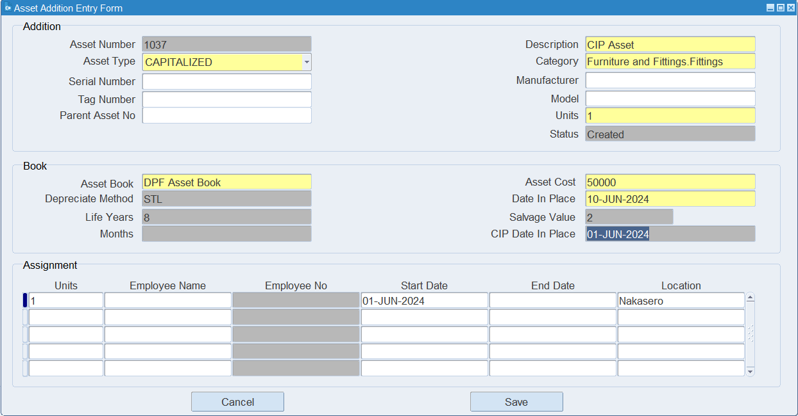

For Accounting
Go to General Ledger Responsibility
Navigation: General Ledger > Journals > JV Workbench
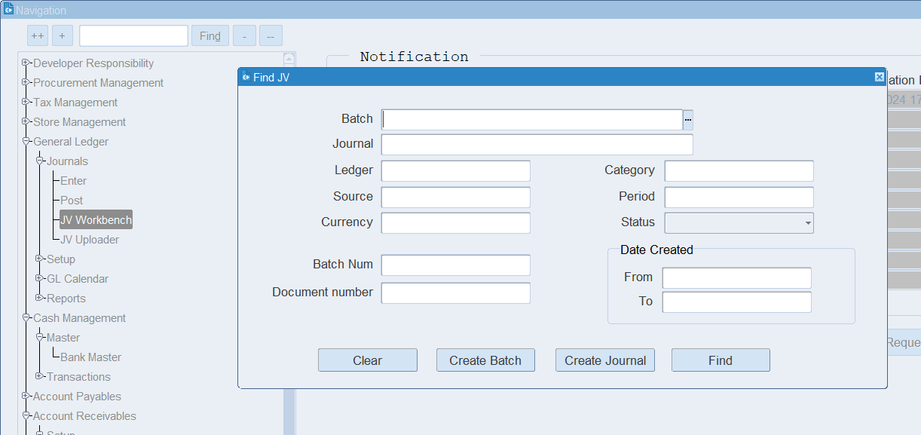
Enter CIP Asset Number in Document Number Field
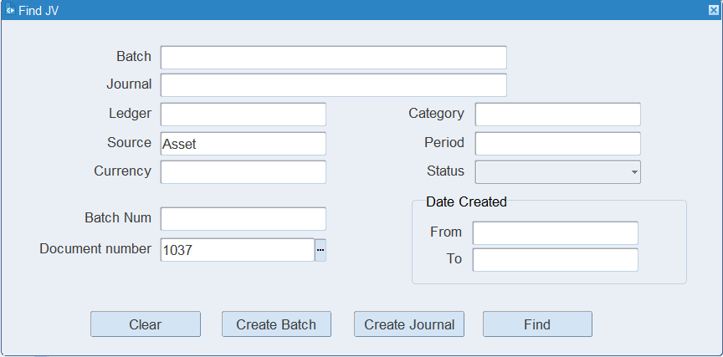
Click Find Button
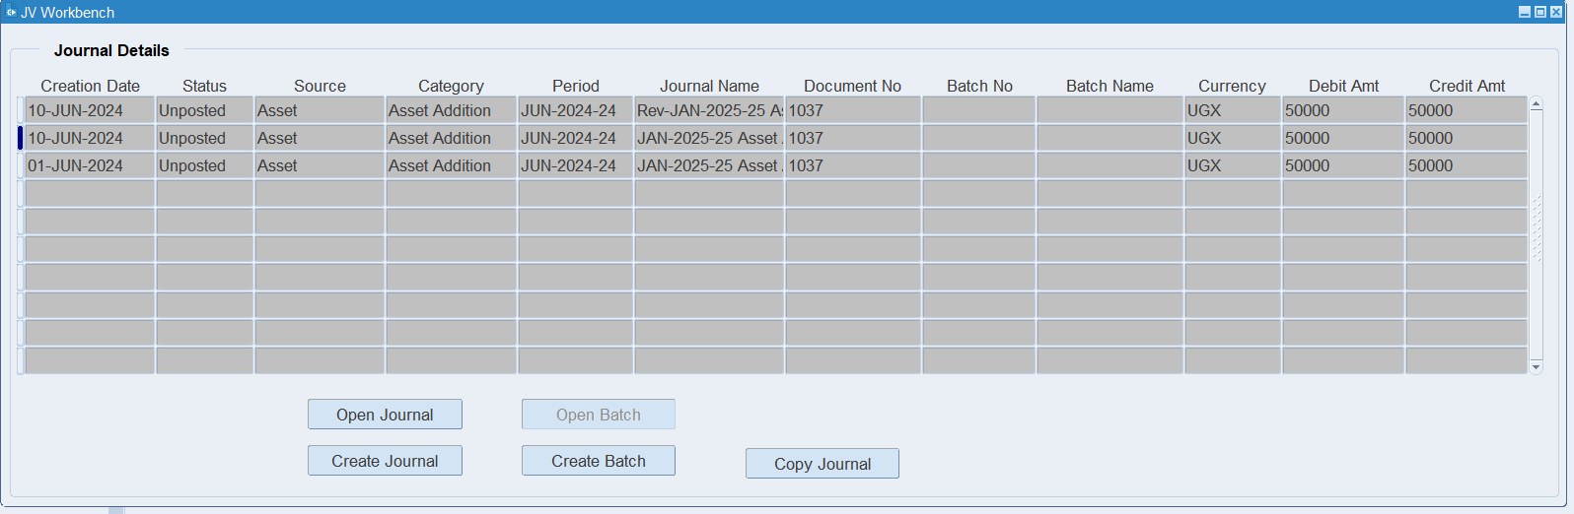
System will generate 2 more accounting line.
1st for Asset capitalization and 2nd for CIP Asset Accounting Reverse
Click Open Journal Button for view accounting for Asset Capitalization
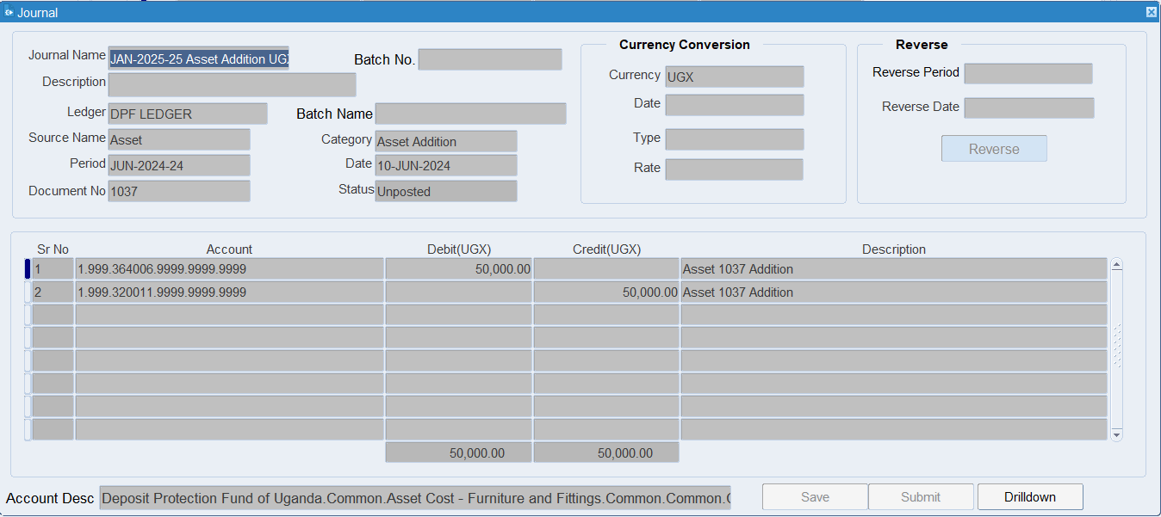

Click Open Journal Button for view reversal accounting for CIP Asset

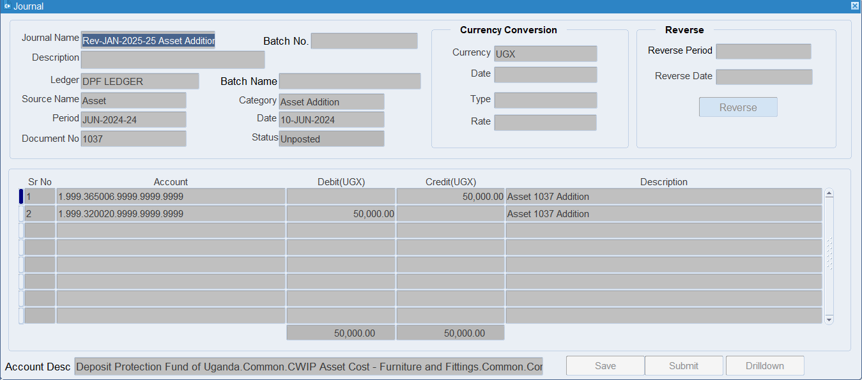

XX END XX

