White Paper User manual For –
Copy Journal Voucher

Module – General Ledger

Author : Ajinkya Patil
Creation Date : 02-Sep-2024
Last Updated : 02-Sep-2024
Version : 1.0

To explain a general voucher using the 5 W’s—Who, What, When, Where, and Why—here’s a breakdown:

- Who:

  - Who issues it? Vouchers are typically issued by businesses, organizations, or financial institutions. They can also be provided by governments or other entities.
  - Who uses it? The voucher is usually given to a customer, employee, or recipient as a form of credit or discount.

- What:

  - What is a voucher? A voucher is a document or digital code that represents a value or credit, which can be redeemed for goods, services, or discounts. It acts as a form of payment or incentive.

- When:

  - When is it issued? Vouchers can be issued at various times, such as during promotions, as rewards, or as part of a financial transaction. They might also be issued periodically or as part of specific programs.
  - When can it be used? The timing of voucher use depends on its validity period, which can be immediate or have a set expiration date.

- Where:

  - Where can it be redeemed? Vouchers are typically redeemable at specified locations or online stores, depending on the issuing entity's policies. Some vouchers might be valid only at particular retailers or service providers.

- Why:
  - Why is it issued? Vouchers are issued to encourage purchases, reward customers, promote brand loyalty, or facilitate transactions. They can also be used to provide financial assistance or incentives.

Navigation – General Ledger > Journals > JV Workbench
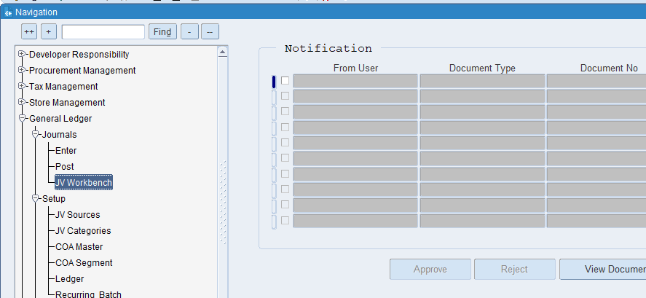
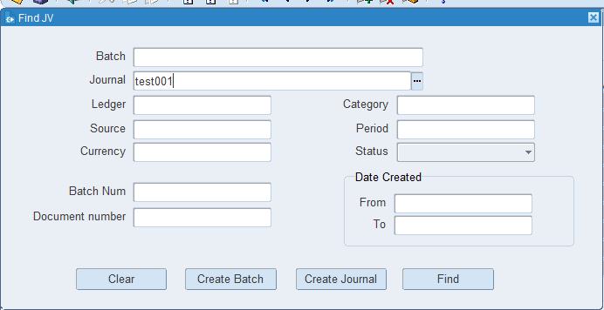
Enter the name of Journal you want to copy & click on find button

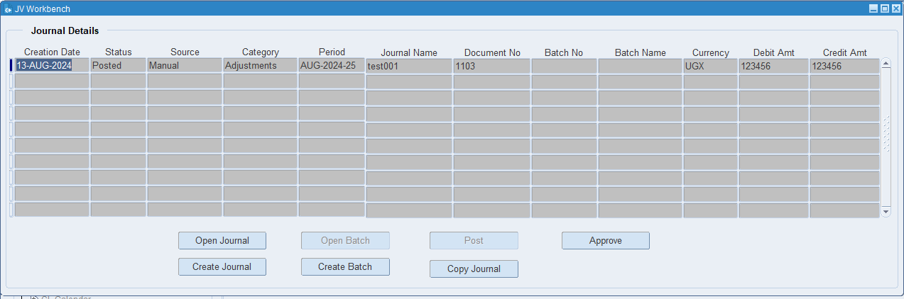
Click on Copy Journal

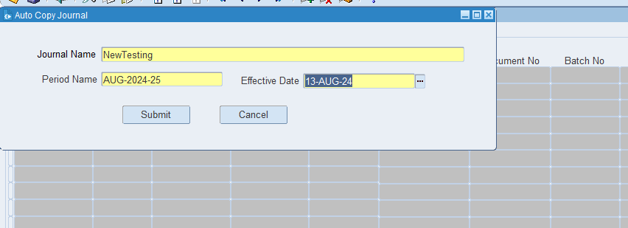
Put the Journal name, period name & Effective date
Click on submit

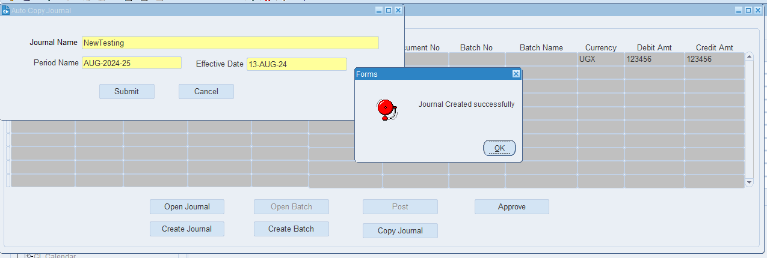
JV Created successfully

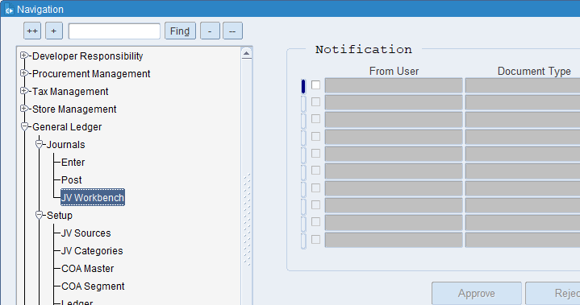
Click on JV Workbench

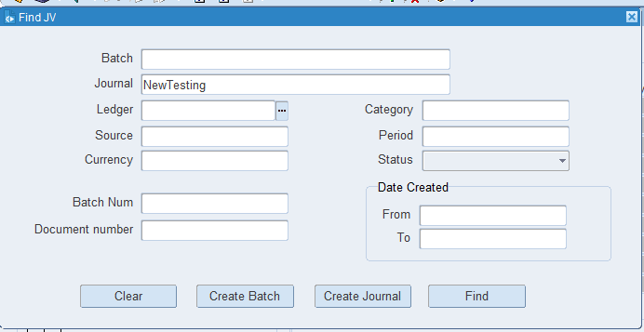
Put the copied JV name & find.

What is a Journal Name?
The choice of journal name helps in organizing and managing financial records efficiently. If you have a specific context or type of transaction in mind, let me know, and I can provide more targeted information.

What is BATCH Number?
In financial systems, batch numbers are used to group transactions that are processed together. For example, a batch number might be assigned to a group of invoices or payroll transactions that are entered into the accounting system at the same time.

What is a Ledger?
a ledger is a fundamental book or digital record where all financial transactions of a business are systematically recorded and categorized. It serves as the central repository for all financial data, which is used to prepare financial statements and reports.

What is a batch name?
A batch name is a unique identifier or label assigned to a group of items, transactions, or data processed together as a single unit. It helps in tracking and managing these items or transactions efficiently.

What is a Source name?
In accounting, the source name might refer to the document or record from which a transaction originates. For example, invoices, receipts, or purchase orders are source documents that provide evidence for entries in the accounting system.

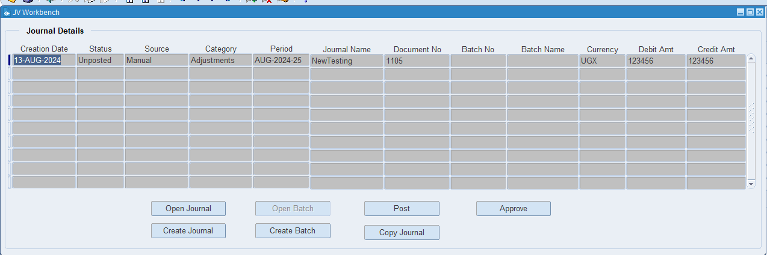
Click on Open Journal

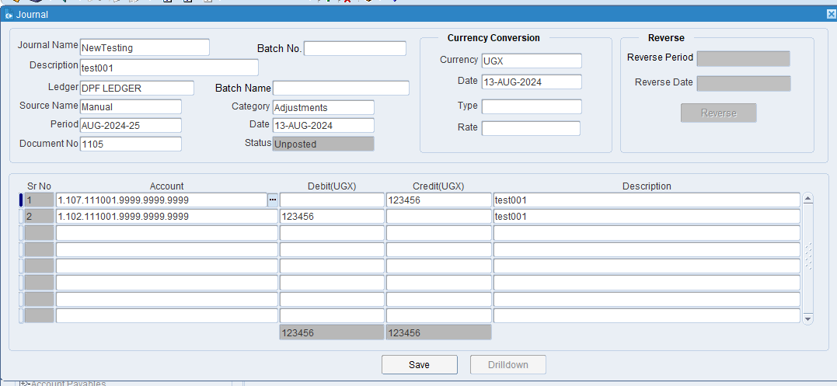
The JV has been copied successfully.

XX END XX

