White Paper User manual For –
Create Journal Batch

Module – General Ledger

Author : Ajinkya Patil
Creation Date : 03-Sep-2024
Last Updated : 03-Sep-2024
Version : 1.0

To understand what a journal batch is, let's break it down using the 5 W's (Who, What, When, Where, Why):

- Who:

  - Who uses a journal batch? Typically, journal batches are used by accountants, financial analysts, and bookkeeping professionals. They are part of the accounting process and are used by individuals or teams responsible for recording and managing financial transactions.

- What:

  - What is a journal batch? A journal batch is a group of related accounting entries recorded together in a batch or set. These entries are usually linked to a specific accounting period or transaction type and are entered into the accounting system in bulk, rather than individually. This method helps in organizing, reviewing, and posting multiple transactions efficiently.

- When:

  - When is a journal batch used? Journal batches are used during the accounting cycle, particularly when there is a need to record multiple transactions at once. This might occur daily, weekly, or monthly, depending on the volume of transactions and the accounting practices of the organization.

- Where:

  - Where is a journal batch recorded? Journal batches are recorded in the accounting software or ledger of an organization. They are typically entered into the general ledger, where they are eventually reviewed and posted to the appropriate accounts.

- Why:

  - Why use a journal batch? Using journal batches streamlines the process of recording and managing multiple transactions. It improves efficiency, reduces the likelihood of errors by consolidating entries, and facilitates easier review and approval processes. Batching also helps in maintaining accurate records and ensuring that transactions are posted systematically.

In summary, a journal batch is a method for grouping and recording multiple accounting entries together to streamline and organize the financial record-keeping process.

Navigation – General Ledger > Journals > JV Workbench

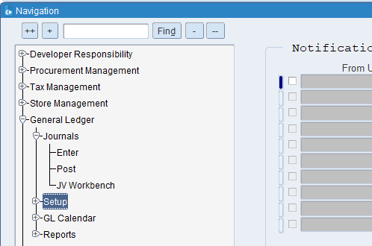
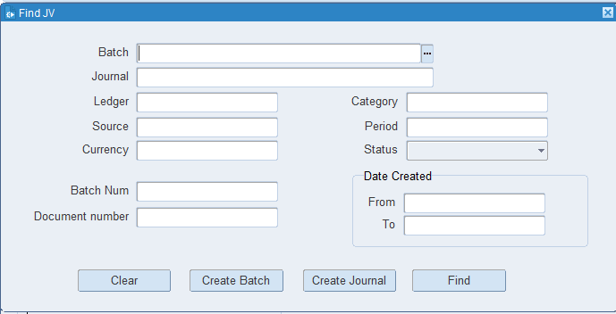
Click on Create Batch button

What is a Journal Name?
The choice of journal name helps in organizing and managing financial records efficiently. If you have a specific context or type of transaction in mind, let me know, and I can provide more targeted information.

What is BATCH Number?
In financial systems, batch numbers are used to group transactions that are processed together. For example, a batch number might be assigned to a group of invoices or payroll transactions that are entered into the accounting system at the same time.

What is a Ledger?
a ledger is a fundamental book or digital record where all financial transactions of a business are systematically recorded and categorized. It serves as the central repository for all financial data, which is used to prepare financial statements and reports.

What is a batch name?
A batch name is a unique identifier or label assigned to a group of items, transactions, or data processed together as a single unit. It helps in tracking and managing these items or transactions efficiently.

What is a Source name?
In accounting, the source name might refer to the document or record from which a transaction originates. For example, invoices, receipts, or purchase orders are source documents that provide evidence for entries in the accounting system.

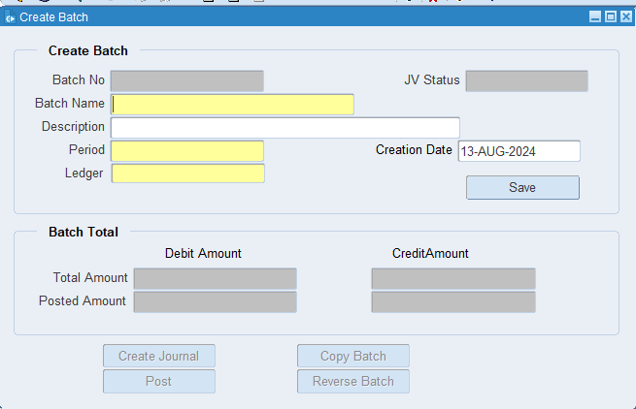
Put the required information

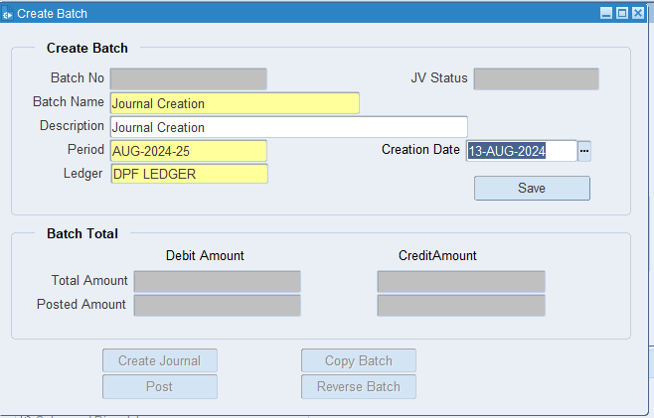
Click on Save
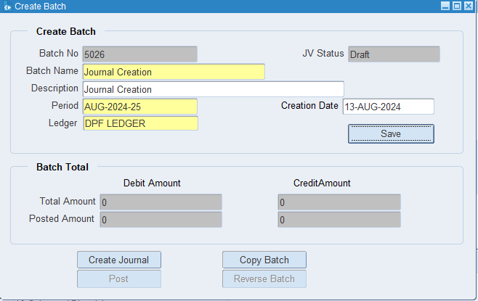
Click on Create Journal
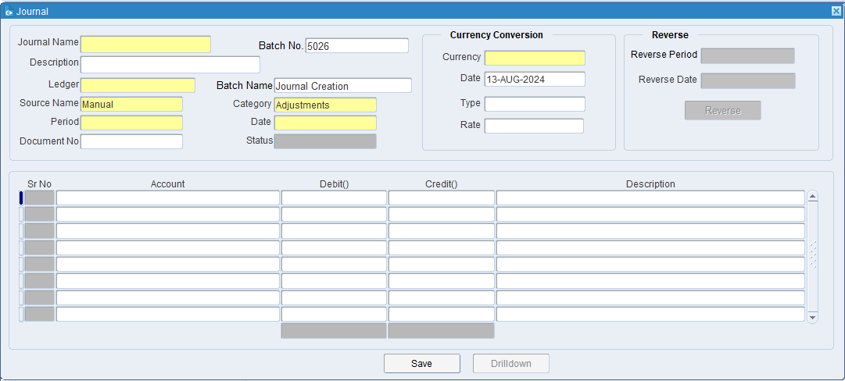
Put the all required information
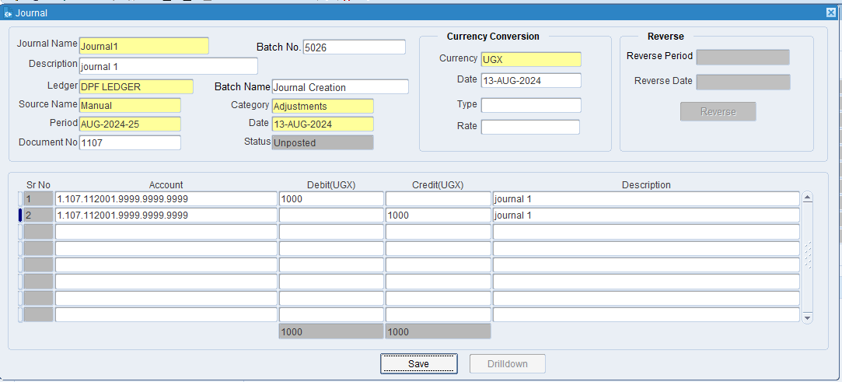
Click on save & close

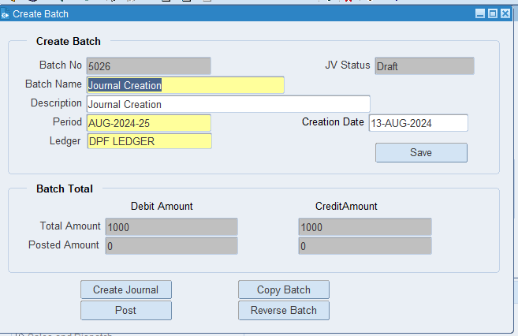
Again, click on the Create Journal
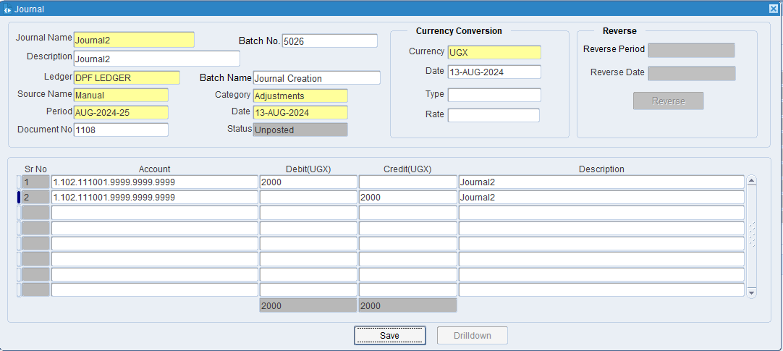
Put the required information then click on save and close.

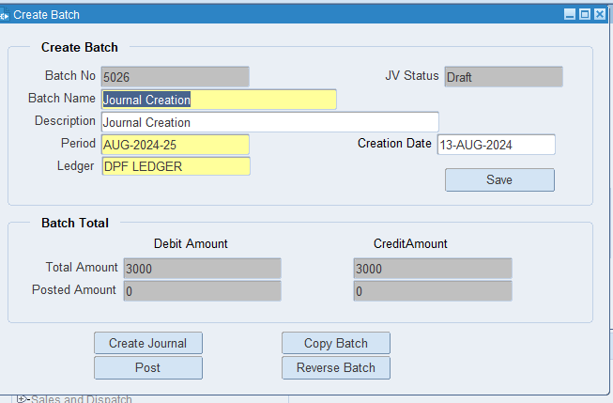

Go to JV Workbench Form again and search Batch No 5026
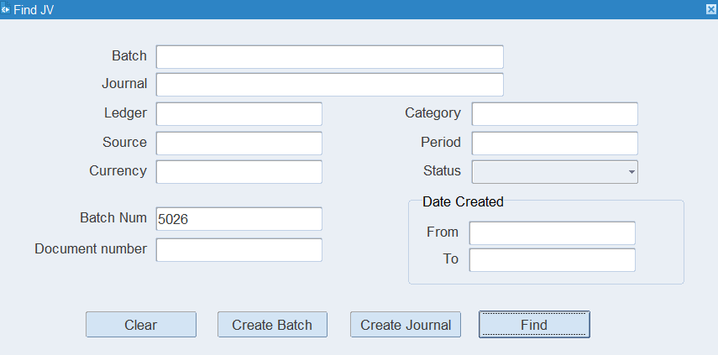

Now you can see JV details under batch no 5026
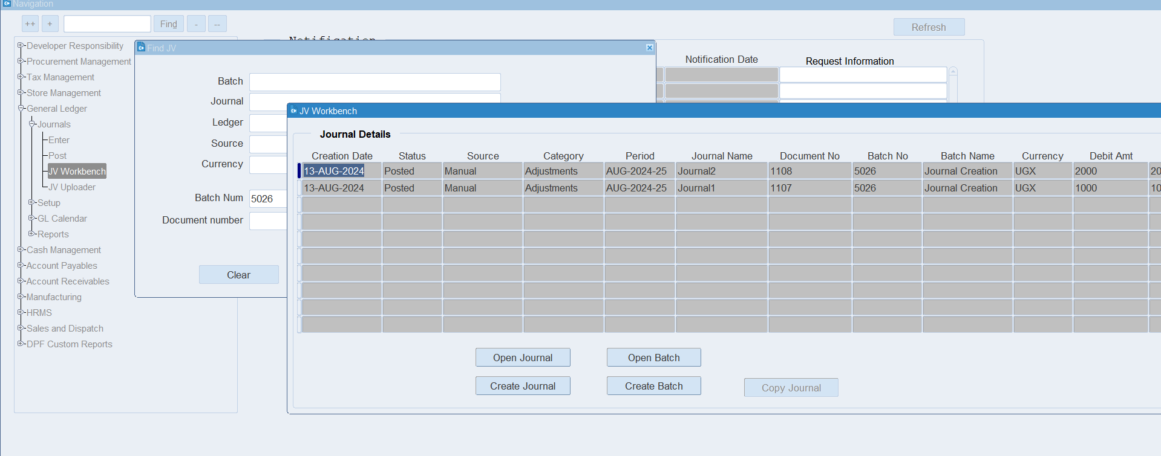

XX END XX

