White Paper User manual For –
Credit Memo Invoice With Foreign Currency

Module – Account Receivables

Author : Ajinkya Patil
Creation Date : 09-Sep-2024
Last Updated : 09-Sep-2024
Version : 1.0

A detailed explanation of a cebit memo in Accounts Receivable using the 5 W's:

1. Who
- Parties Involved: A credit memo typically involves three key parties:
  - Seller: The business that issued the invoice and is owed payment.
  - Buyer: The customer who received the goods or services and is being credited.
  - Accounts Receivable Department: The internal team managing the company's outstanding invoices and payments.

2. What
- Definition: A credit memo (or credit memorandum) is a document issued by a seller to a buyer, reducing the amount the buyer owes due to various reasons. It serves as an official record that acknowledges a reduction in the amount owed.
- Purpose: It can be issued for reasons such as:
  - Returned goods
  - Overbilling
  - Discounts applied after the invoice was issued
  - Adjustments for pricing errors or service issues

3. When
- Timing: Credit memos are issued after an invoice has been sent and a payment is due. The specific timing can depend on:
  - The occurrence of a return or dispute
  - The discovery of an error in billing
  - Agreement on a discount or adjustment after the fact

4. Where
- Context: Credit memos are typically processed within the accounting or finance department of a business. They are documented in:
  - Accounting software or ERP systems
  - Accounts Receivable records
  - Customer accounts to reflect the updated balance

5. Why
- Purpose of Issuing a Credit Memo:
  - Customer Relations: To maintain goodwill with customers by promptly addressing issues.
  - Financial Accuracy: To ensure the financial records reflect the true amounts owed.
  - Compliance: To comply with accounting standards and practices, ensuring all transactions are accurately documented.

Navigation – Account Receivables – Transaction – Receivable Invoice

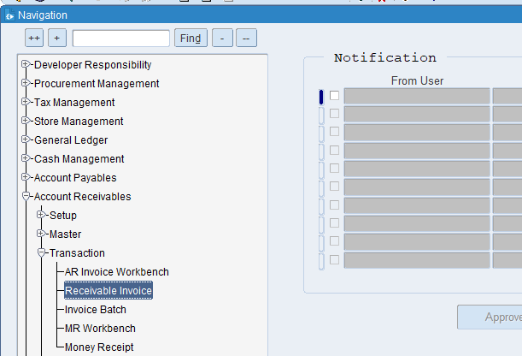

Select Type is Credit Memo
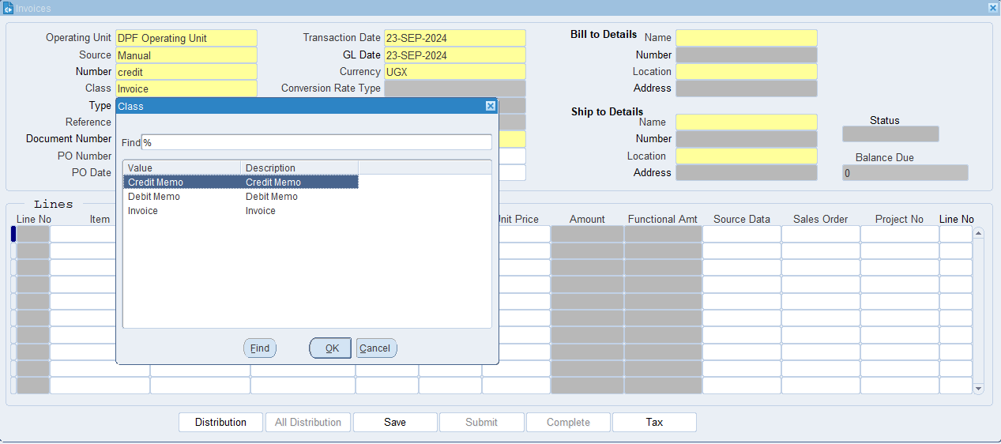

What is an Operating Unit?
An operating unit is a distinct segment or division within a company that manages a specific part of the company's operations. It can be thought of as a self-contained unit responsible for its own set of activities, resources, and objectives.

What is a source?
In the context of an Accounts Receivable (AR) invoice, the term "source" refers to the origin or point of creation of the invoice. It provides context for where the invoice originated or what triggered its issuance. Understanding the source can be crucial for tracking, verifying, and managing invoices efficiently.

What is the AR Invoice number?
A distinct, sequential number assigned to an invoice issued by a company to a customer. It is used to uniquely identify and track the invoice throughout the billing and payment cycle.

What is GL Date?
The GL date indicates the specific date on which a transaction is recorded in the General Ledger. This date determines the accounting period in which the transaction will be included for financial reporting and analysis.

What is Invoice Currency?
Invoice currency specifies the type of currency used to calculate and display the amounts due on an invoice. This could be the currency of the supplier, the customer, or a mutually agreed-upon currency.

What is class?
A categorization or grouping applied to an AR invoice to classify it based on specific criteria, such as the type of transaction, department, or product/service line.

What is Type?
The classification or category assigned to an AR invoice that indicates the nature of the invoice or the type of transaction it represents.

What is the Document Number?
A unique numerical or alphanumeric code assigned to an AR invoice to distinguish it from other invoices and provide a reference point for tracking and managing.

What is the Payment Term?
The specific conditions agreed upon by the buyer and seller regarding how and when payment for goods or services should be made. They are outlined in the invoice or contract and detail the payment schedule, due dates, and any discounts or penalties.

What is Bill-To Detail?
Bill To refers to the address and contact information of the party responsible for paying the invoice. This is the location where the invoice should be sent and where payment should be made.

What is Ship-To Detail?
Ship To refers to the address and contact information where the goods or services should be delivered. This is where the seller sends the physical products or where the service is to be provided.

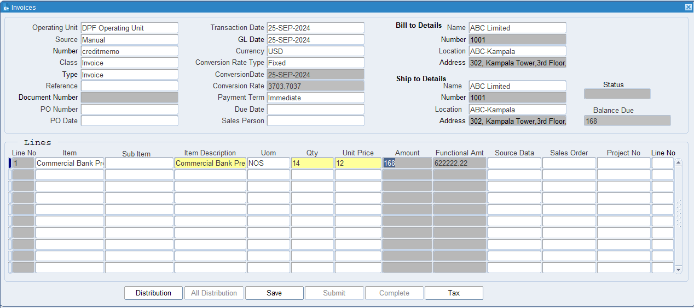
Put Currency as USD then Click on Tax (Tax is not Mandatory, impose tax only if necessary, otherwise ignore it)

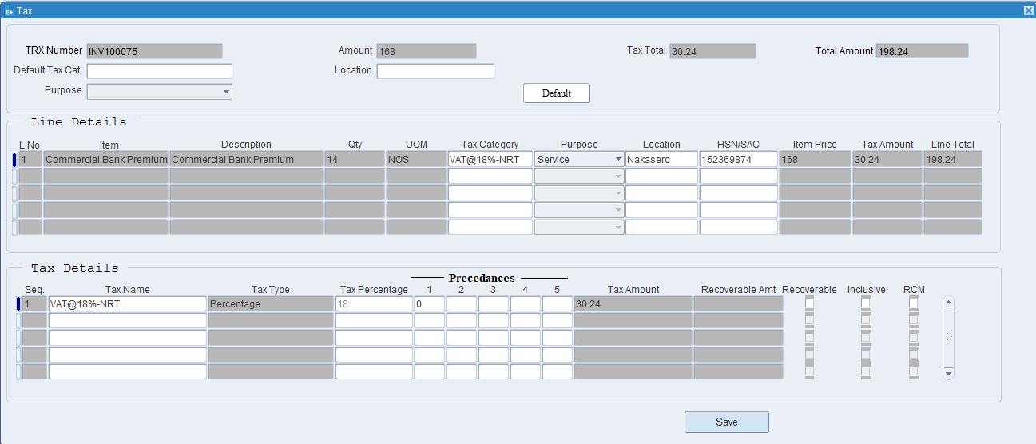

Put the Tax Category, Purpose, Location HSN/ SAC Code then click on Save.

What is Tax Category?
a tax category refers to a classification used to apply the correct tax rules and rates to transactions. This categorization ensures that taxes are calculated accurately based on the nature of the goods or services being provided and the applicable tax regulations.

What is HSN & SAC Code?
HSN (Harmonized System of Nomenclature Code) codes are used to classify goods in a standardized manner across international borders. They help in identifying products for trade and taxation purposes, ensuring uniformity in the classification of goods.

SAC (Services Accounting Code) codes are used to classify services in a standardized manner for taxation purposes. They help in identifying the type of service provided and determining the applicable GST rates.

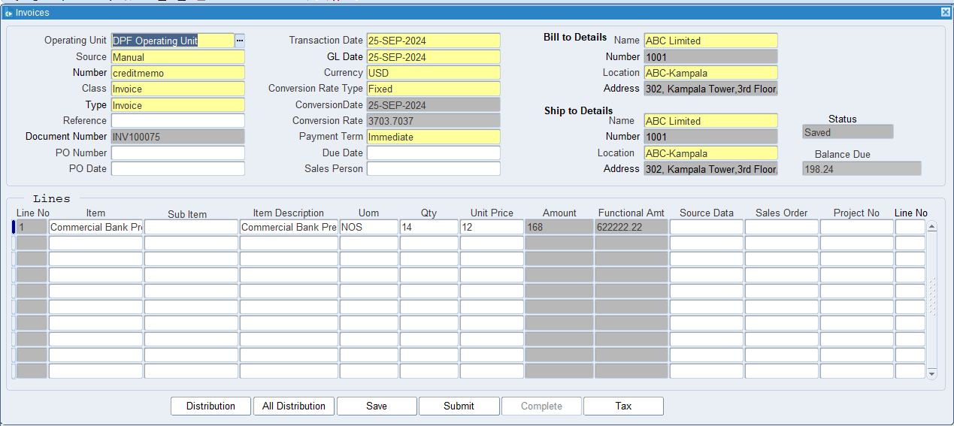
Click on Save.

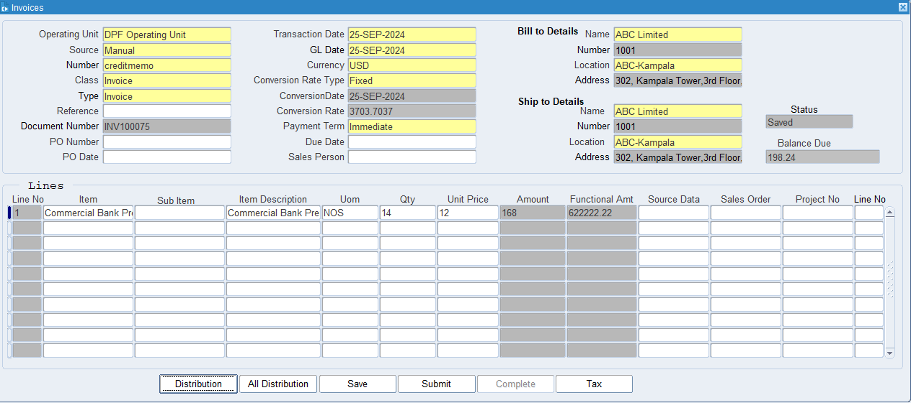
Click On Submit for approval and then click on Complete.

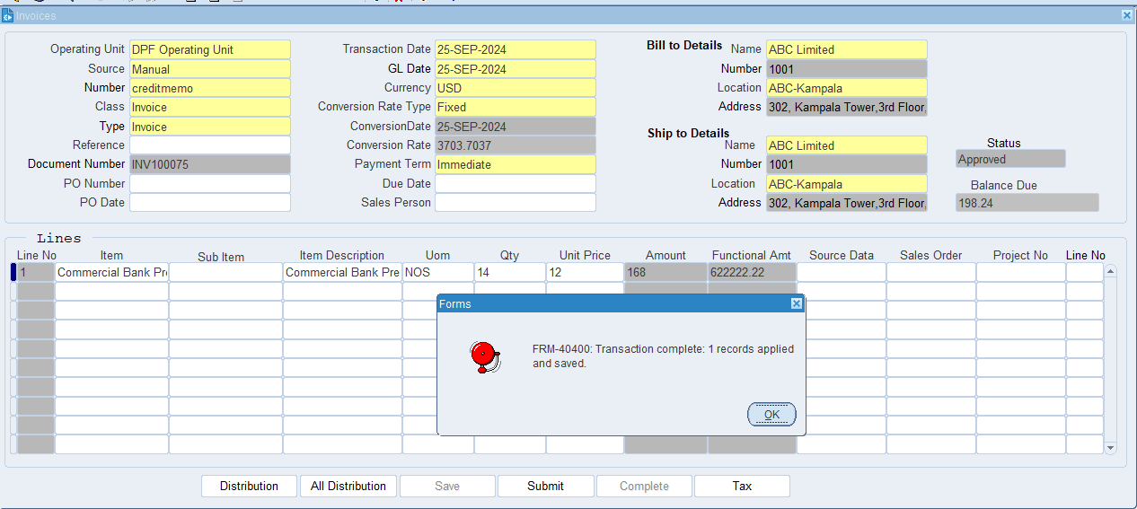

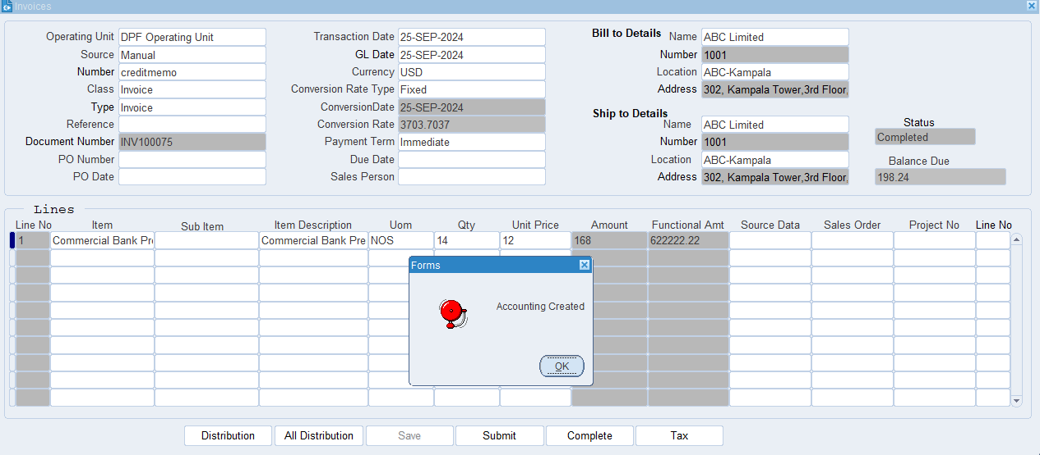
The Cebit Memo has been created.

XX END XX

