White Paper User Manual For –
Employee Master

Module – Human Resource

Author : Sourav Suman
Creation Date : 18-Oct-2024
Last Updated : 18-Oct-2024
Version : 1.0

- What is Employee Master?
The Employee Master database component stores comprehensive employee and Applicant information, which is crucial for HR management. In which we can store the basic and employment-related information of the employee or applicant as well as we can store some other information of the employee or applicant such as family details, Contact details, Previous employment details, education details etc.
- When can it be used?
The Employee Master is used in several key scenarios:
- Onboarding: Recording new employee information.
- Employee Management: Updating records for promotions, transfers, and exits.
- Payroll Processing: Providing data for accurate salary and benefits calculations.
- Performance Evaluations: Tracking reviews and training.
Overall, it supports efficient HR operations and strategic workforce management.
- where it is used?
The Employee Master is used in various systems and departments within an organization, including:
- Human Resources Management Systems (HRMS): Central repository for employee data.
- Payroll Systems: For salary calculations and benefits administration.
- Performance Management Systems: Tracking employee performance and evaluations.
- Learning Management Systems (LMS): Managing employee training and development records.
- Reporting and Analytics Tools: Generating workforce metrics and insights.
Overall, it supports various HR functions across the organization.
- why it is used?
The Employee Master is used for several important reasons:
- Centralized Information: Provides a single source of truth for all employee data, ensuring consistency and accuracy.
- Efficient HR Management: Facilitates streamlined HR processes like onboarding, promotions, and terminations.
- Accurate Payroll Processing: Ensures precise salary calculations and benefits management.
- Performance Tracking: Helps monitor employee performance, development, and training needs.
- Enhanced Communication: Provides easy access to employee information for managers and HR personnel.
Overall, it supports effective human resource management and strategic decision-making.

- Who used it?
The Employee Master is primarily used by:
- HR Professionals: For managing employee records, onboarding, and compliance.
- Payroll Administrators: To process salaries and benefits accurately.
- Managers and Supervisors: For performance tracking and team management.
- Data Analysts: For workforce analytics and reporting.
- Training and Development Coordinators: To manage employee training and development programs.
Overall, it is utilized by various roles within an organization that require access to employee information.

Navigation – HRMS – Employee Master
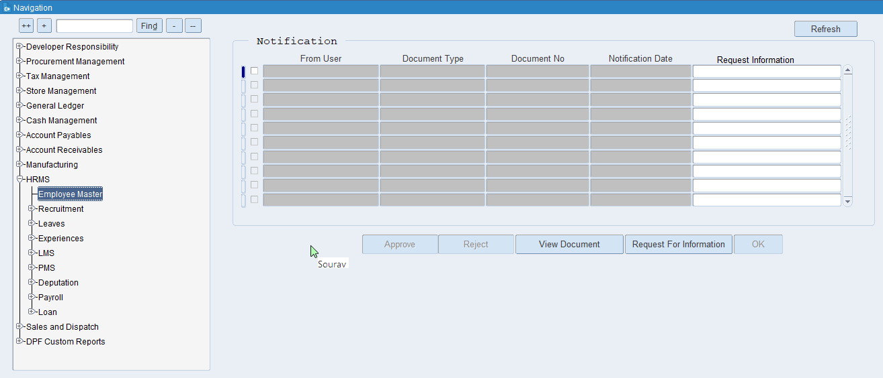

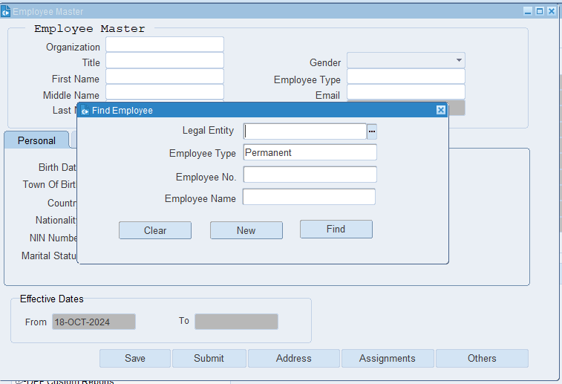

Find – Using the Find button, we can locate existing employees and applicants.
New – Using the New button, we can create a New Employee and Applicant.
Clear – By using the Clear button, we can remove the specified data.

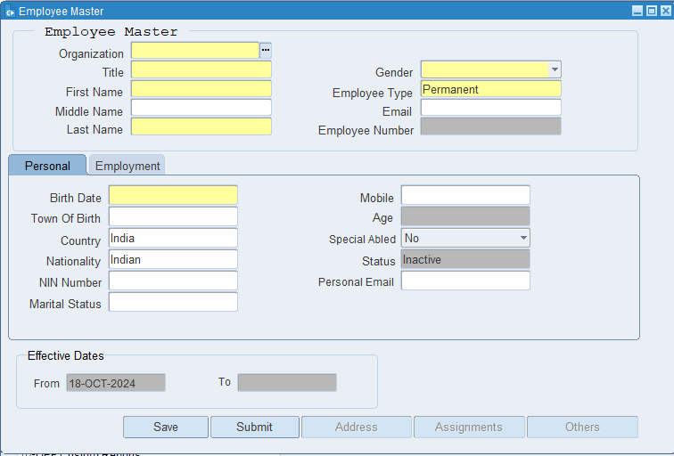
Put the Organization Name, Title, First name, Last name, DOB, and Employee Type. Then click on the save button.
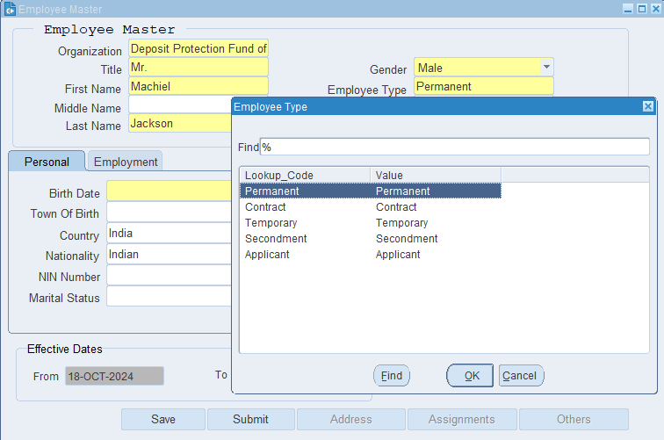
Permanent Employee - A permanent employee is someone who is hired on a long-term basis and is typically not subject to an end date in their employment contract.
Contract Employee - A contract employee is an individual hired to perform specific tasks or projects for a predetermined period, typically defined by a contract.
Temporary Employee - A temporary employee is hired for a short-term period to meet specific needs within an organization.
Secondment - Secondment refers to a temporary transfer of an employee from their usual role or location to another position or department, often within the same organization or between organizations.
Applicant - An applicant is an individual who applies for a job or position within an organization.

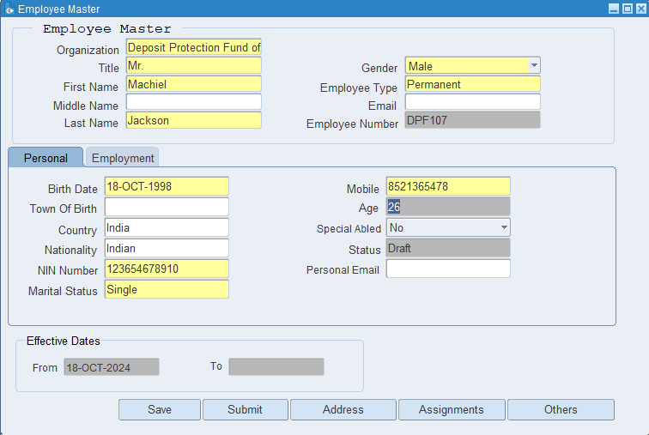
Click on Address

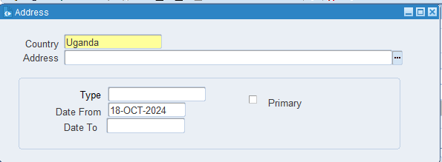
Click on LOV

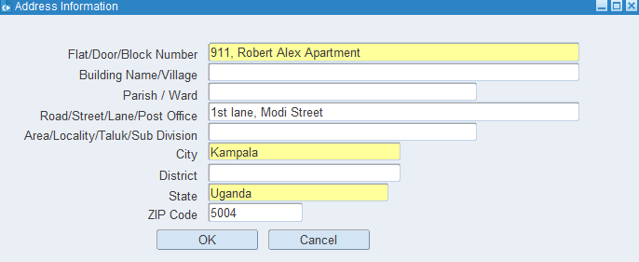
Put the necessary Information then click on Ok.

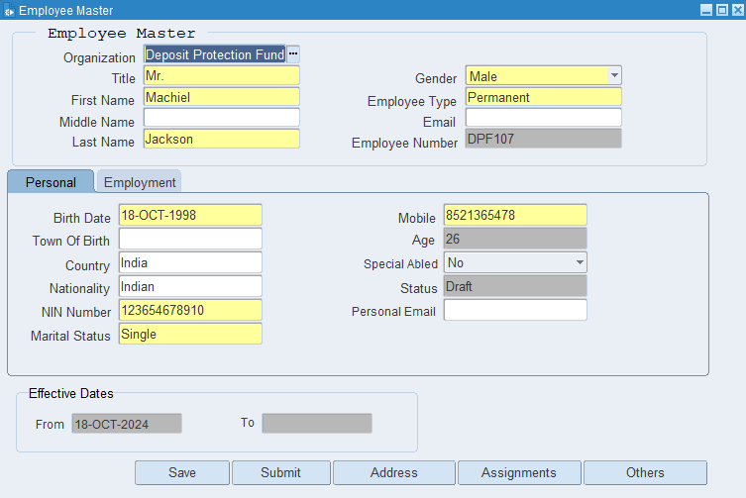
Click on Save.

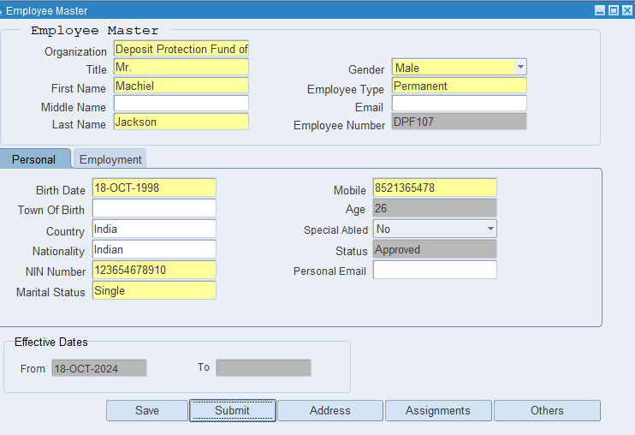
Click on Submit.
The Employee has been created.

XX END XX

