White Paper User Manual For –

White Paper User Manual For –
Leave Management

Module – Human Resource

Author : Sourav Suman
Creation Date : 18-Oct-2024
Last Updated : 18-Oct-2024
Version : 1.0

This user guide will be considered for the following process:
- Apply Leave
- Leave Approval

Overview:
Leave management refers to the processes and systems that organizations use to manage employee leave requests, approvals, and records. This includes various types of leave, such as vacation, sick leave, parental leave, and personal days. Effective leave management ensures that employees can take time off while maintaining business operations smoothly.

Key components of leave management include:
- Policy Development: Establishing clear policies regarding leave entitlements, procedures for requesting leave, and the approval process.
- Tracking and Recording: Maintaining accurate records of leave balances, types of leave taken, and any relevant documentation.
- Request and Approval Processes: Implementing systems for employees to request leave and for managers to approve or deny those requests.
- Compliance: Ensuring adherence to legal requirements and regulations regarding employee leave, such as the Family and Medical Leave Act (FMLA) in the U.S.
- Communication: Keeping open lines of communication between employees and management regarding leave status and any potential impacts on workload or scheduling.

Why it is used?

Leave management is important for several reasons:
- Employee Well-being: It allows employees to take necessary time off for health, family, or personal reasons, contributing to overall well-being.
- Productivity: Proper management ensures that workloads are balanced and that teams can maintain productivity even when some members are away.
- Compliance: Helps organizations adhere to legal requirements regarding employee leave, reducing the risk of fines or legal issues.
- Transparency: Clear processes and policies foster trust and transparency between employees and management.
- Planning: Enables better workforce planning and resource allocation, minimizing disruptions.
- Retention: Supporting employees in taking leave can lead to higher job satisfaction and lower turnover rates.
Overall, effective leave management creates a healthier work environment and supports organizational efficiency.

Where it used?

Leave management typically occurs within organizations across various departments, including:
- Human Resources (HR): HR departments are primarily responsible for developing leave policies, tracking leave balances, and ensuring compliance with legal requirements.
- Payroll: Integration with payroll systems is essential for accurately calculating leave-related pay and managing benefits.
- Management and Team Leads: Managers play a key role in approving leave requests and ensuring team workloads are managed during absences.
- Employee Self-Service Portals: Many organizations use software that allows employees to request leave, check balances, and view policies.
Overall, leave management is a collaborative effort involving HR, management, and employees, facilitated by technology.
When it used?
Leave management is an ongoing process that occurs throughout the employment lifecycle. Key moments include:
- When Employees Join: Onboarding often includes informing new hires about leave policies and entitlements.
- During Employment: Employees can request leave as needed for vacations, illness, family matters, or other personal reasons.
- At Periodic Reviews: Organizations may review leave balances and policies regularly, often during performance evaluations or annual audits.
- During Legal Changes: Updates to labour laws may necessitate adjustments to leave policies and procedures.
- During Busy Seasons: Companies may focus on leave management during peak times, ensuring adequate coverage and planning for absences.
Effective leave management is proactive and responsive, adapting to the needs of the workforce and the organization.

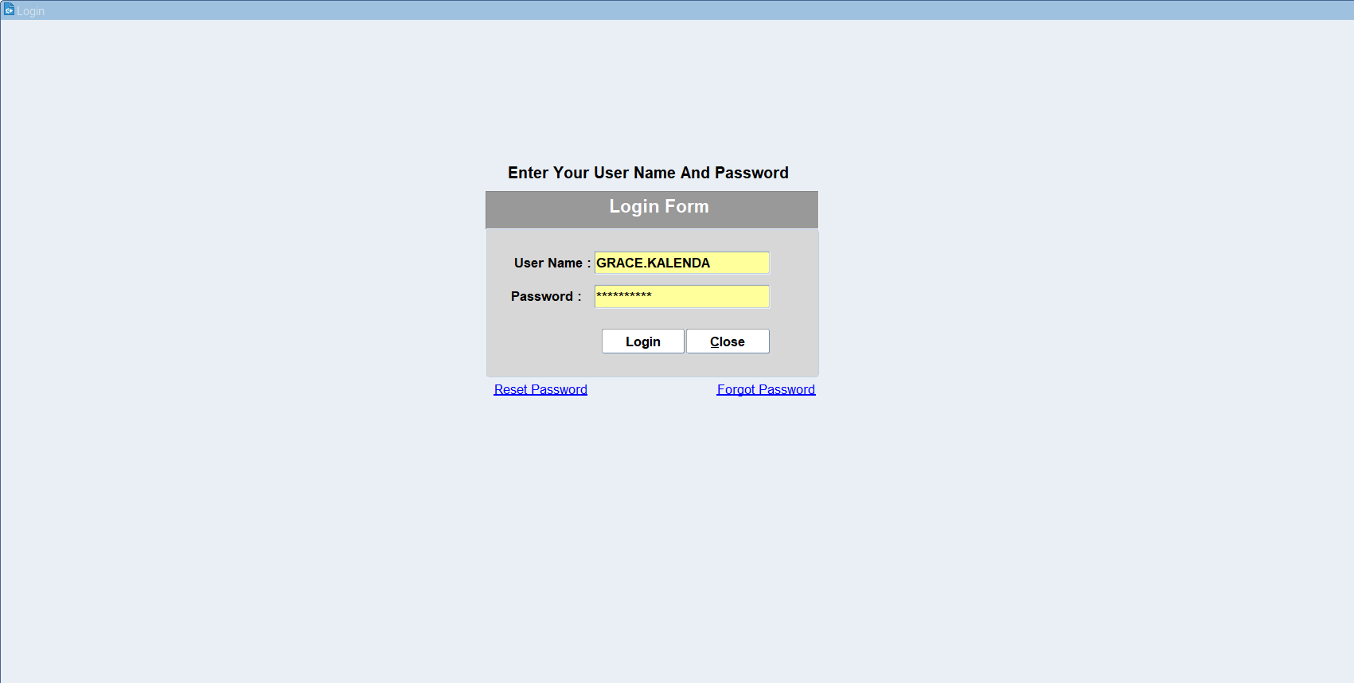
Put the Login details & click on login

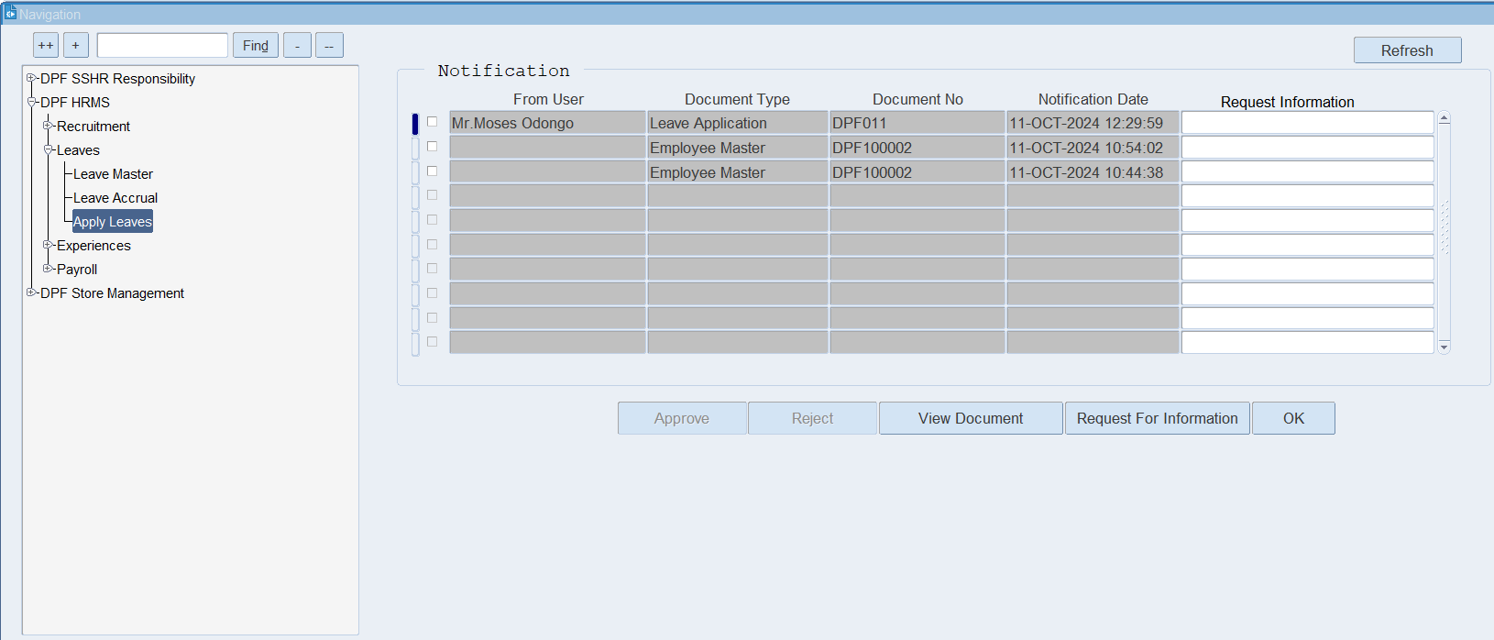
Click on Apply leaves.

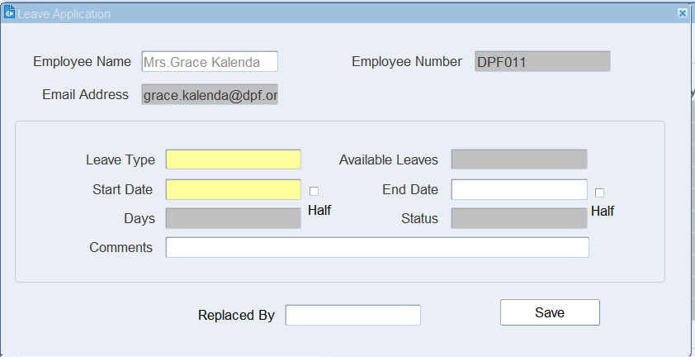
Put the Leave details like Leave type, Start and End date of the leave.

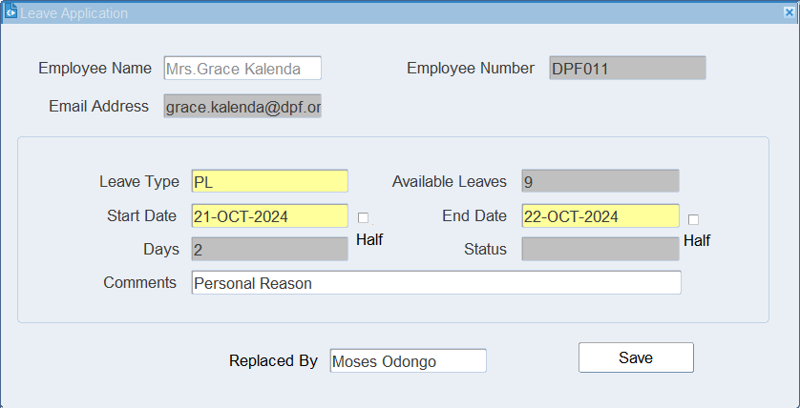
Put the reason for leave & The person who replaced by.

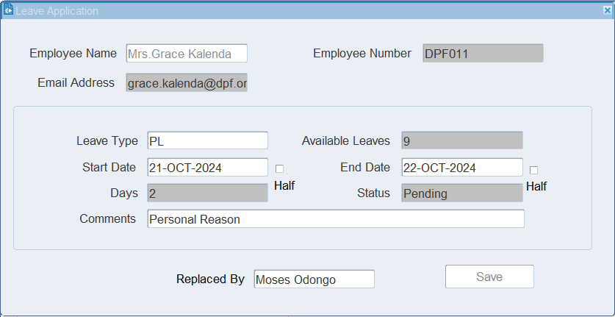
Click on Save.

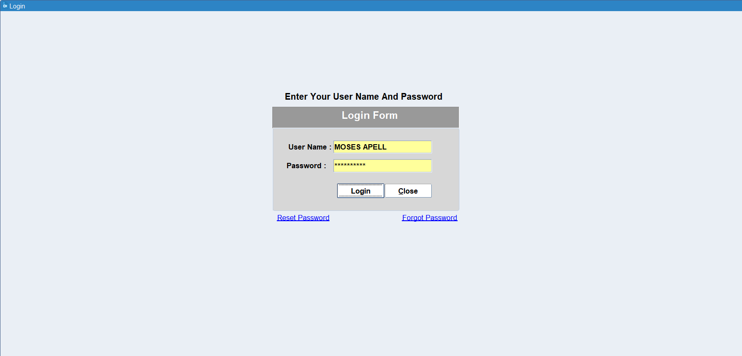
Put the login details of the approver.

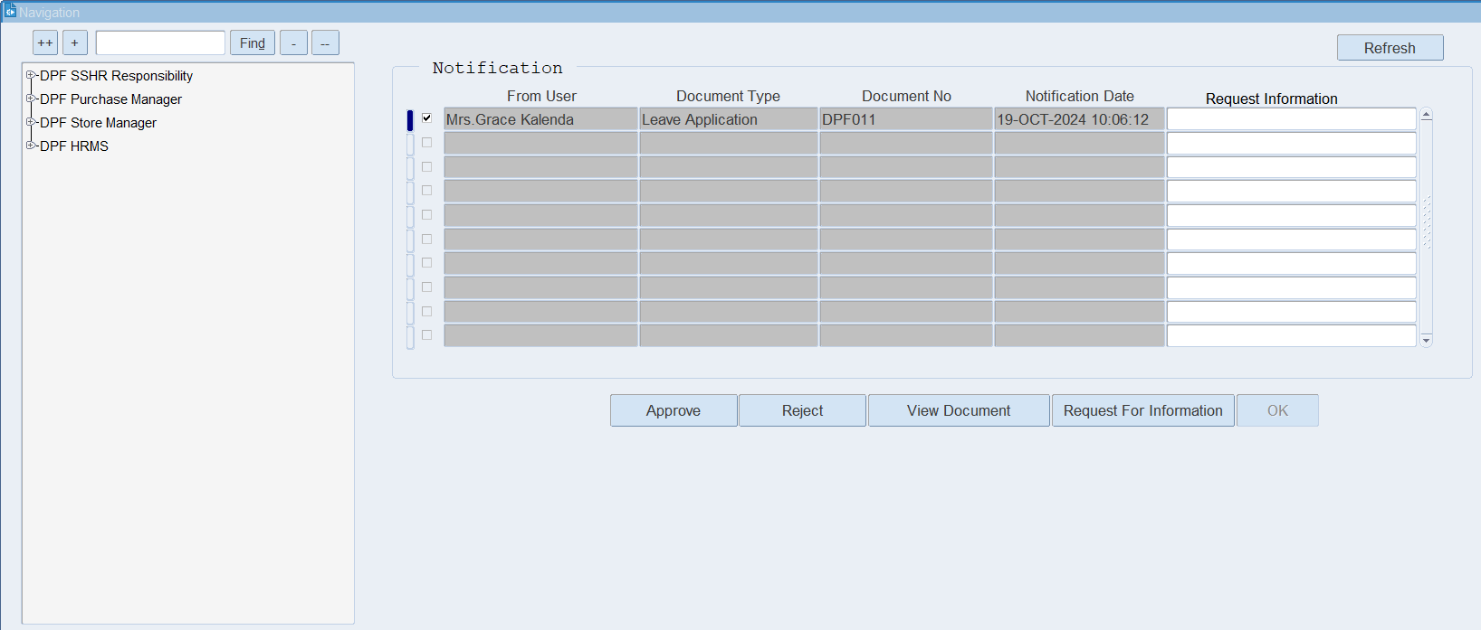
On the notification bar, we can see the leave notification.
Click on View Document for review purpose.

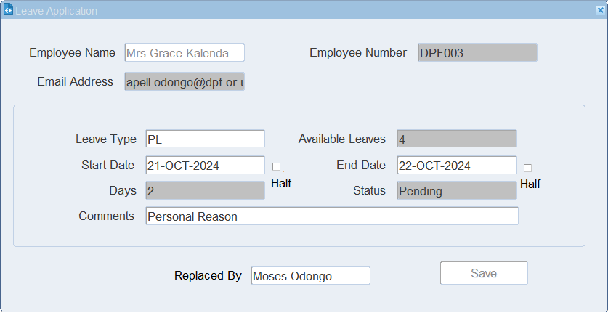
Here, we can see the leave details.

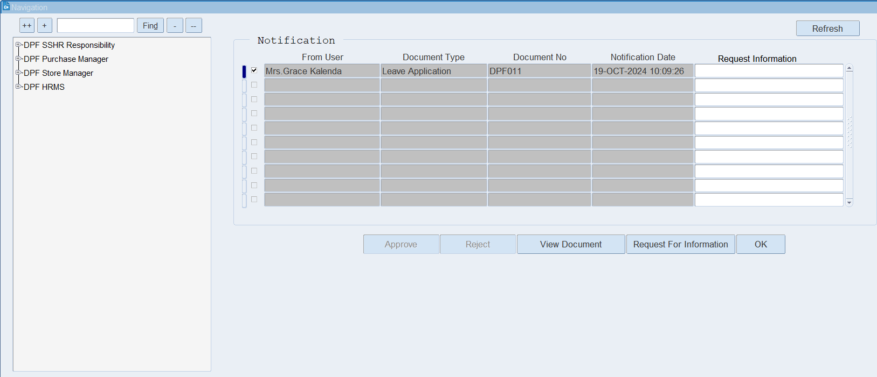
Click on the Approve button for leave approval.

XX END XX

