White Paper User Manual For –
Manual Asset Addition

Module – Fixed Asset

Author : Niraj Chaurasia
Creation Date : 20-Jan-2025
Last Updated : 20-Jan-2025
Version : 1.0

Login from the User Credential to whom the functionality is provided
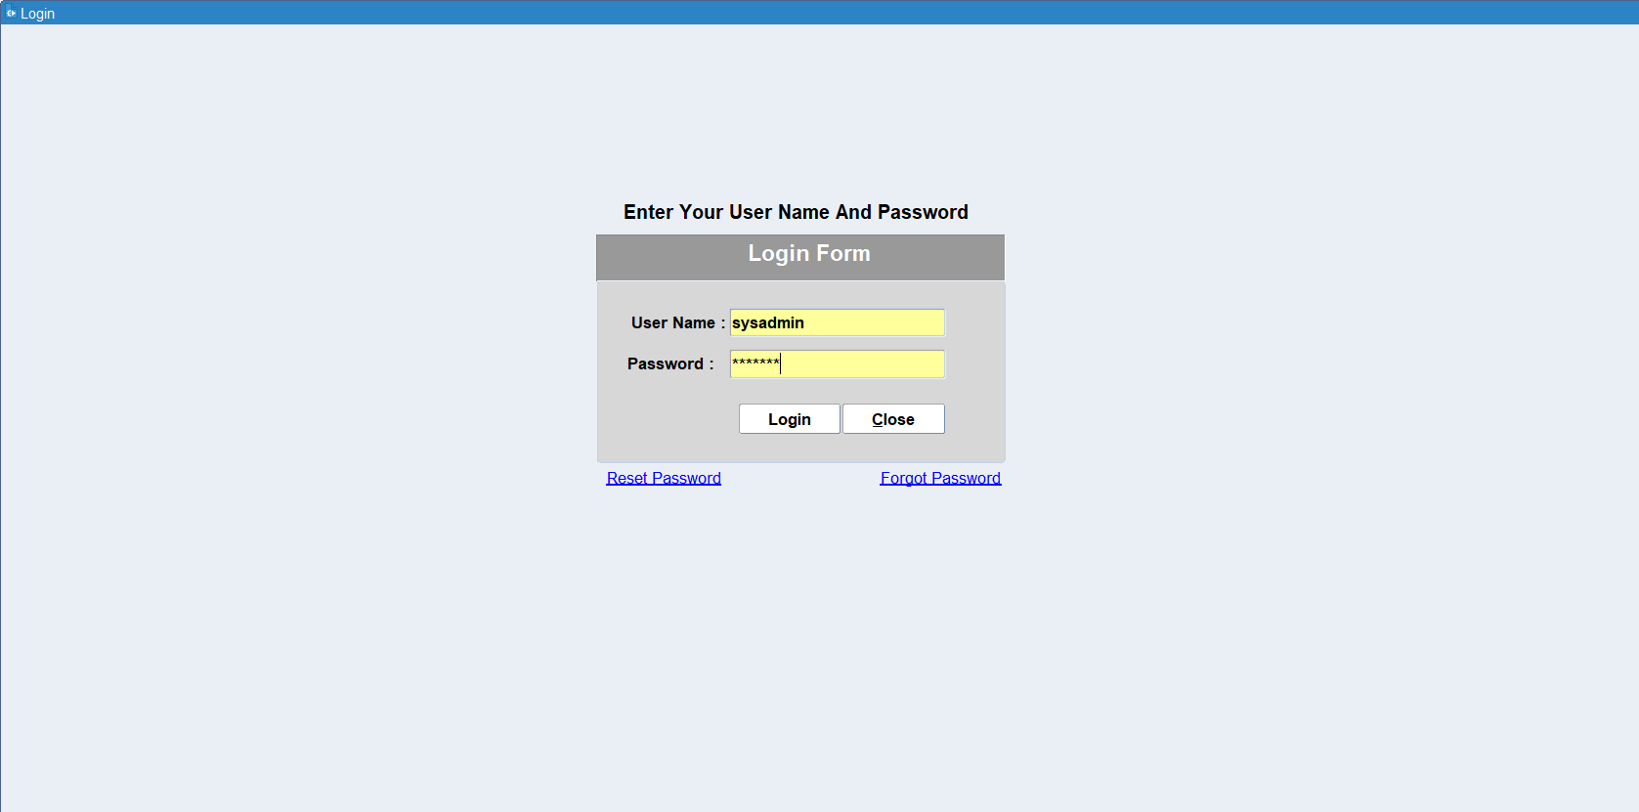

Navigation: Asset Management > Asset Addition
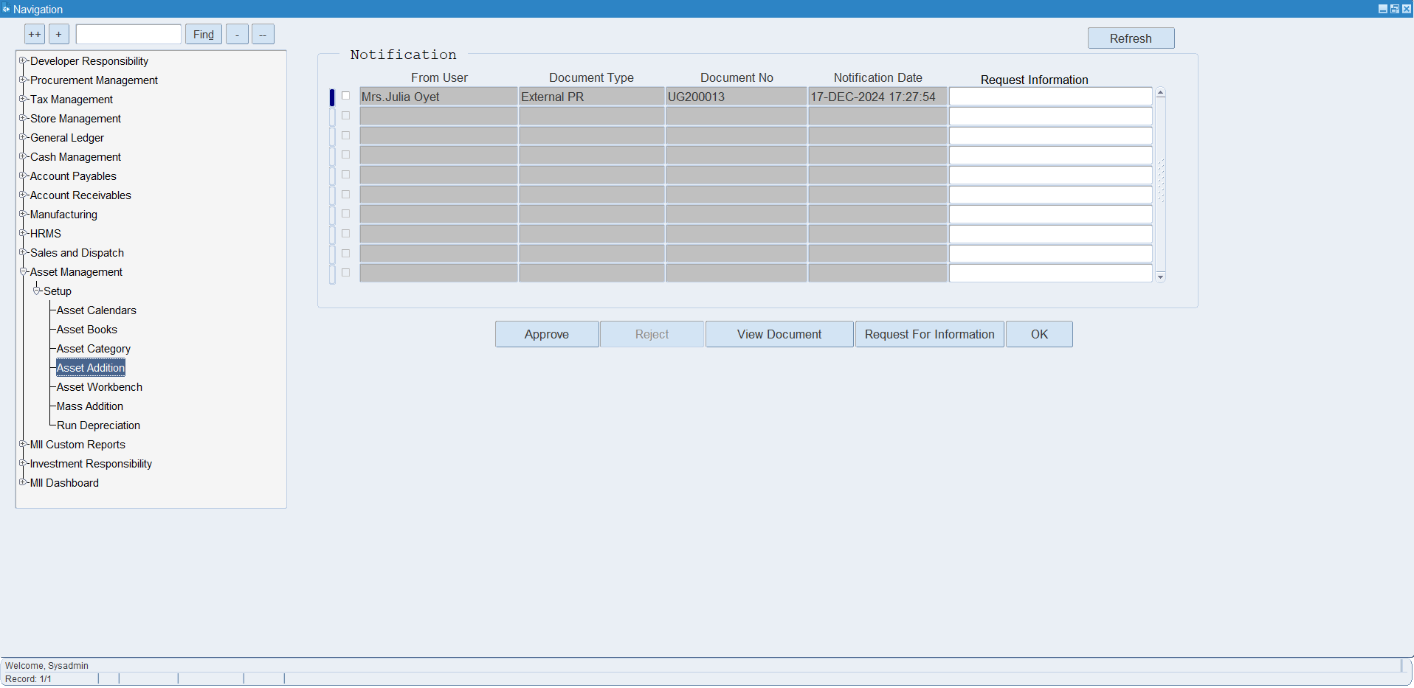

After double click Asset Addition form will be open as shown below
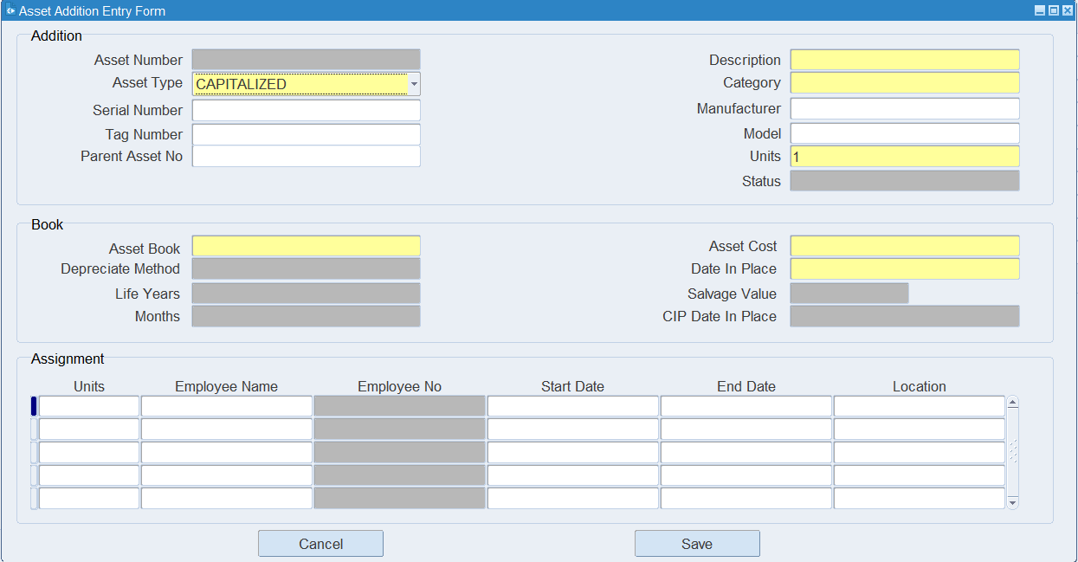
Entered all Asset Details as per requirement and Save the Entries
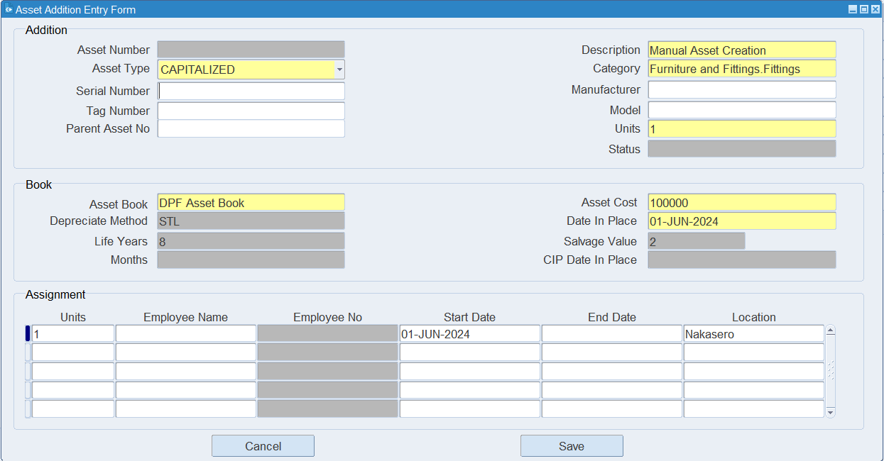

After Save System will Auto Generate Asset Number
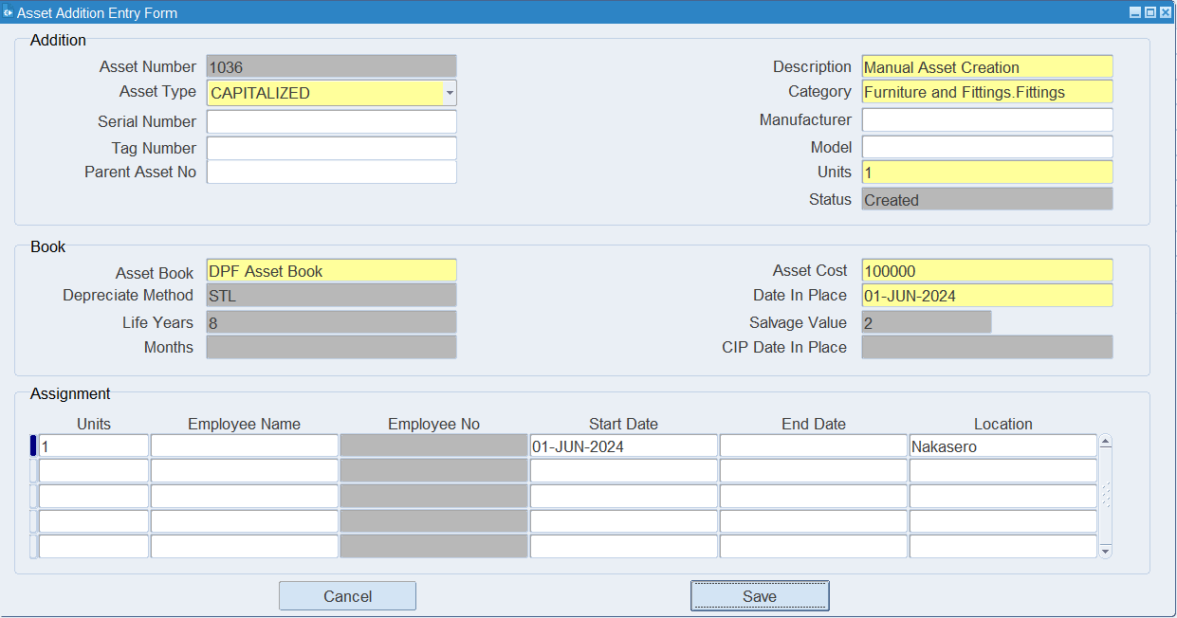
Go to Asset Workbench form for viewing Asset
Navigation: Asset Management > Asset Workbench
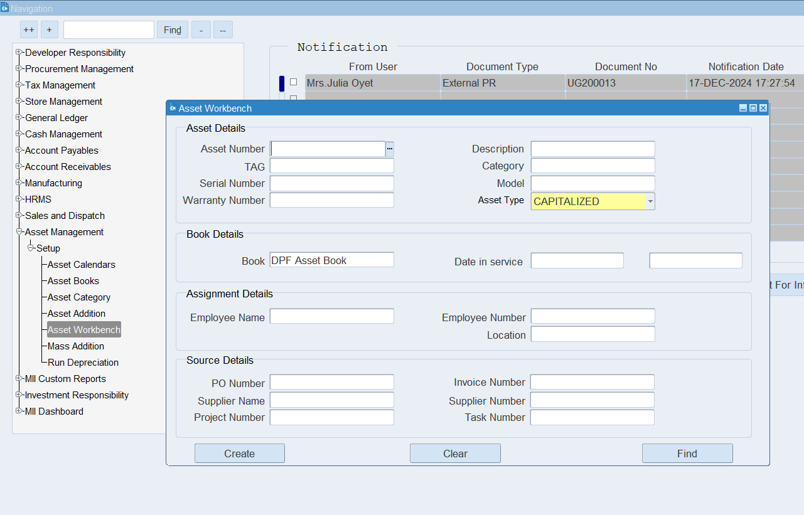

Select Asset Number from Asset Number Field (LOV)
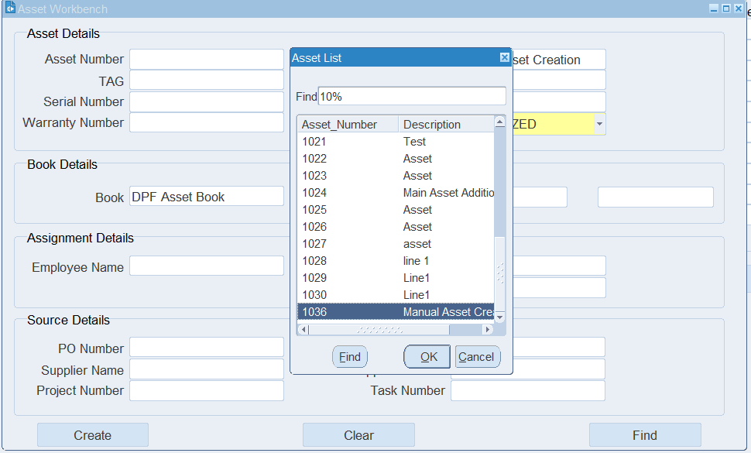
Click Find Button
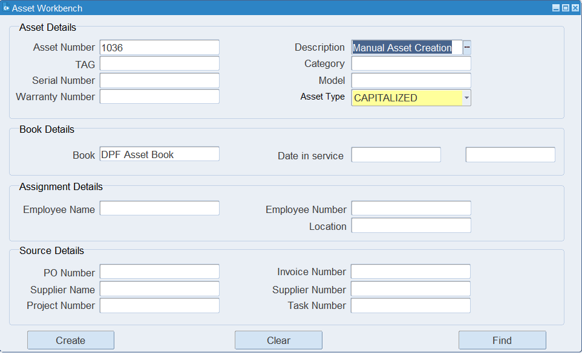

Asset Detail forms will be open
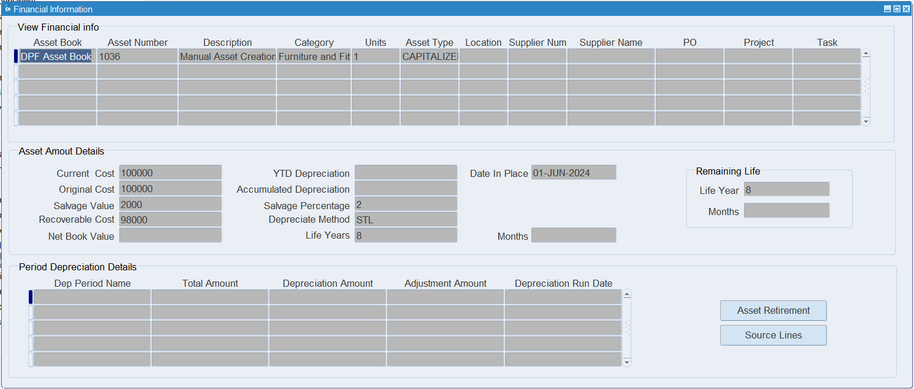
In this from we can see all details related to Asset.
For Accounting
Go to General Ledger Responsibility
Navigation: General Ledger > Journals > JV Workbench
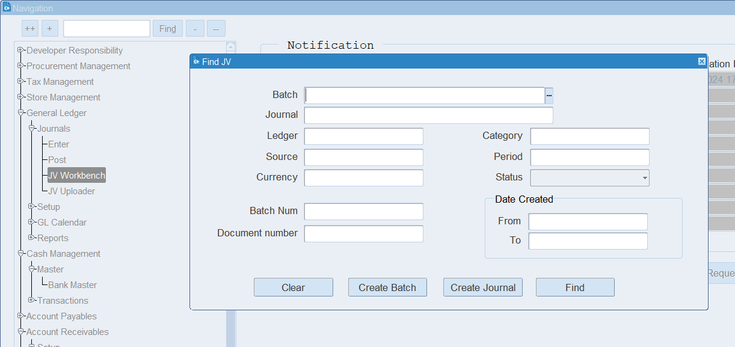

Enter Asset Number in Document Number Field
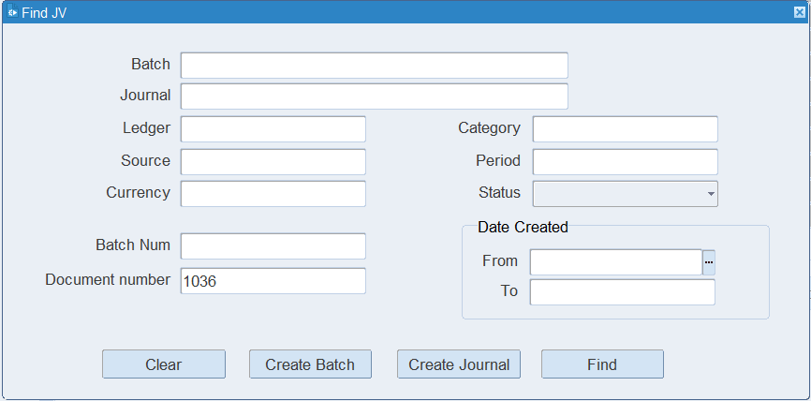
Click Find Button
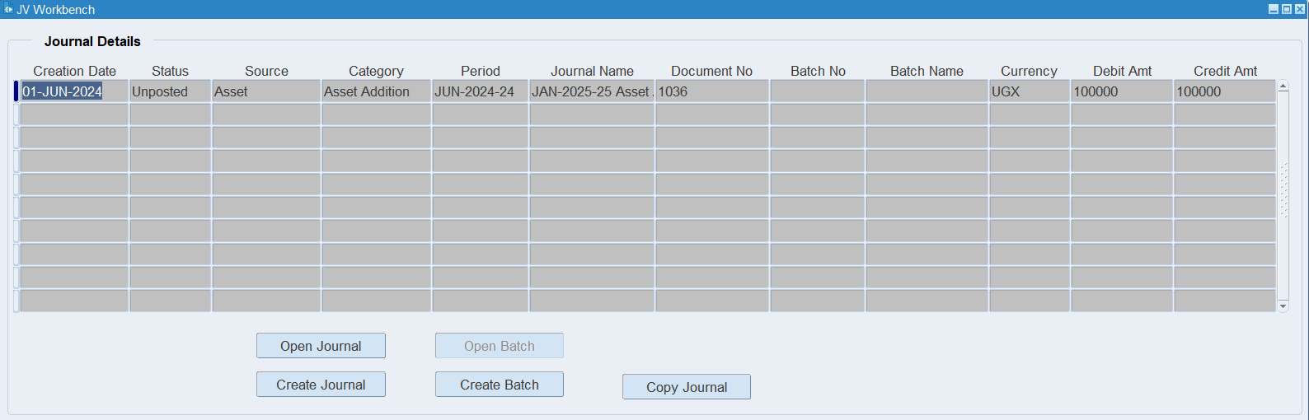

Click Open Journal Button for view Depreciation Accounting
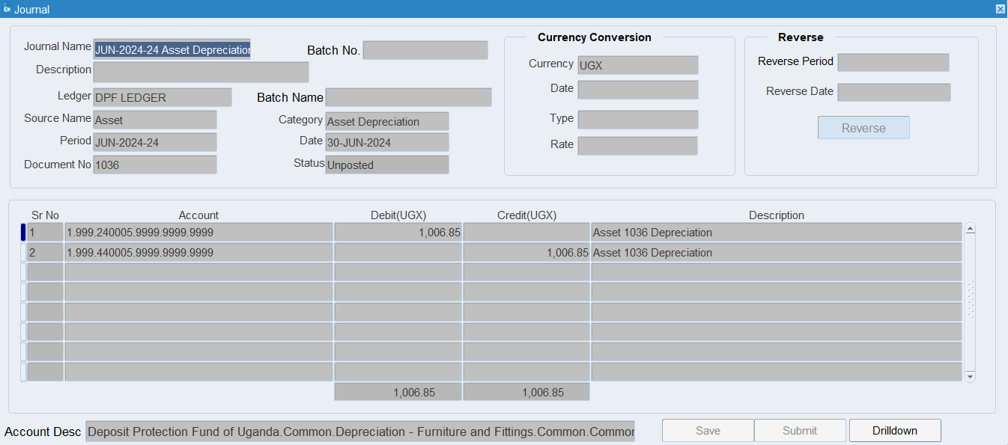

XX END XX

