White Paper User manual
Manual Clearing

Module – Cash Management

Author : Ajinkya Patil
Creation Date : 01-Oct-2024
Last Updated : 01-Oct-2024
Version : 1.0

Manual clearing allows users to clear payments, receipts, and other transactions without first reconciling them. Users can also undo the cleared status of a payment or receipt. Here’s a breakdown using the 5 W's:
1. Who?
- Participants: Typically involves accountants, financial analysts, or clerks who are responsible for managing financial transactions and reconciling accounts.

2. What?
- Process: Manual clearing refers to the manual reconciliation of transactions, such as payments and receipts, ensuring that they are correctly matched and recorded in the system. This may involve investigating discrepancies and adjusting entries.

3. When?
- Timing: This process usually occurs at the end of a financial period, such as monthly or quarterly, or whenever discrepancies are identified that require attention.

4. Where?
- Location: Manual clearing takes place within the Oracle financial software modules, particularly in accounts payable and accounts receivable areas.

5. Why?
- Purpose: The main goal is to ensure that financial records are accurate and complete, preventing errors that could lead to financial misstatements or operational issues.

This process is crucial for maintaining the integrity of financial data and ensuring compliance with accounting standards.

Navigation – Cash Management – Transactions – Bank Clearing

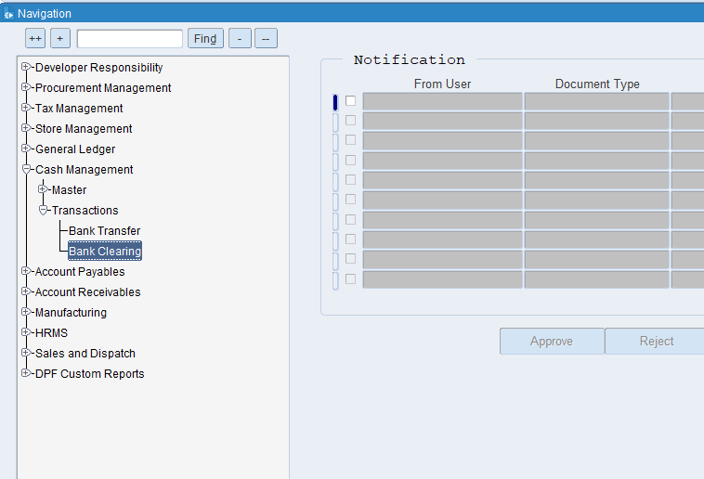

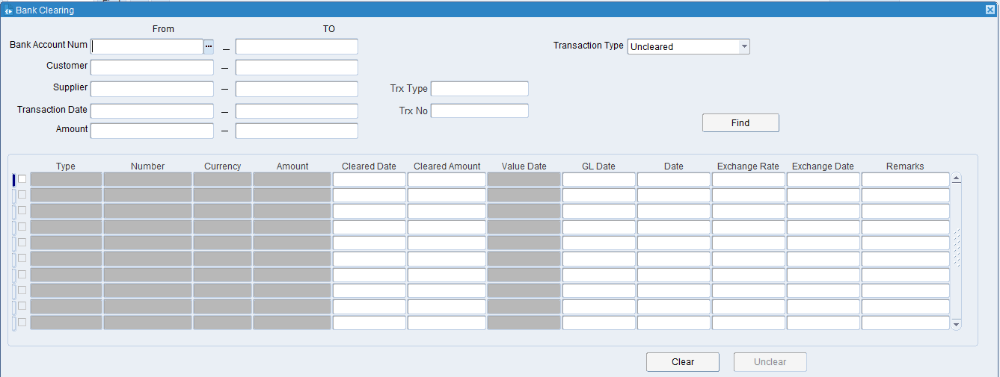

Put the required details

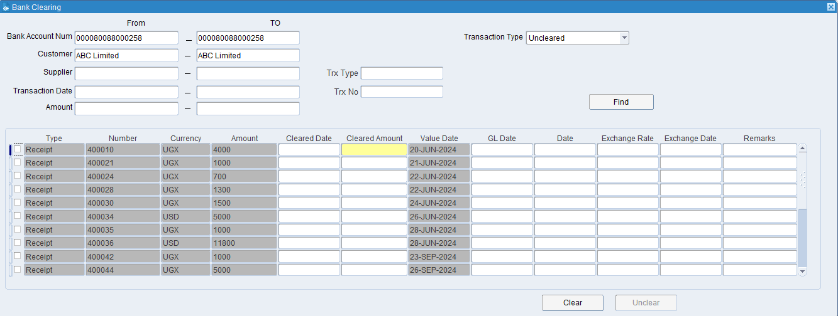

Tick on the line, select transaction type as an Uncleared and put the required details.

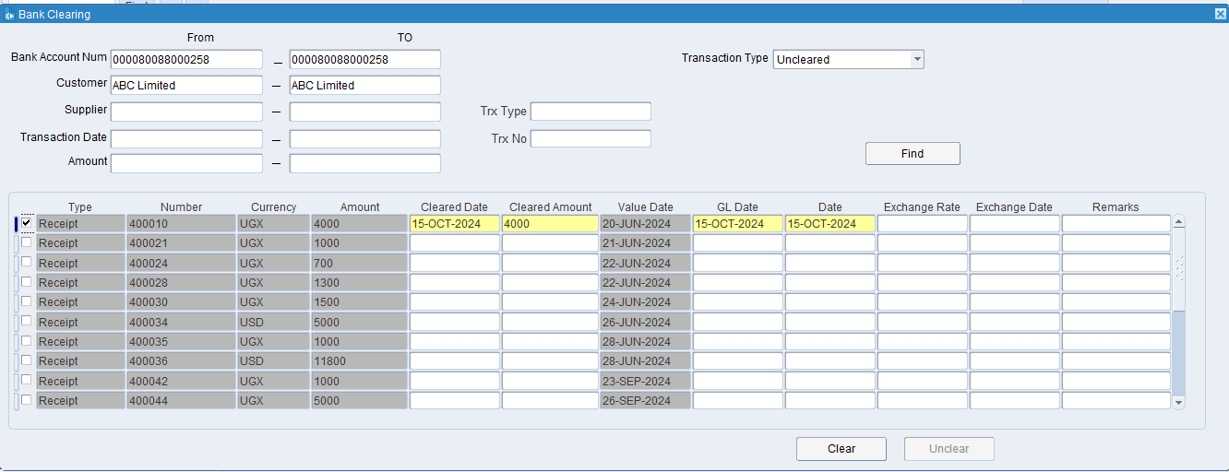

Click on Clear Button

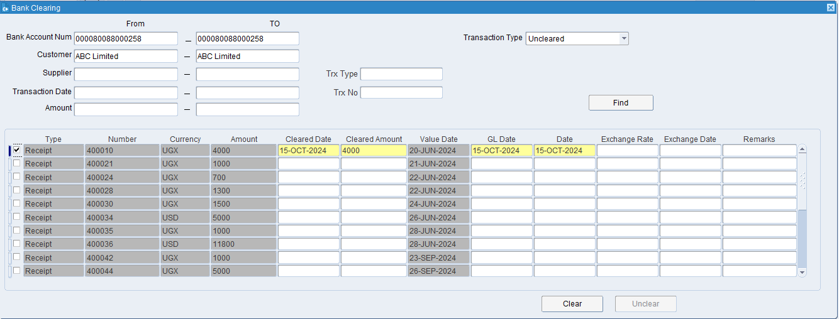
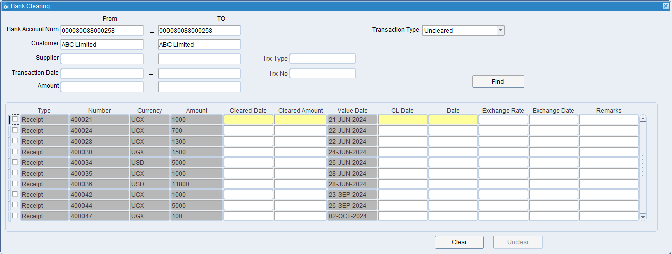
The transaction has been successfully cleared.

XX END XX

