White Paper User manual For –
Manual Credit Memo Invoice

Module – Account Payables

Author : Ajinkya Patil
Creation Date : 17-Sep-2024
Last Updated : 17-Sep-2024
Version : 1.0

A credit memo (or credit memorandum) is a document issued by a seller or service provider to a customer, indicating a reduction in the amount the customer owes. It is essentially the opposite of a debit memo. Here’s an explanation of a credit memo using the 5 W’s (Who, What, When, Where, Why):
1. Who
- Who Issues It: The seller or service provider issues a credit memo to the customer. It is typically issued by the accounts receivable or billing department.
- Who Receives It: The recipient is the customer or client who is receiving a reduction in their account balance or a refund.
2. What
- What It Is: A credit memo is a formal document that decreases the amount owed by the customer. It provides details about the reduction and adjusts the customer’s account accordingly.
- What It Includes: It typically includes:
  - Credit Memo Number: A unique identifier for the memo.
  - Date: The date the credit memo is issued.
  - Customer Information: Details of the customer to whom it is issued.
  - Amount: The amount being credited.
  - Reason: Explanation for the credit, such as returned goods, overpayment, or adjustment for a billing error.
3. When
- When It’s Issued: A credit memo is issued when there is a need to reduce a customer’s account balance. This could be due to returned products, pricing adjustments, errors in billing, or other reasons requiring a reduction in the amount owed.
- When It’s Applied: The credit is applied to the customer’s account immediately or according to the terms specified in the memo.
4. Where
- Where It’s Used: Credit memos are used in various business contexts, including accounting, finance, and customer service departments. They are part of the financial records and are used to adjust accounts receivable.
- Where It’s Filed: The credit memo is filed in the accounts receivable records of the issuing company and may be sent to the customer through email or physical mail.
5. Why
- Why It’s Issued: The main reasons for issuing a credit memo include:
  - Returns: To account for products that were returned by the customer.
  - Billing Errors: To correct mistakes made in an invoice or billing statement.
  - Discounts or Adjustments: To apply discounts or adjustments that were not originally included in the invoice.
  - Overpayments: To acknowledge and adjust for payments made in excess of the amount due.
In summary, a credit memo is a crucial document for managing customer accounts and ensuring that financial records accurately reflect the amounts owed and adjustments made. It helps maintain good customer relations by addressing issues related to billing and payment.

Navigation – Account Payables > Invoice
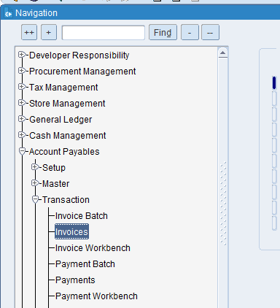

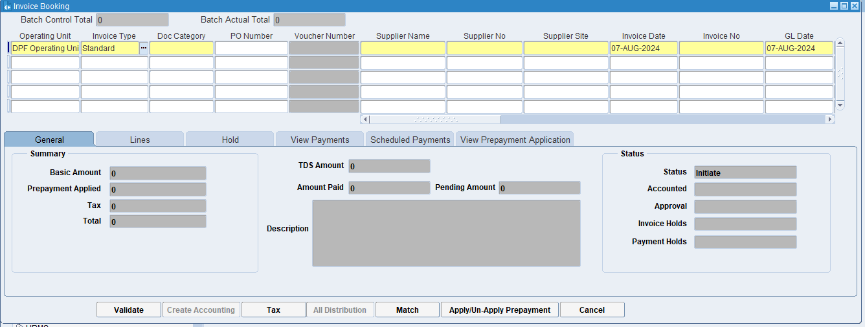
Click on Invoice type LOV

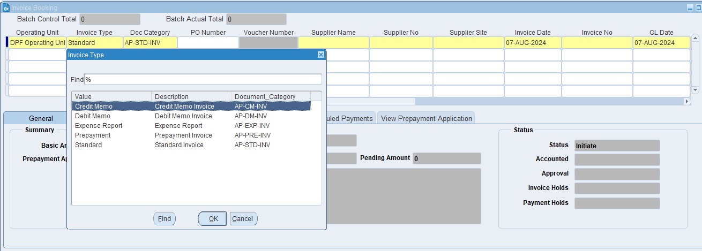
Select Credit Memo & Doc Category

What is Document Category?
This is a classification assigned to an invoice to indicate its type or purpose. It helps the ERP system to apply specific rules, workflows, and processing steps based on the category. Examples might include "Sales Invoice," "Purchase Invoice," "Credit Note," or "Debit Note."

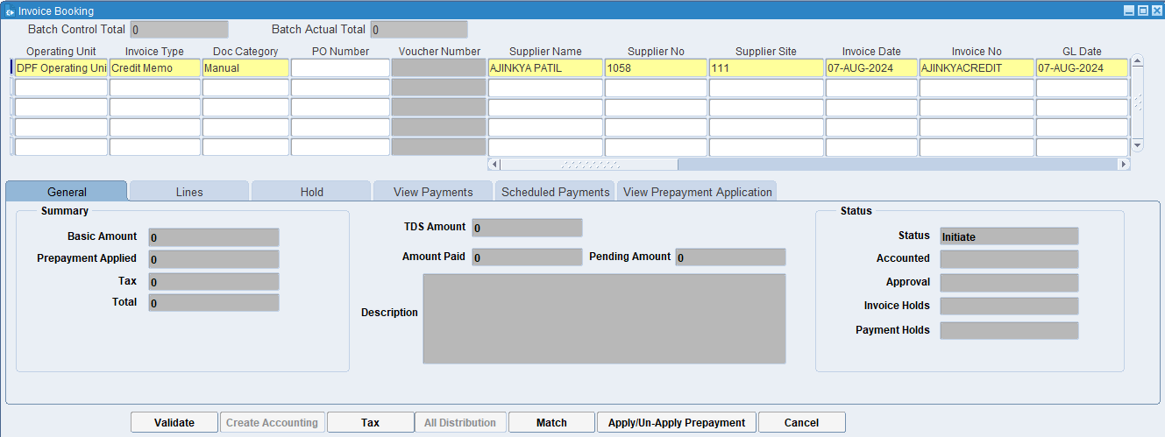
Put the supplier’s name & Required GL date

What is Supplier's name?
It identifies the party that has supplied the goods or services, ensuring that there is clarity on who the invoice is coming from. This helps in maintaining accurate records and resolving any discrepancies related to the supplier.

What is a supplier site?
The supplier site provides detailed information about where a supplier operates, ships from, or where services are delivered. This helps in managing logistics, shipping, and procurement processes efficiently.

What is the Invoice Number?
The invoice number uniquely identifies each invoice, making it easy to reference and track. It helps in distinguishing one invoice from another, which is essential for organization and clarity in financial records.

What is GL Date?
The GL date indicates the specific date on which a transaction is recorded in the General Ledger. This date determines the accounting period in which the transaction will be included for financial reporting and analysis.

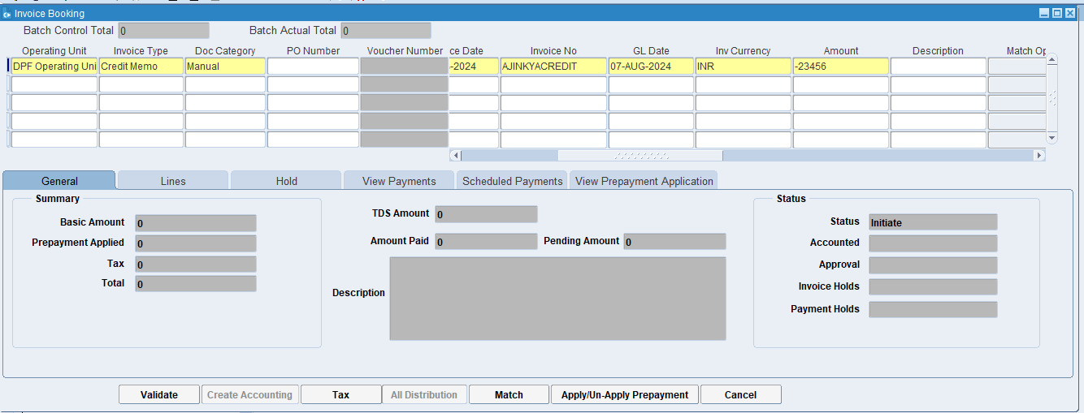
Take Invoice amount in negative value

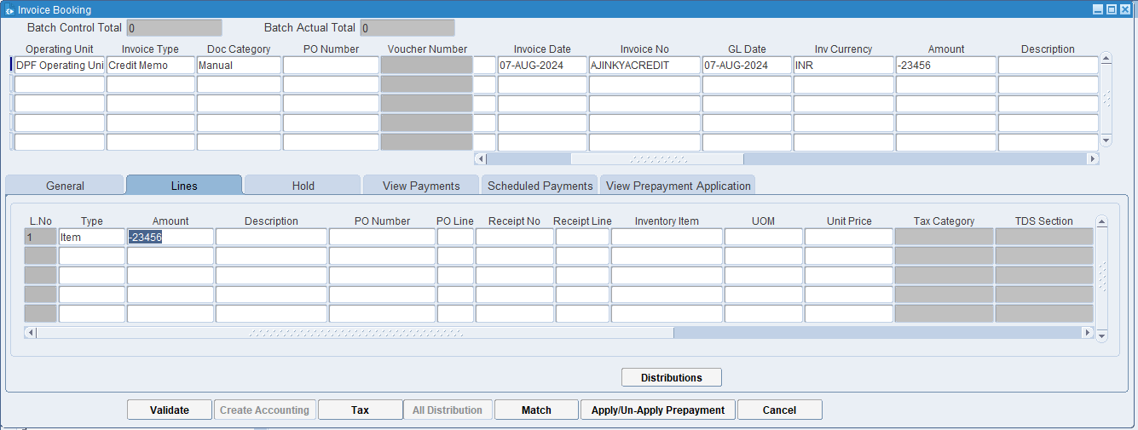
Fill in Lines Details and then click the Distributions button

What is Distributions?
In the context of invoicing and accounting, distributions refer to the process of allocating the costs of an invoice to different accounts, cost center, or department within an organization. This ensures that expenses are recorded accurately in the financial records and helps in proper budgeting and financial analysis.

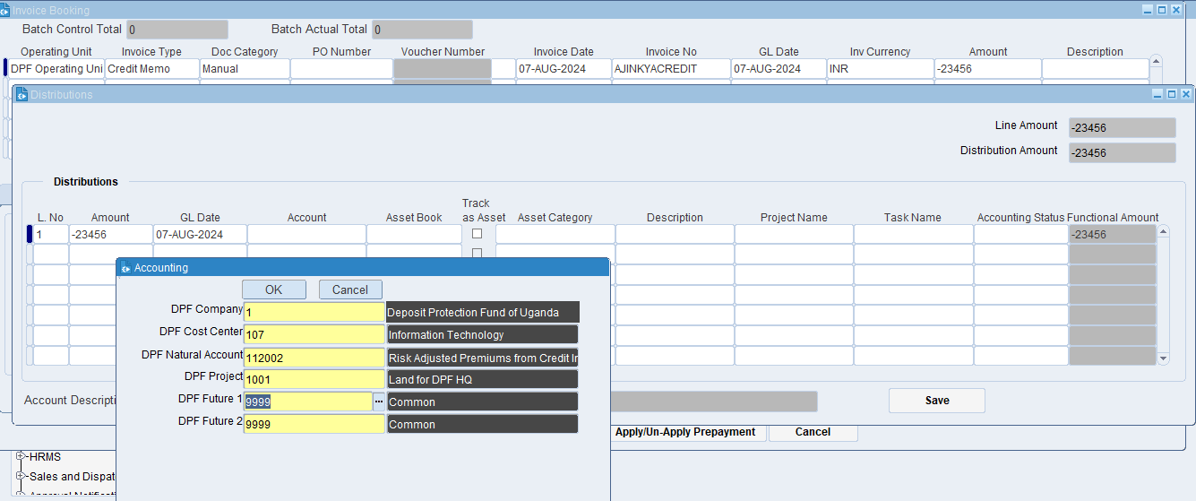
Fill Lines Distributions Details and Accounts Details.
Click on ok

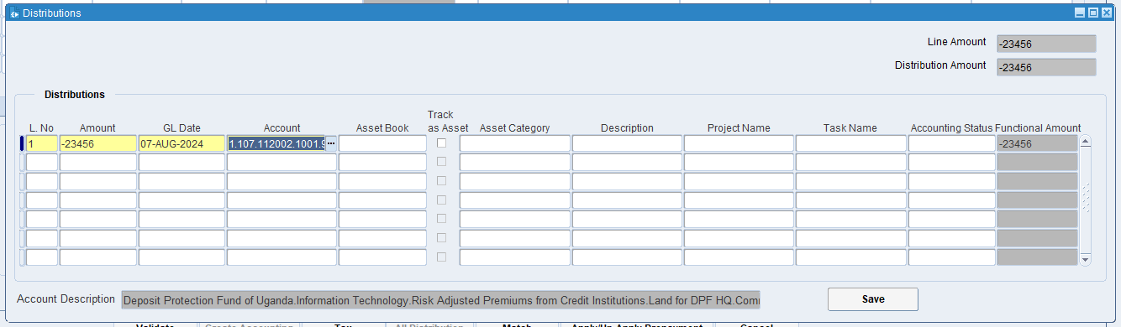
Click on Save
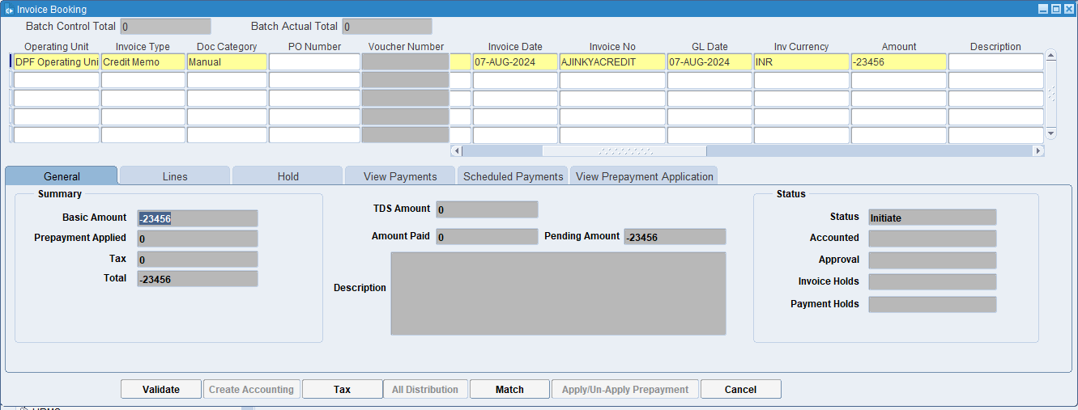
Click on Tax

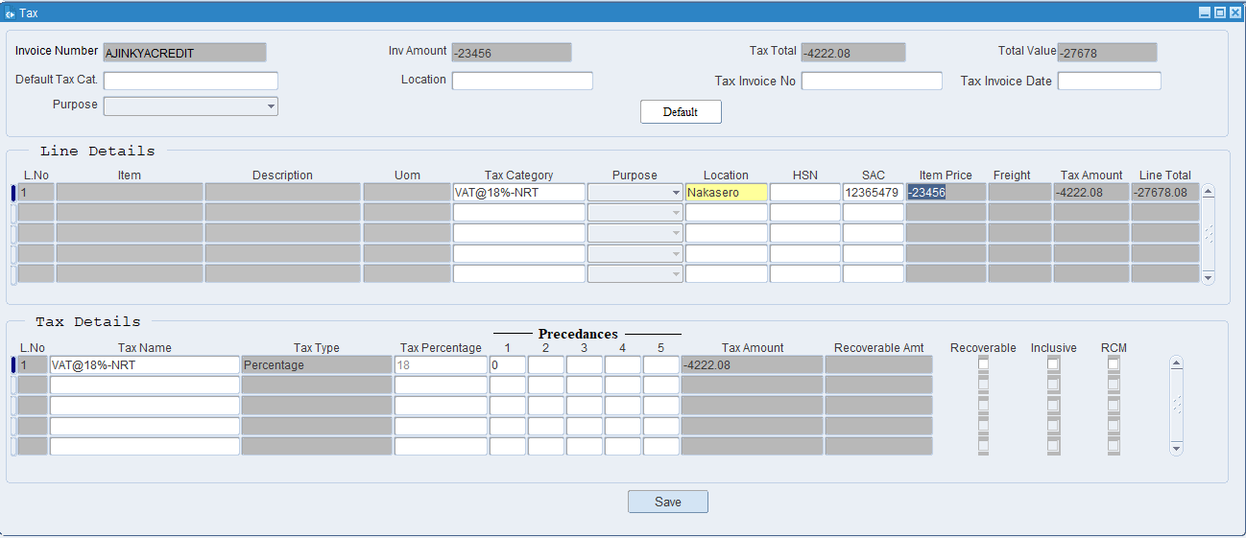
Put the tax details then click on save.

What is Tax Category?
a tax category refers to a classification used to apply the correct tax rules and rates to transactions. This categorization ensures that taxes are calculated accurately based on the nature of the goods or services being provided and the applicable tax regulations.

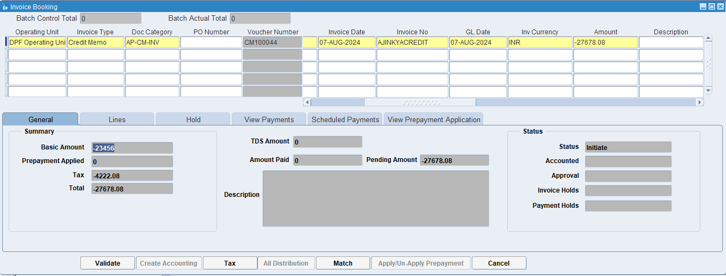
Click on Validate
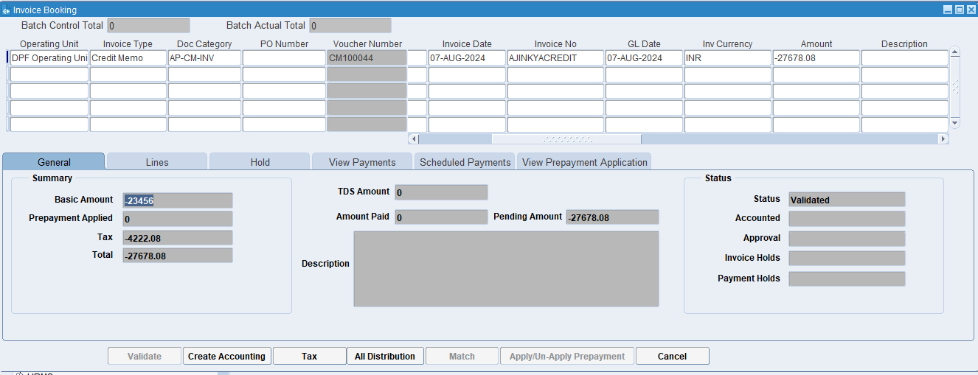
Click on Create Accounting

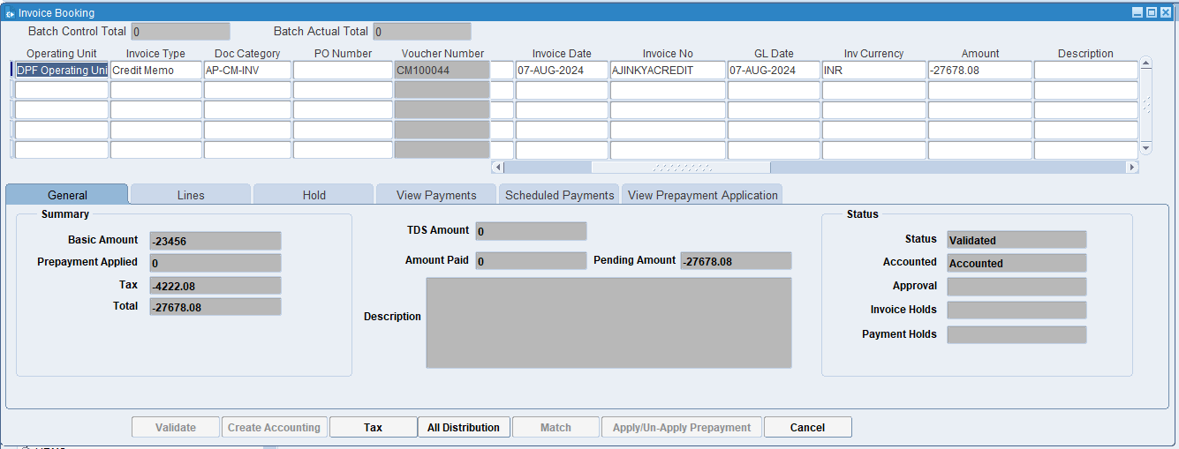
Invoice is Validated & Accounted.

XX END XX

