White Paper User manual For –
Manual Debit Memo

Module – Account Payables

Author : Ajinkya Patil
Creation Date : 17-Sep-2024
Last Updated : 17-Sep-2024
Version : 1.0

A debit memo is a document used to adjust an account by increasing the amount owed by a customer or decreasing the amount owed to a supplier. It’s often issued to correct errors or account for adjustments in financial transactions. To explain a debit memo using the 5 W’s (Who, What, When, Where, Why), here’s a breakdown:

1. Who
- Who Issues It: A debit memo is usually issued by a seller or service provider to the buyer or client.
- Who Receives It: The recipient is typically the customer or client whose account is being adjusted.

2. What
- What It Is: A debit memo is a formal document that indicates an increase in the amount owed by the customer or a decrease in the amount receivable from the customer. It details the reason for the adjustment and provides a new balance if applicable.
- What It Includes: It usually includes details such as the debit memo number, date, the account affected, the amount of adjustment, and a description of the reason for the adjustment.

3. When
- When It’s Issued: A debit memo is issued when there is a need to adjust a previous transaction. This could be due to errors in invoicing, changes in terms, or corrections for returned goods.
- When It’s Applied: The adjustment or change reflected by the debit memo typically takes effect immediately or according to the terms specified in the memo.

4. Where
- Where It’s Used: A debit memo is used in various settings, such as in business transactions, accounting departments, and financial reporting. It is relevant in contexts where accounts are maintained and adjustments are necessary.
- Where It’s Filed: The document is usually filed in the accounts receivable or payable records of the issuing company and may also be communicated to the recipient through email or physical mail.

5. Why
- Why It’s Issued: The primary reasons for issuing a debit memo include:
  - Correction of Errors: To correct mistakes in previous invoices or transactions.
  - Adjustments for Returns: To account for goods that were returned or services that were not delivered as expected.
  - Changes in Terms: To reflect changes in payment terms or additional charges that were not included in the original invoice.

In summary, a debit memo is an important tool in financial management and accounting, used to correct or adjust accounts and ensure accurate financial records.
Navigation – Account Payables > Invoice

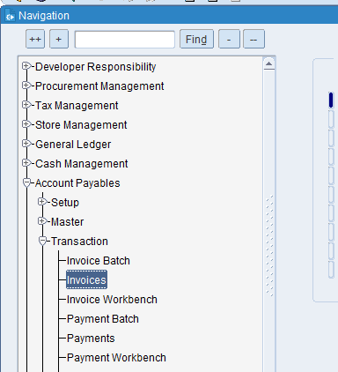

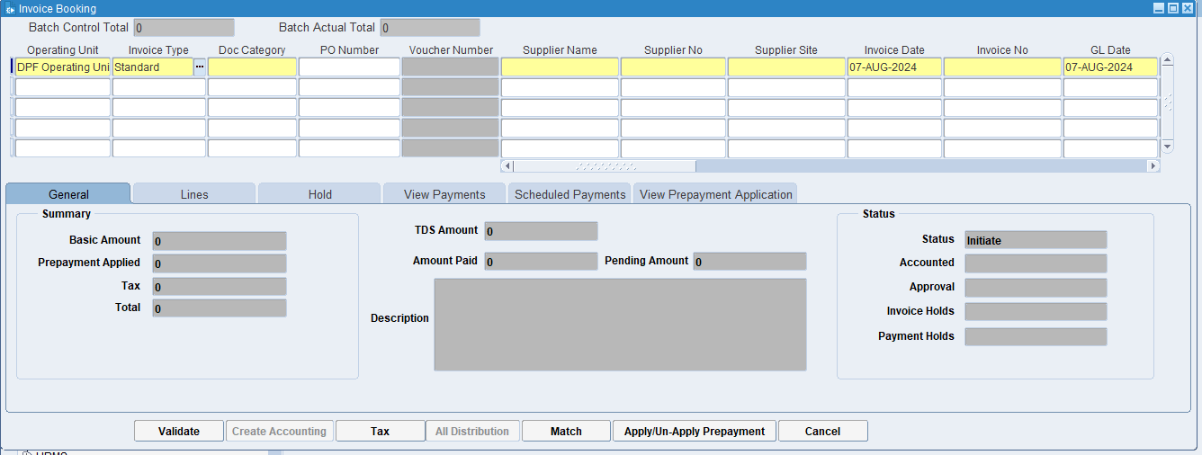
Click on Invoice type LOV

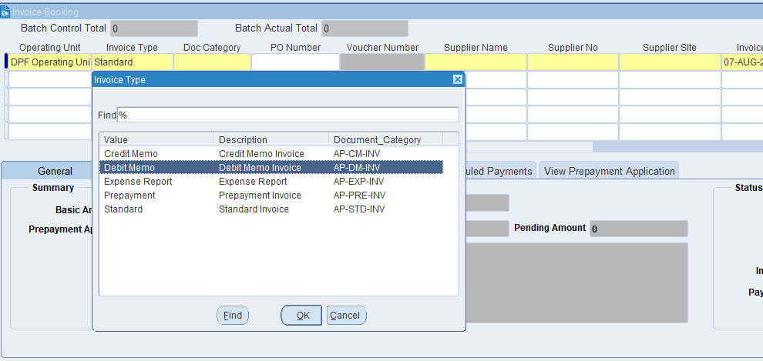
Select the Debit Memo then select Doc Category

What is Document Category?
This is a classification assigned to an invoice to indicate its type or purpose. It helps the ERP system to apply specific rules, workflows, and processing steps based on the category. Examples might include "Sales Invoice," "Purchase Invoice," "Credit Note," or "Debit Note."

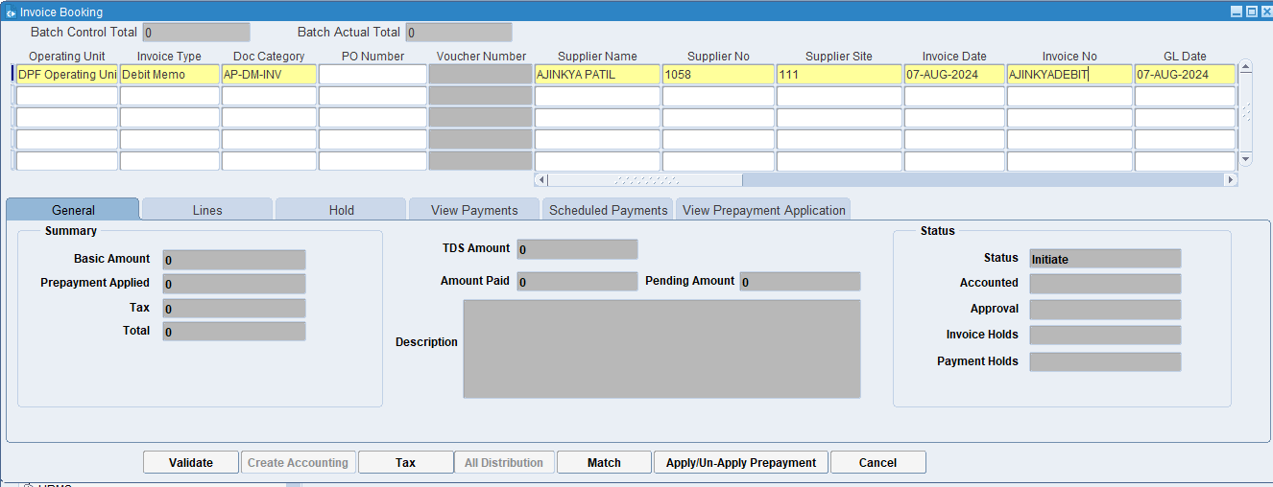
Put the Supplier name, site & Invoice number.

What is Supplier's name?
It identifies the party that has supplied the goods or services, ensuring that there is clarity on who the invoice is coming from. This helps in maintaining accurate records and resolving any discrepancies related to the supplier.

What is a supplier site?
The supplier site provides detailed information about where a supplier operates, ships from, or where services are delivered. This helps in managing logistics, shipping, and procurement processes efficiently.

What is the Invoice Number?
The invoice number uniquely identifies each invoice, making it easy to reference and track. It helps in distinguishing one invoice from another, which is essential for organization and clarity in financial records.

What is GL Date?
The GL date indicates the specific date on which a transaction is recorded in the General Ledger. This date determines the accounting period in which the transaction will be included for financial reporting and analysis.

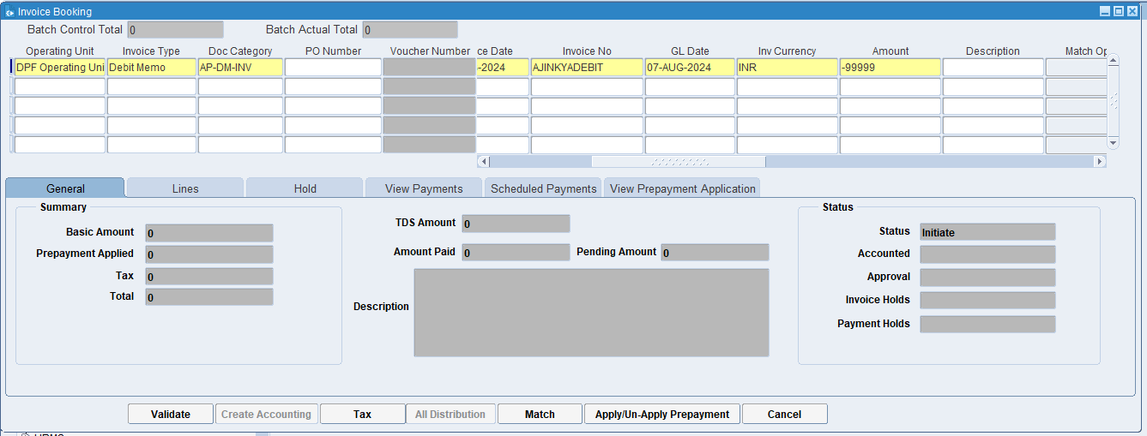
Take Invoice amount in negative value
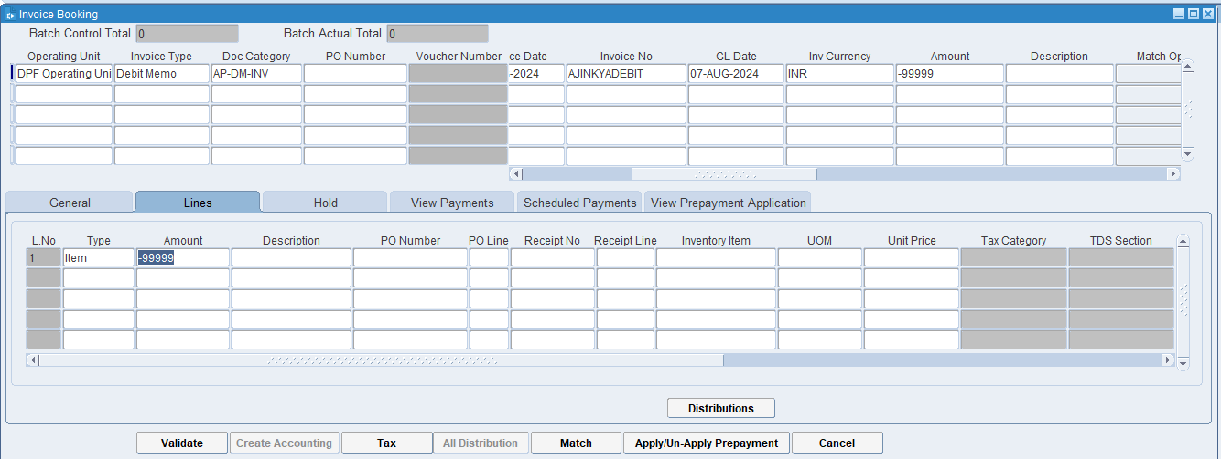
Fill in Lines Details and then click the Distributions button

What is Distributions?
In the context of invoicing and accounting, distributions refer to the process of allocating the costs of an invoice to different accounts, cost center, or department within an organization. This ensures that expenses are recorded accurately in the financial records and helps in proper budgeting and financial analysis

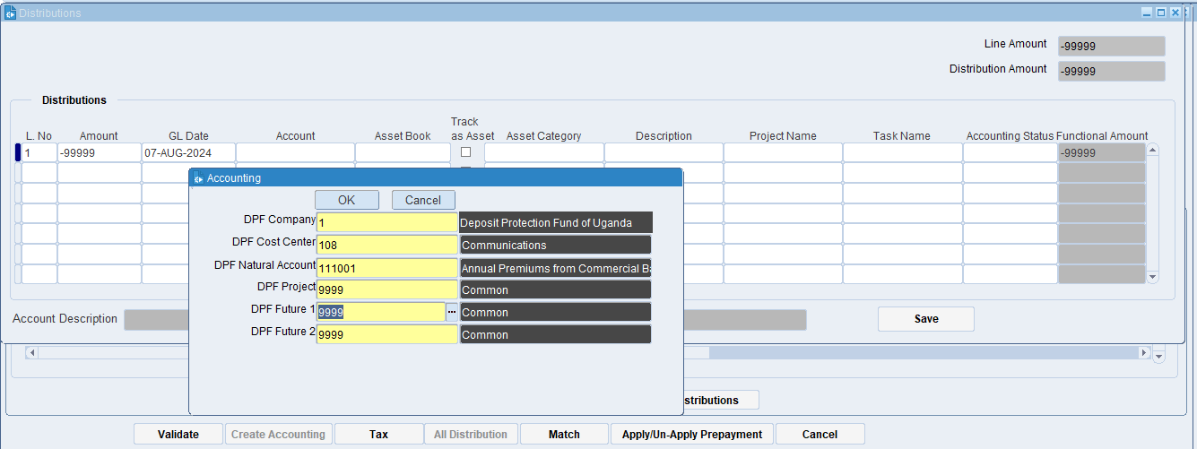
Fill Lines Distributions Details and Accounts Details.
Click on ok

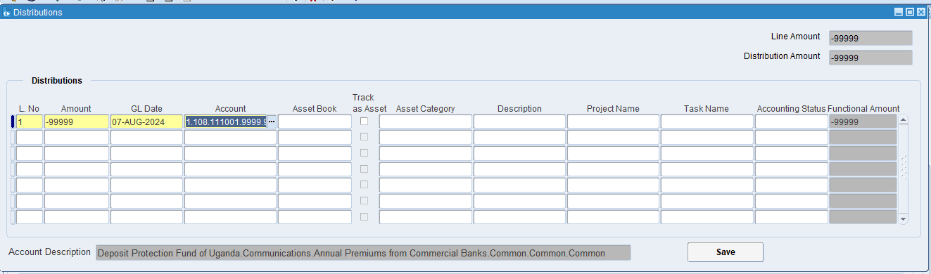
Click on Save
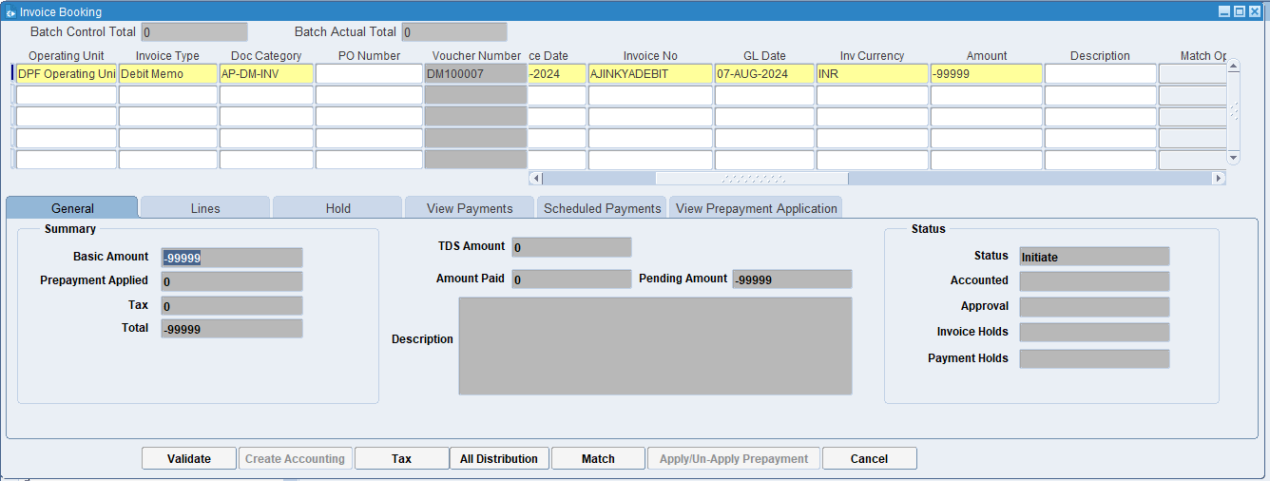
Click on the Tax

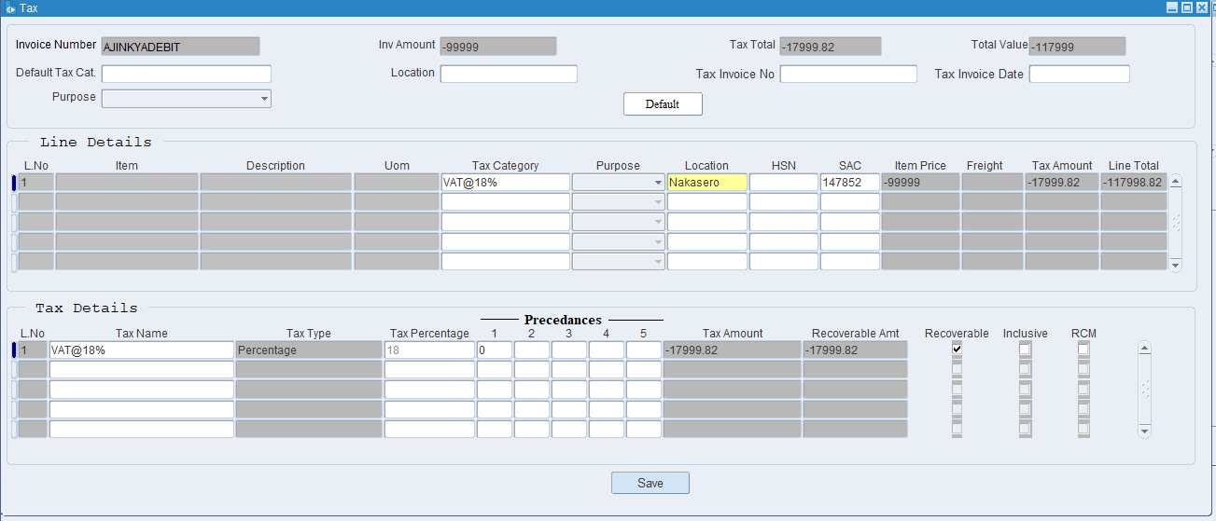
Put the tax details then click on save.

What is Tax Category?
a tax category refers to a classification used to apply the correct tax rules and rates to transactions. This categorization ensures that taxes are calculated accurately based on the nature of the goods or services being provided and the applicable tax regulations.

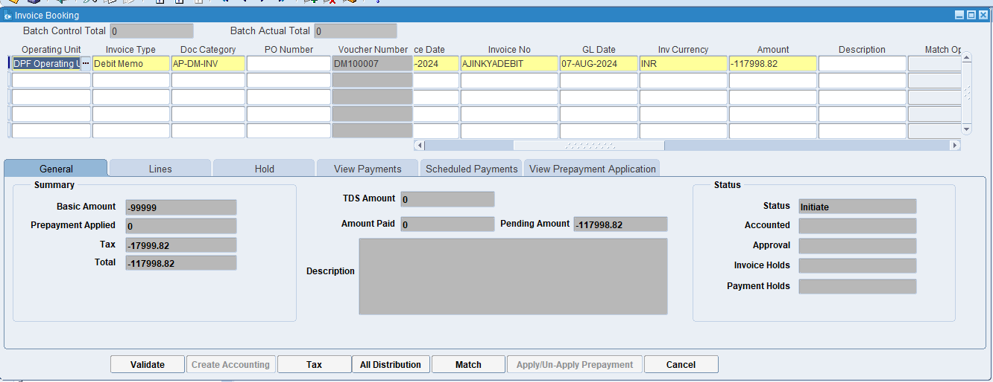
Click on Validate

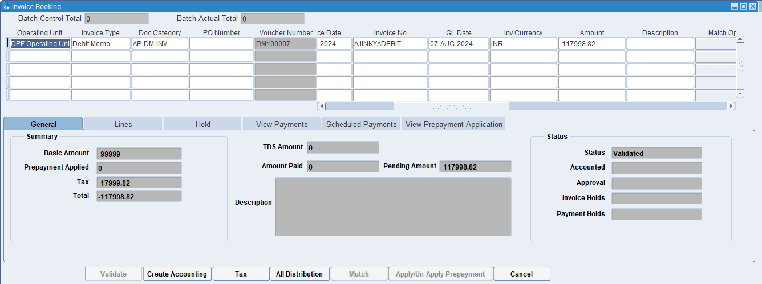
Click on Create Accounting

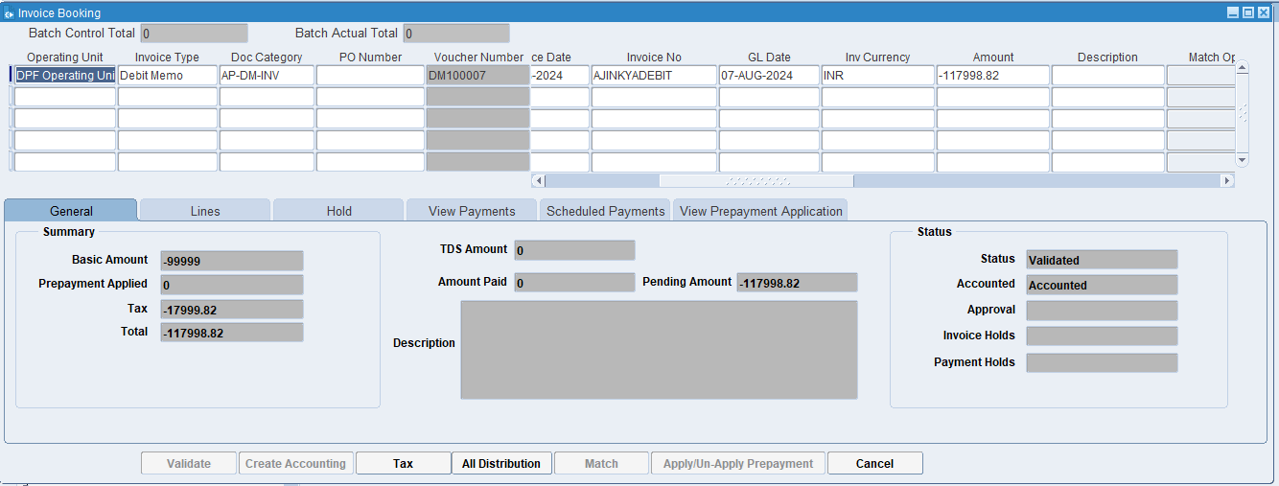
Invoice is Validated & Accounted.

XX END XX

