White Paper User manual For –
Manual Standard Invoice with Foreign Currency

Module – Account Payables

Author : Ajinkya Patil
Creation Date : 19-Sep-2024
Last Updated : 19-Sep-2024
Version : 1.0

- What is a standard Invoice?
This is a digital document generated by the ERP system that details transactions between a company and its customers or vendors. It includes essential information like item descriptions, quantities, prices, taxes, and total amounts due. ERP systems automate invoice creation, processing, and tracking to streamline financial operations.

- When does it occur?
In an ERP system, invoices are typically generated after goods or services are delivered or upon completion of a project. The system can automatically generate invoices based on sales orders, purchase orders, or service records. The timing can be configured according to business processes and payment terms.

- Where is it used?
Invoices within an ERP system are created, stored, and managed within the ERP platform. They can be accessed through various modules such as Accounts Receivable, Accounts Payable, or Sales and Distribution. The system ensures that invoices are centrally located and integrated with other business processes.

- Who is involved?
The standard invoice is typically managed by accounting personnel, financial managers, or procurement staff within an organization. It may also involve other roles such as sales representatives or inventory managers, depending on the ERP system's setup and the organization's workflow.

- Why use Standard Invoices?
The standard invoice in an ERP system ensures accurate and efficient billing and payment processing. It helps maintain financial records, manage cash flow, and reconcile accounts. Automating invoice management reduces errors, speeds up the billing cycle, and improves overall financial control within the organization.

Navigation – Accounts Payables > Invoices

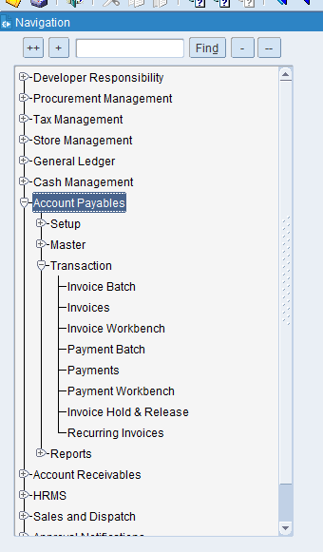

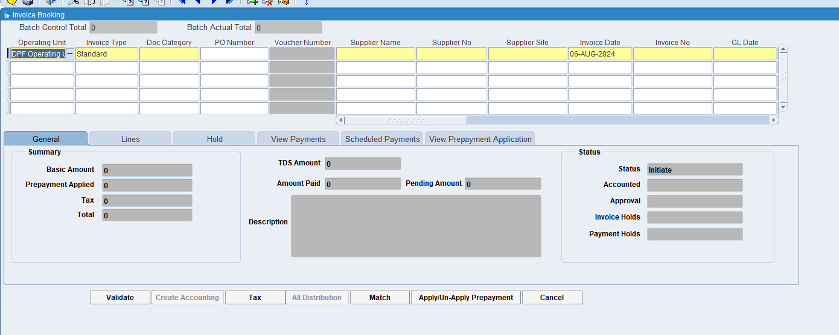

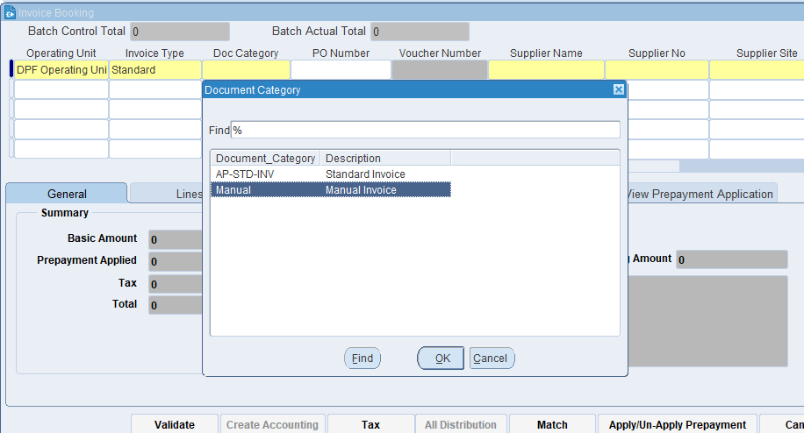
In the Doc Category select the Manual Invoice option.

What is Document Category?
This is a classification assigned to an invoice to indicate its type or purpose. It helps the ERP system to apply specific rules, workflows, and processing steps based on the category. Examples might include "Sales Invoice," "Purchase Invoice," "Credit Note," or "Debit Note."

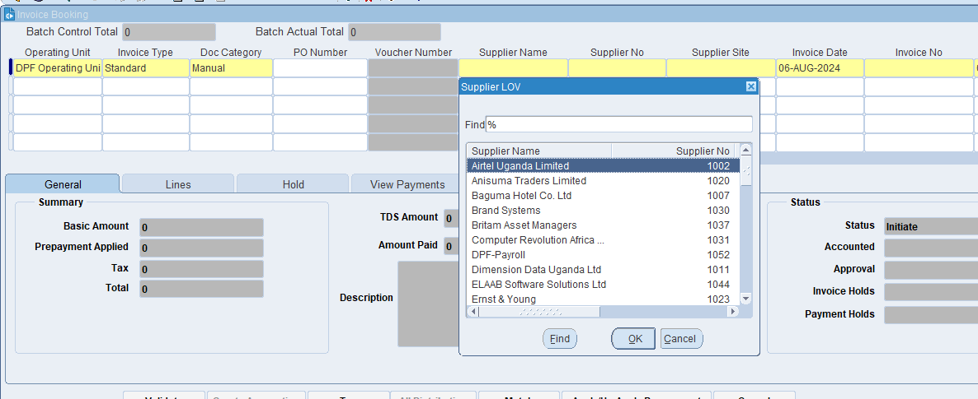
Select the required supplier name

What is Supplier's name?
It identifies the party that has supplied the goods or services, ensuring that there is clarity on who the invoice is coming from. This helps in maintaining accurate records and resolving any discrepancies related to the supplier.

What is a supplier site?
The supplier site provides detailed information about where a supplier operates, ships from, or where services are delivered. This helps in managing logistics, shipping, and procurement processes efficiently.

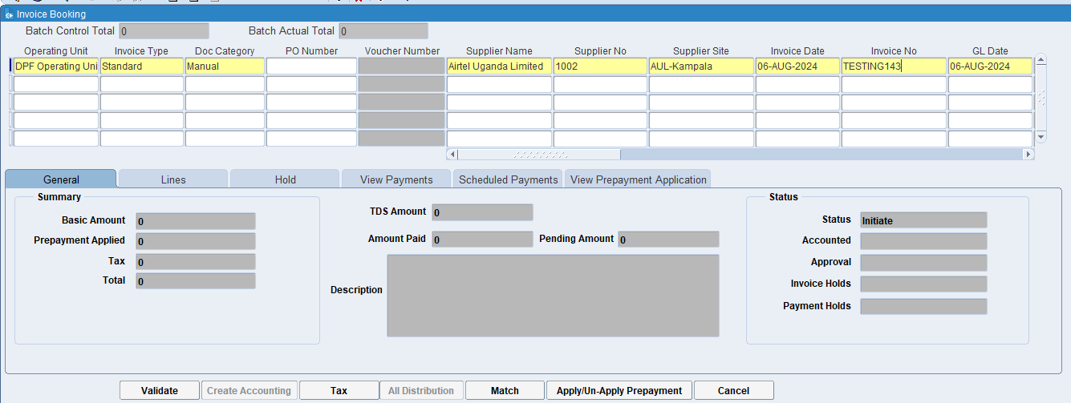
Put Invoice date & Invoice number & open AP period GL date.

What is the Invoice Number?
The invoice number uniquely identifies each invoice, making it easy to reference and track. It helps in distinguishing one invoice from another, which is essential for organization and clarity in financial records.

What is GL Date?
The GL date indicates the specific date on which a transaction is recorded in the General Ledger. This date determines the accounting period in which the transaction will be included for financial reporting and analysis.

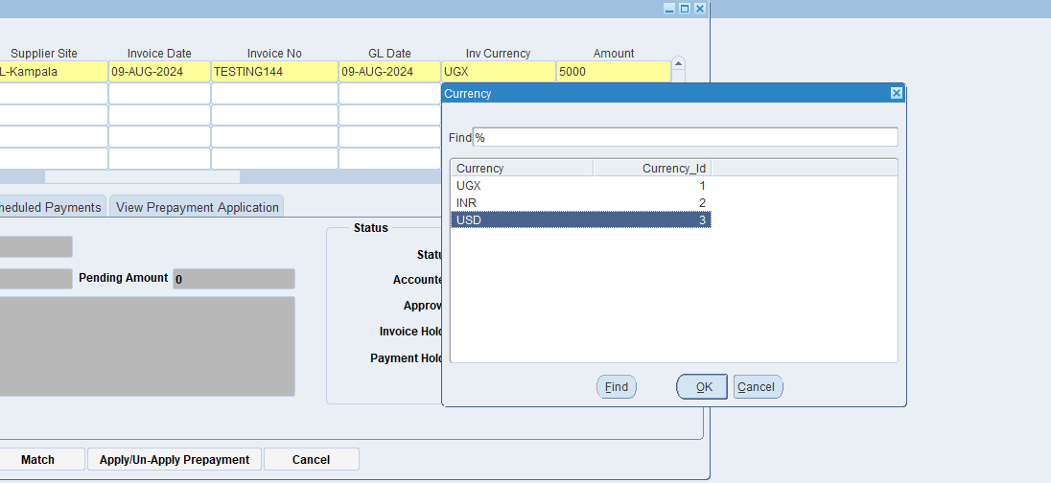
Put the Foreign currency USD & Amount

What is Invoice Currency?
Invoice currency specifies the type of currency used to calculate and display the amounts due on an invoice. This could be the currency of the supplier, the customer, or a mutually agreed-upon currency.

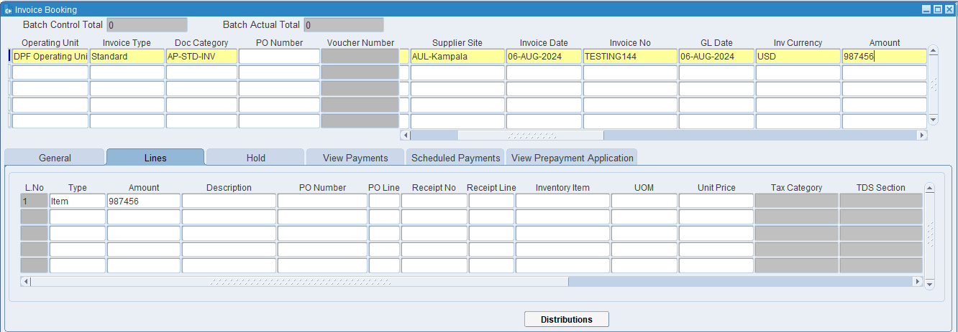
Then click on lines

What is Lines?
In the context of an invoice, lines refer to the individual entries or rows on the invoice that detail each specific item or service being billed. Each line typically includes a description, quantity, unit price, and total amount for the particular item or service.

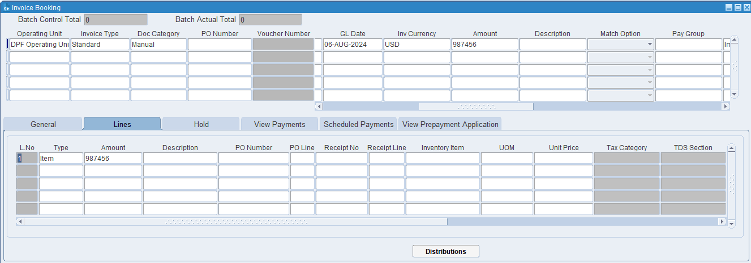
Click on Distributions

What is Distributions?
In the context of invoicing and accounting, distributions refer to the process of allocating the costs of an invoice to different accounts, cost center, or departments within an organization. This ensures that expenses are recorded accurately in the financial records and helps in proper budgeting and financial analysis.

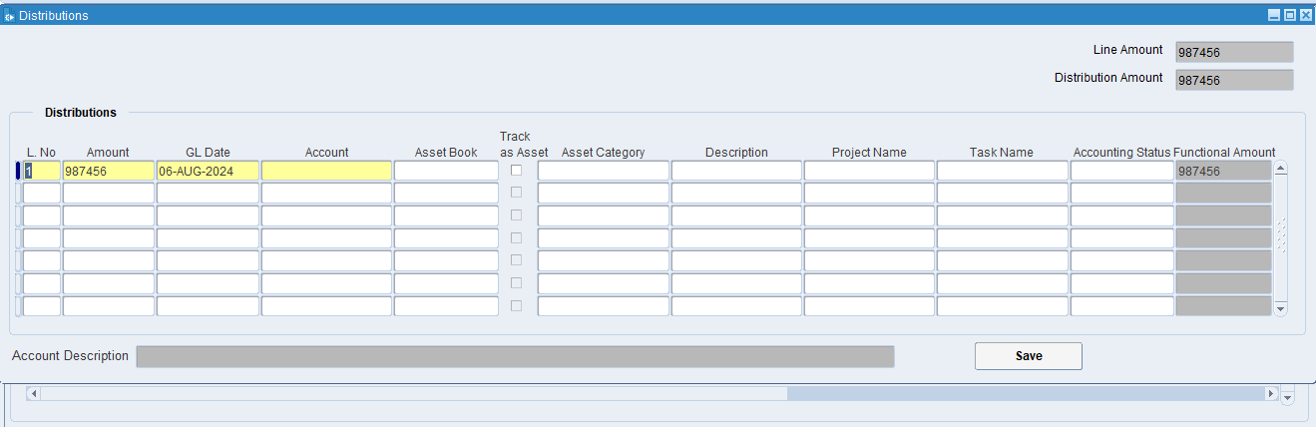
Click on Account
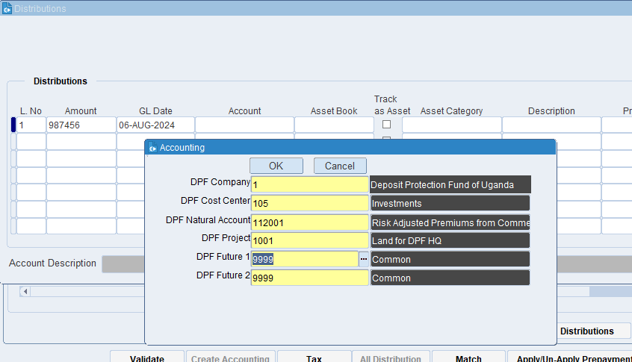
Put the required information then click on ok.

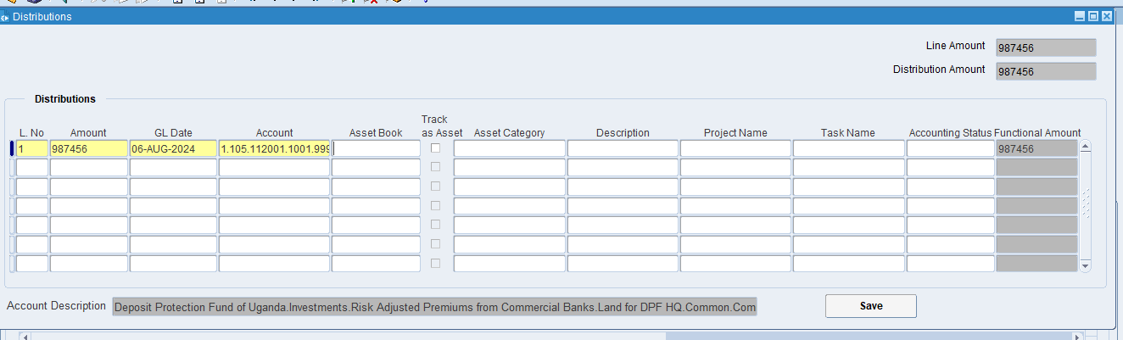
Click on Save
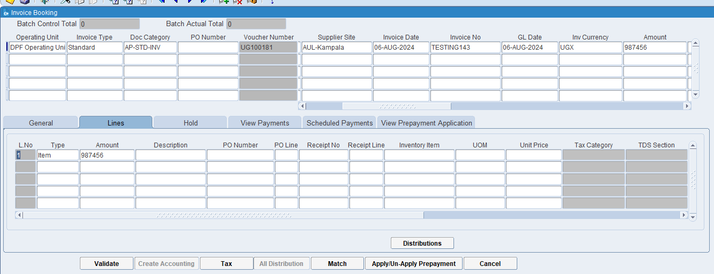
Click on the Tax

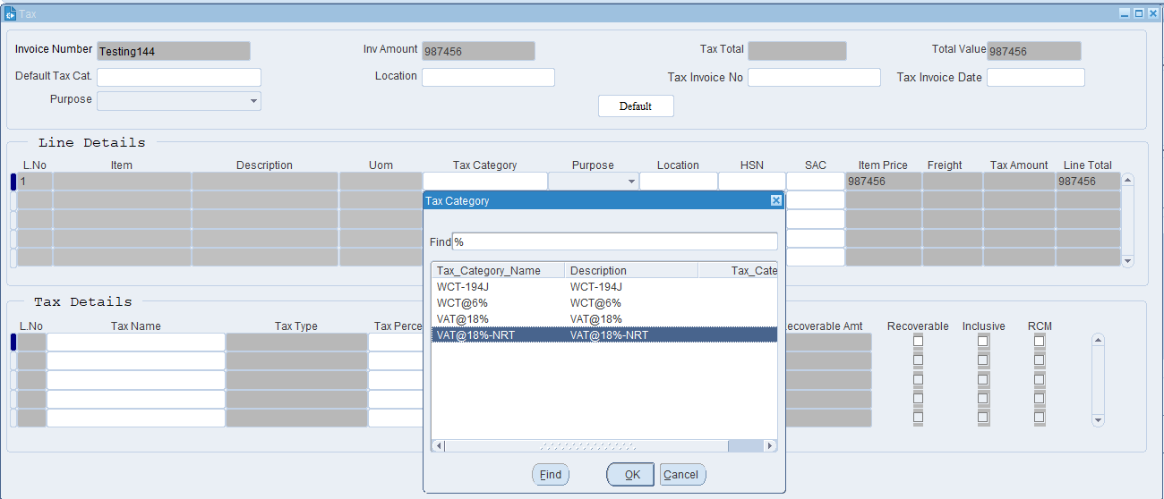
Select the required tax category from the list then click on ok.

What is Tax Category?
a tax category refers to a classification used to apply the correct tax rules and rates to transactions. This categorization ensures that taxes are calculated accurately based on the nature of the goods or services being provided and the applicable tax regulations.

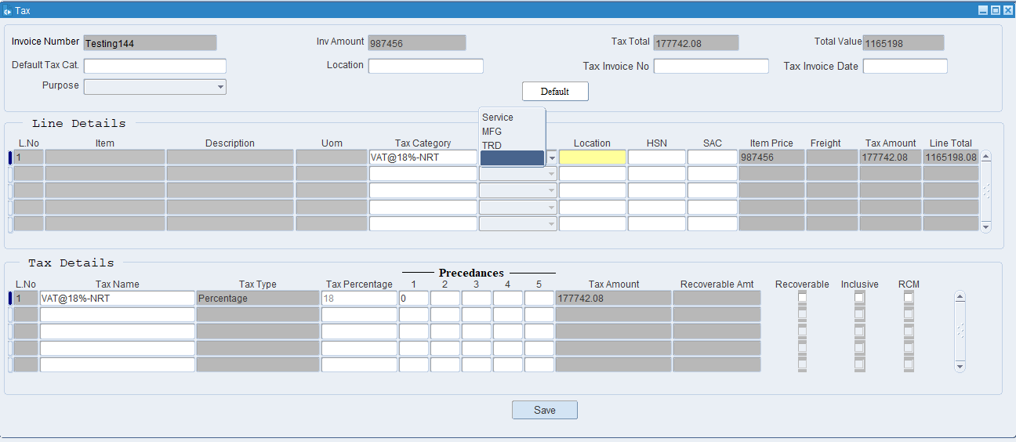
Select purpose

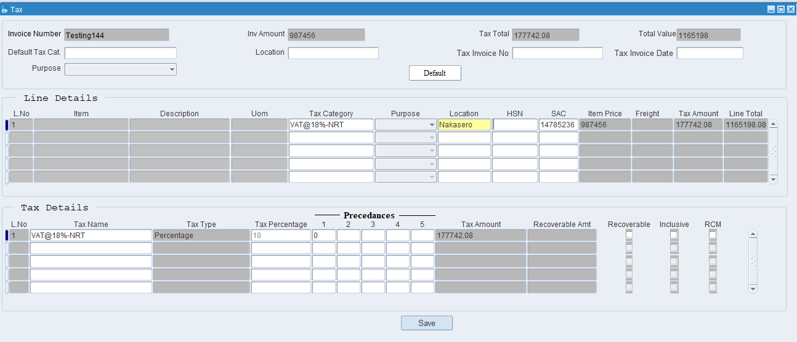
Put the location
Then Click on Save at bottom.

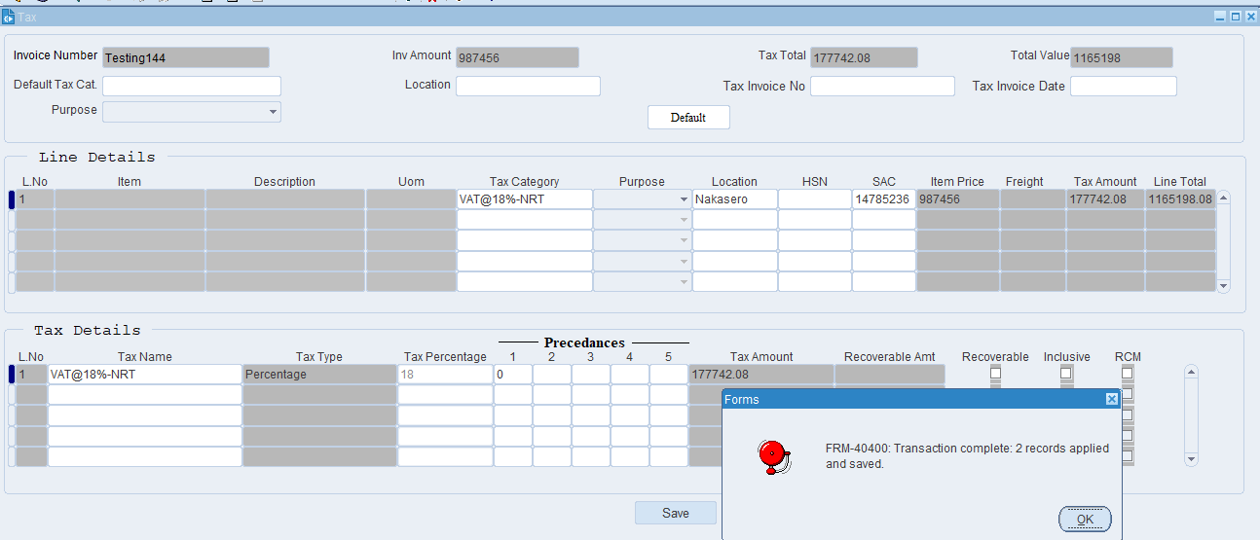
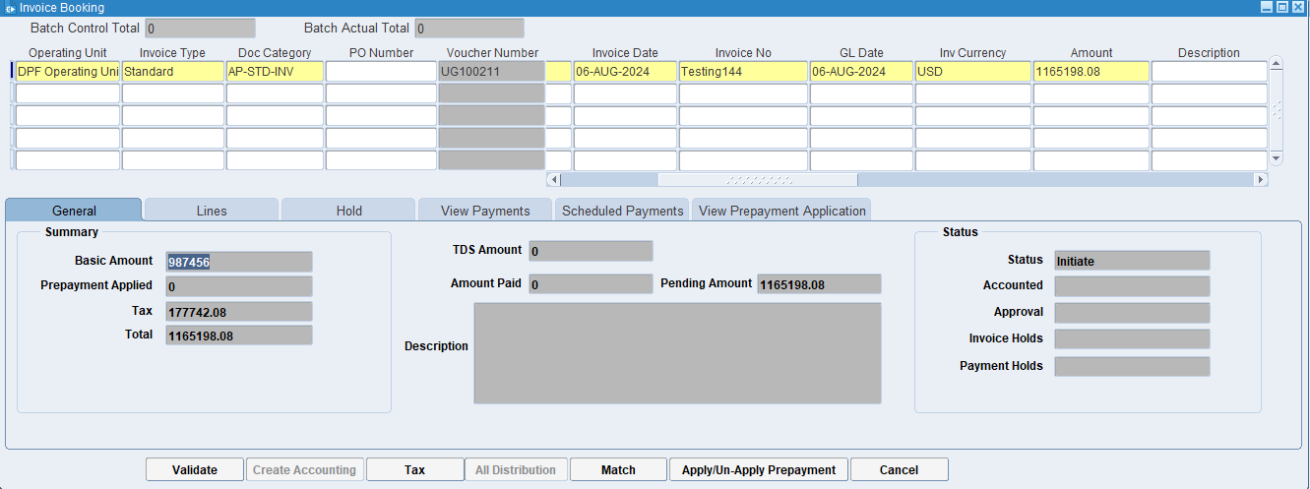
Click on Validate

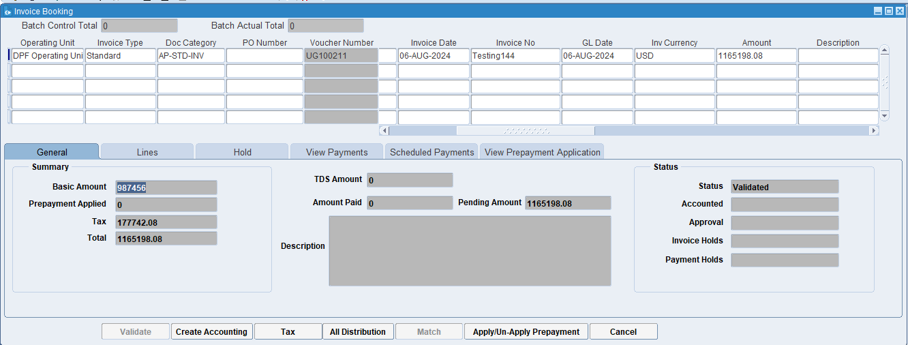
Now status is changed from Initiate to Validated.
Then click on the Create Accounting.

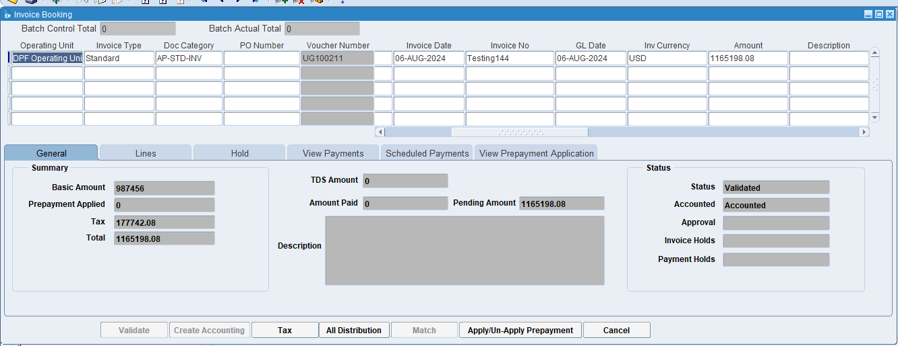
Now Invoice is Accounted.

XX END XX

