White Paper User manual
Manual Unclearing

Module – Cash Management

Author : Ajinkya Patil
Creation Date : 03-Oct-2024
Last Updated : 03-Oct-2024
Version : 1.0

Manual Unclearing involves the process of reconciling and clearing transactions or entries in financial systems. Here’s a breakdown using the 5 W's:
To approach manual bank unclearing in Oracle using the 5 W's (Who, What, When, Where, Why), here’s a breakdown:

Who
- Bank Employees: Responsible for processing uncleared transactions.
- Accounting Team: Ensures accurate recording of transactions.
- Finance Managers: Oversee the overall unclearing process.

What
- Manual Bank Unclearing: The process of identifying and reconciling transactions that have not been cleared in the bank statement against the accounting records.
- Tools: Oracle Financials or other financial software used for tracking and managing bank transactions.

When
- Timing: Typically performed at the end of the accounting period or monthly after bank statements are received.
- Frequency: Can be done daily, weekly, or monthly, depending on the volume of transactions and organizational policy.

Where
- Location: This process occurs within the finance department, often in an office environment. It utilizes Oracle Financials software for data entry and reconciliation.
- Database: Accessing the Oracle database where financial records are stored.

Why
- Accuracy: To ensure financial statements reflect accurate cash balances and transactions.
- Compliance: Adhering to financial regulations and standards.
- Fraud Prevention: Identifying discrepancies helps in spotting potential fraud or errors early.

Navigation – Cash Management – Transactions – Bank Clearing

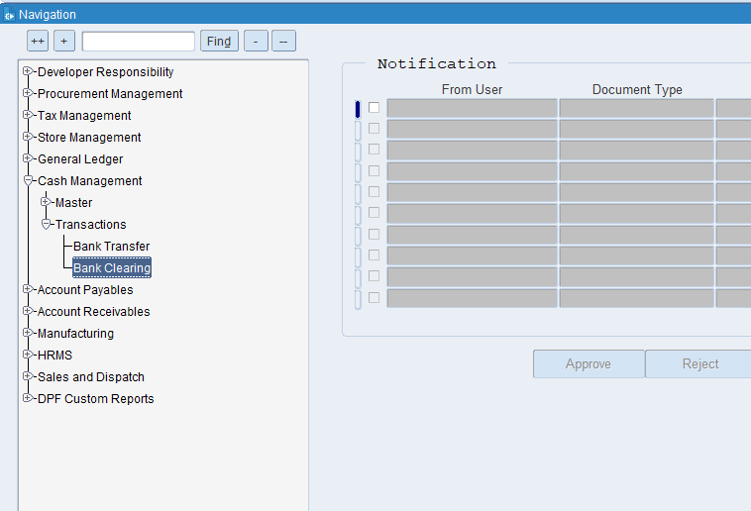

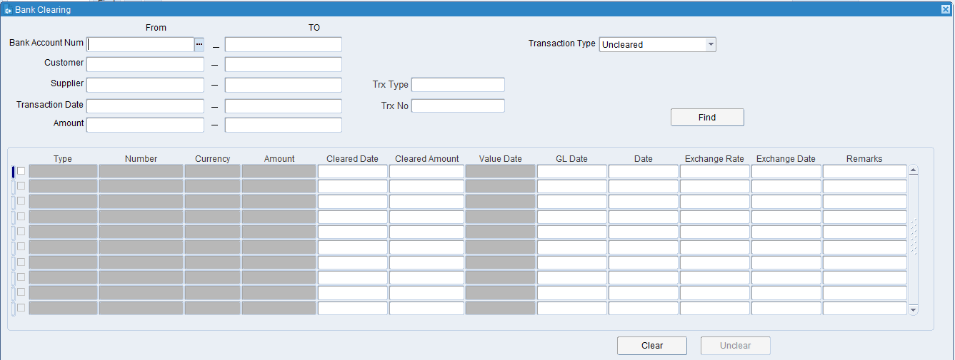

Put the required details like Trx Type, Transaction type etc. then click on Find.

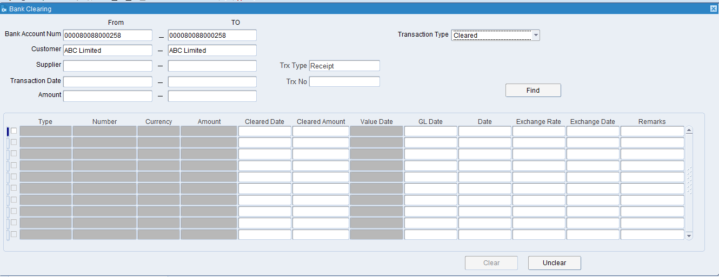

Tick on the line, do the necessary changes in GL date & Date then click on Unclear.

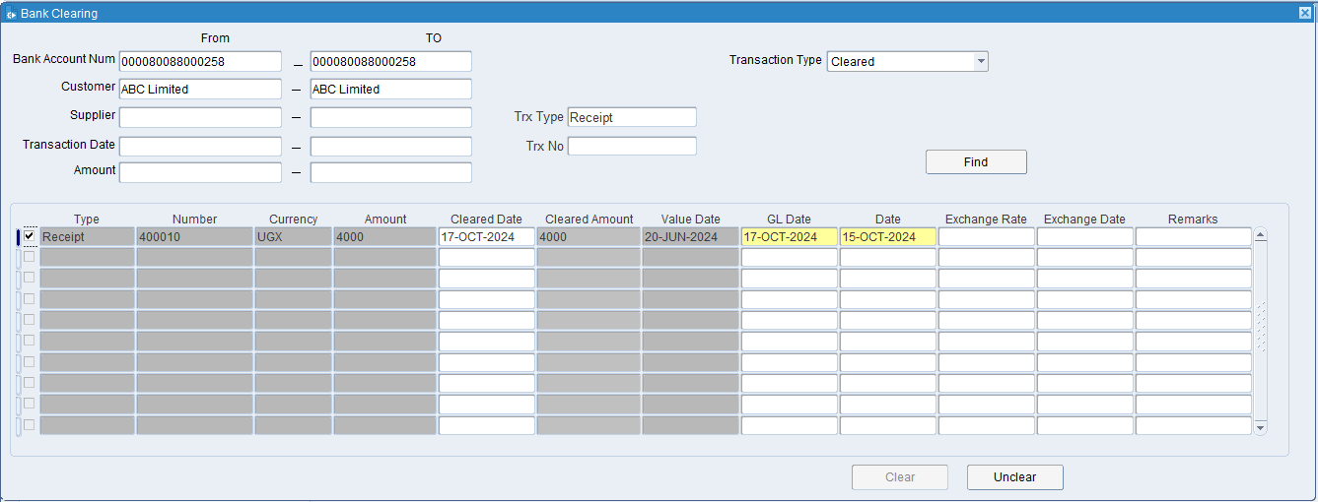

Click on the Unclear Button.

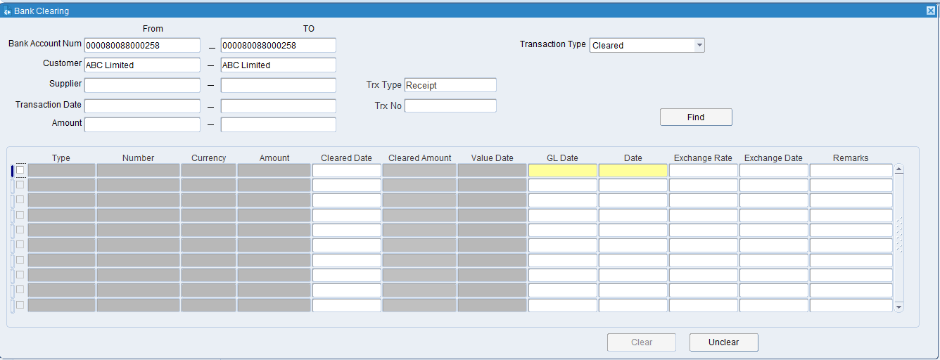

The transaction has been successfully Uncleared.

XX END XX

