White Paper User Manual For –
Menu Creation

Module – Developer Responsibility

Author : Sourav Suman
Creation Date : 18-Nov-2024
Last Updated : 18-Nov-2024
Version : 1.0

Login From the User Credential to whom the functionality is Provided.
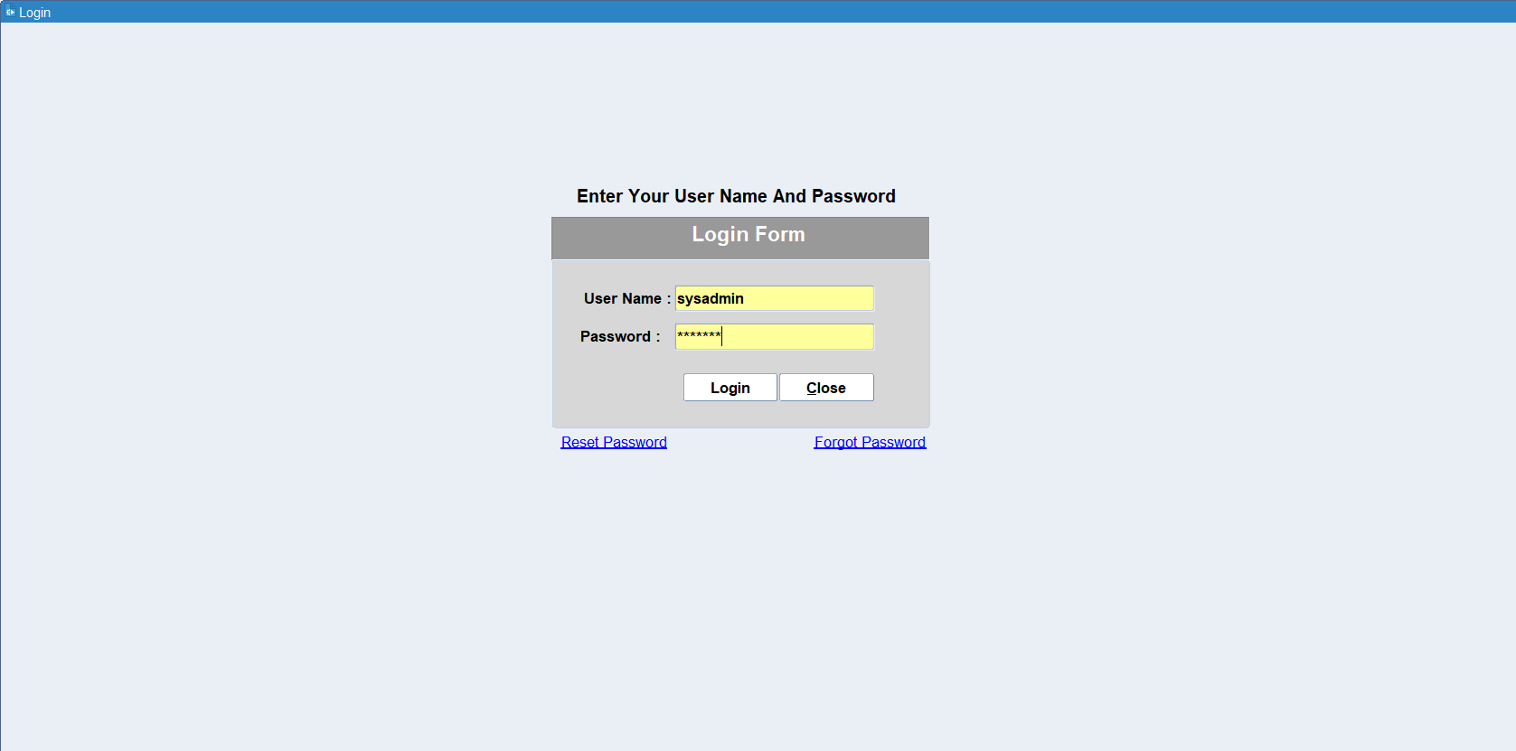

Navigation: Developer Responsibility > Menu
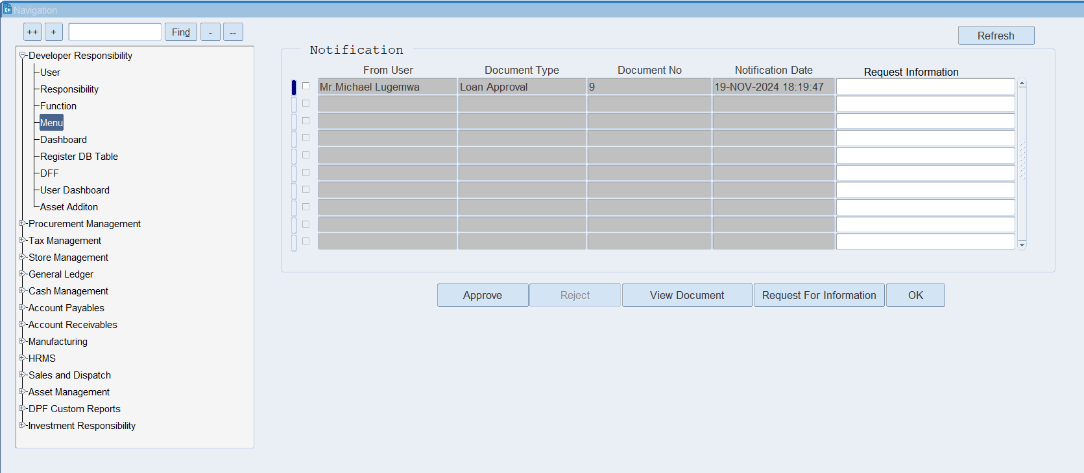

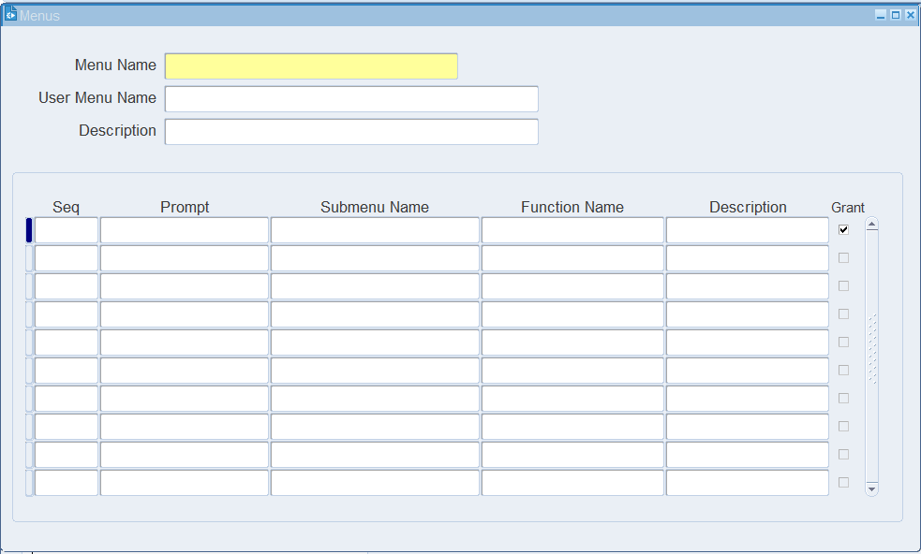
Menu form will be Open like as shown above.
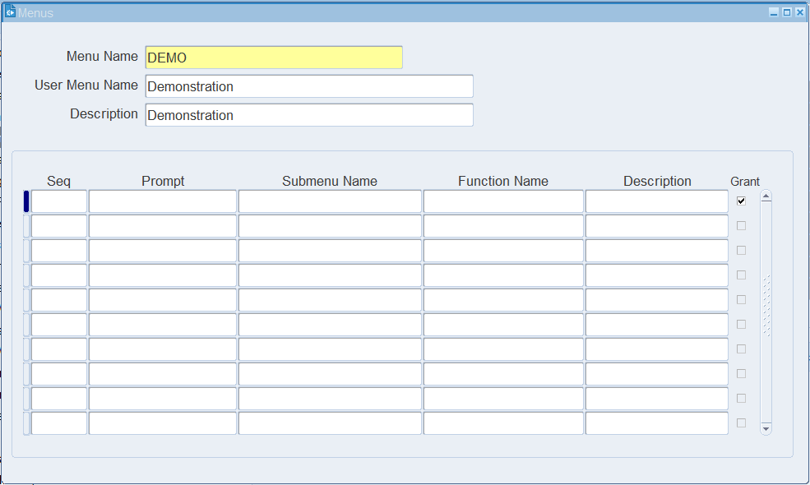
Enter the Mandatory field as Menu Name and Description > Click on Function name field after filling header information.

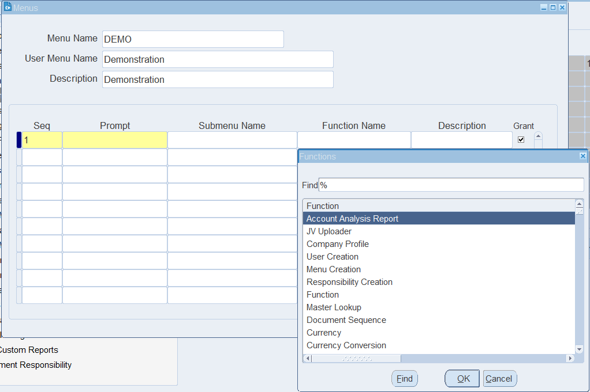
Select the functions which you want to put in the menu, for this click on Function name list of value >Select the Function.
- Note: You can select multiple function in a single menu or you can also select submenu in the menu.

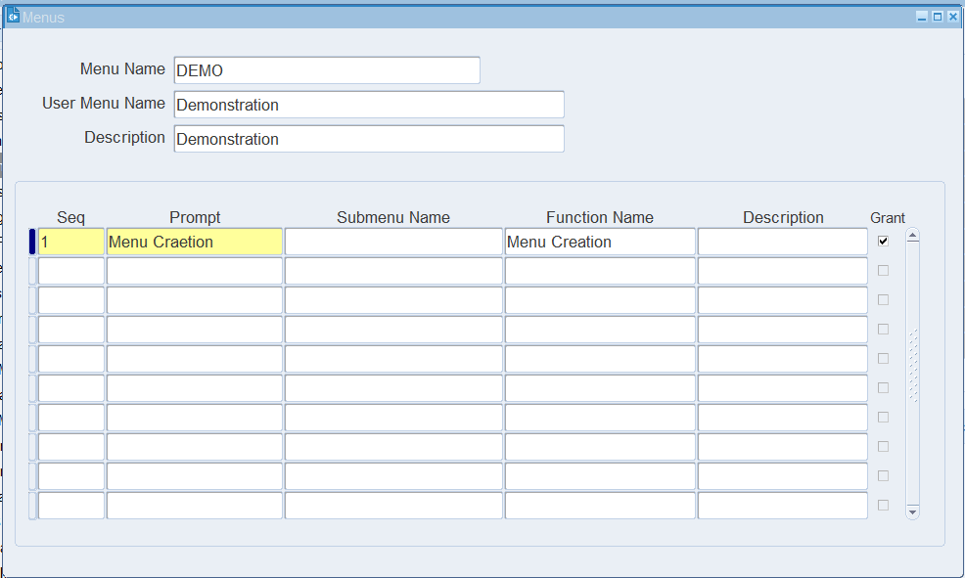
Enter the Prompt name as per your desire which is shown in the Responsibility Function name, and enable the function access by click on Grant check box.

XX END XX

