White Paper User manual For –
Miscellaneous Money Receipt

Module – Account Receivables

Author : Ajinkya Patil
Creation Date : 17-Oct-2024
Last Updated : 17-Oct-2024
Version : 1.0

A miscellaneous receipt is a payment that is not associated with a billing transaction. It is used to record cash received that is not related to receivables, such as interest, refunds, stock sales, and investments.

Navigation – Account Receivables – Transaction – Money Receipt

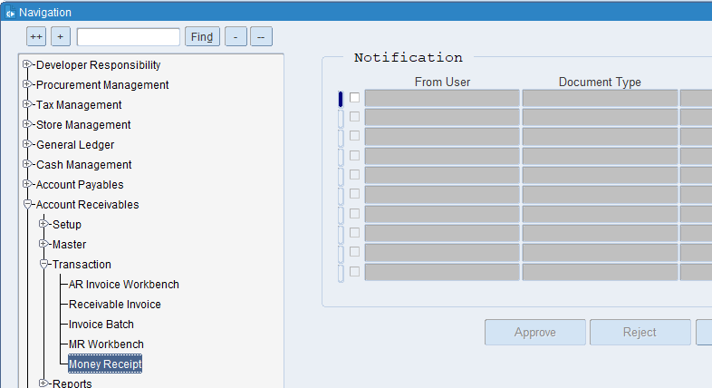

Select Receipt Type Miscellaneous and Activity Name
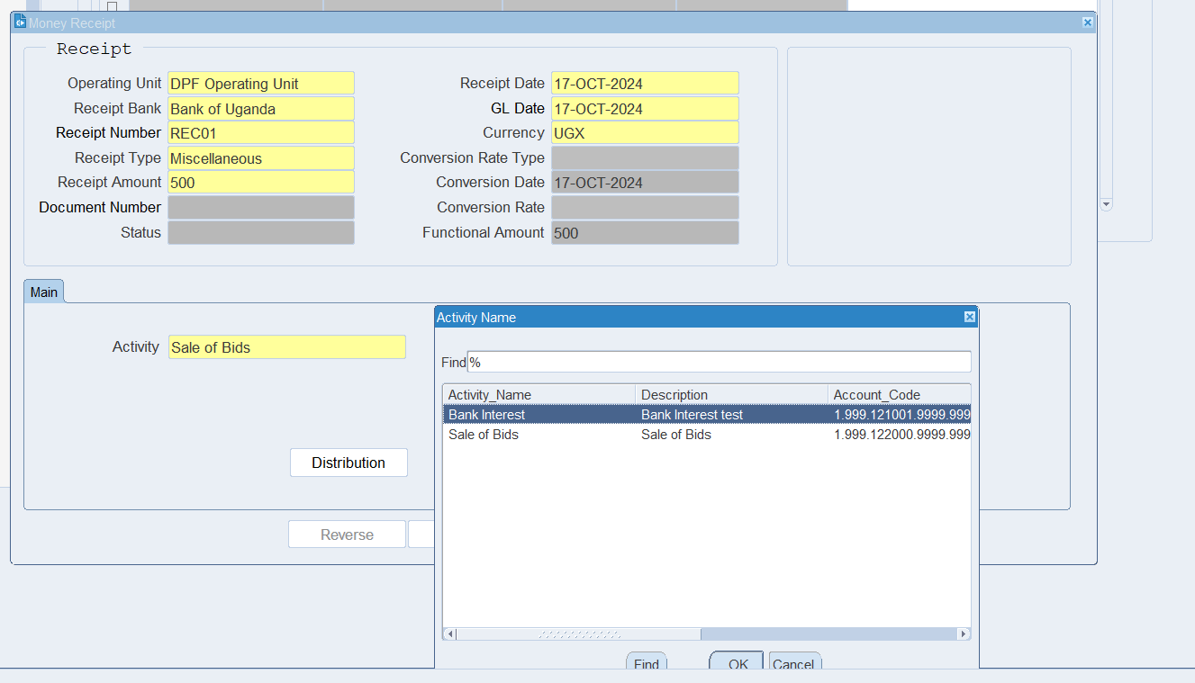

What is an Operating Unit?
An operating unit is a distinct segment or division within a company that manages a specific part of the company's operations. It can be thought of as a self-contained unit responsible for its own set of activities, resources, and objectives.

What is GL Date?
The GL date indicates the specific date on which a transaction is recorded in the General Ledger. This date determines the accounting period in which the transaction will be included for financial reporting and analysis.

What is Invoice Currency?
Invoice currency specifies the type of currency used to calculate and display the amounts due on an invoice. This could be the currency of the supplier, the customer, or a mutually agreed-upon currency.

What is Type?
The classification or category assigned to an Money receipt that indicates the nature of the invoice or the type of transaction it represents.

What is the Document Number?
A unique numerical or alphanumeric code assigned to an AR invoice to distinguish it from other invoices and provide a reference point for tracking and managing.

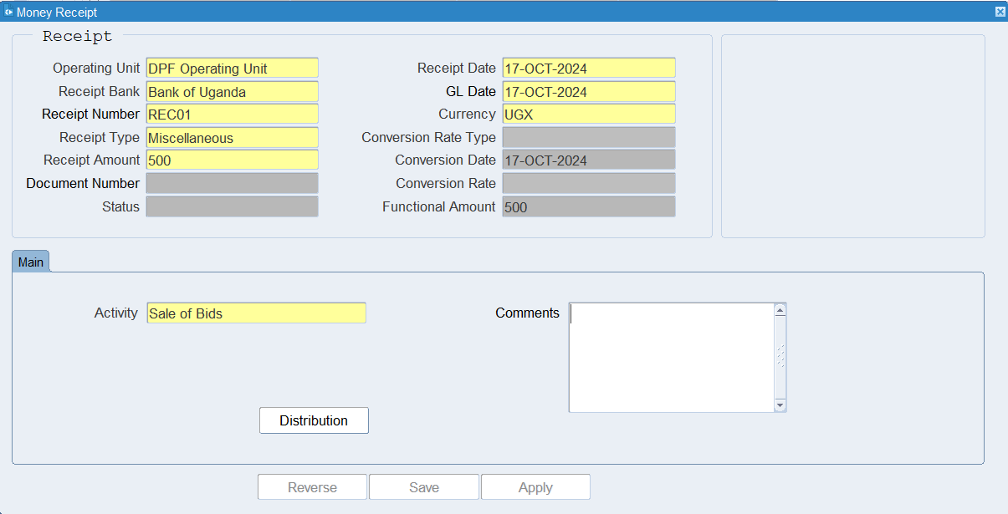
Put all the required details and Click Distribution Button

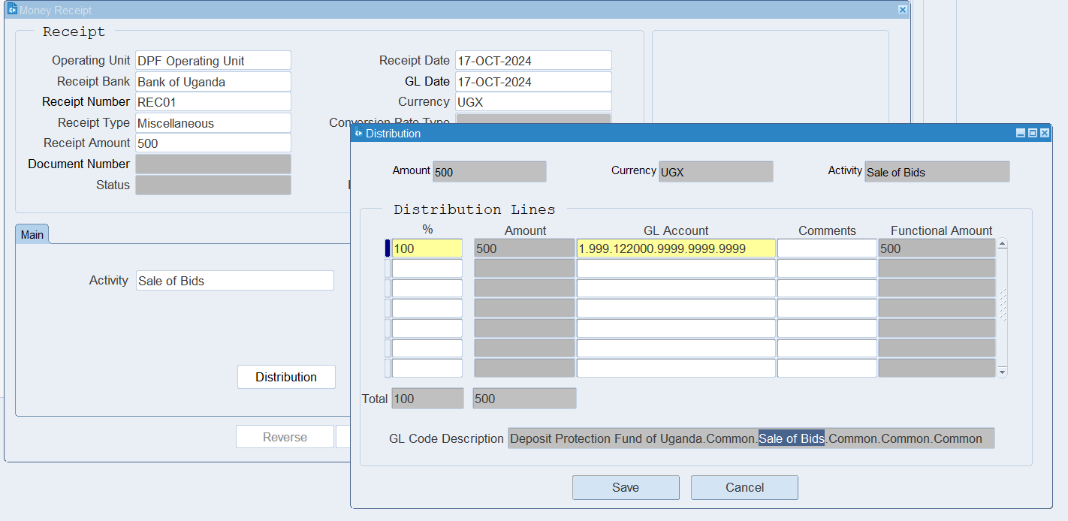

Click on Save
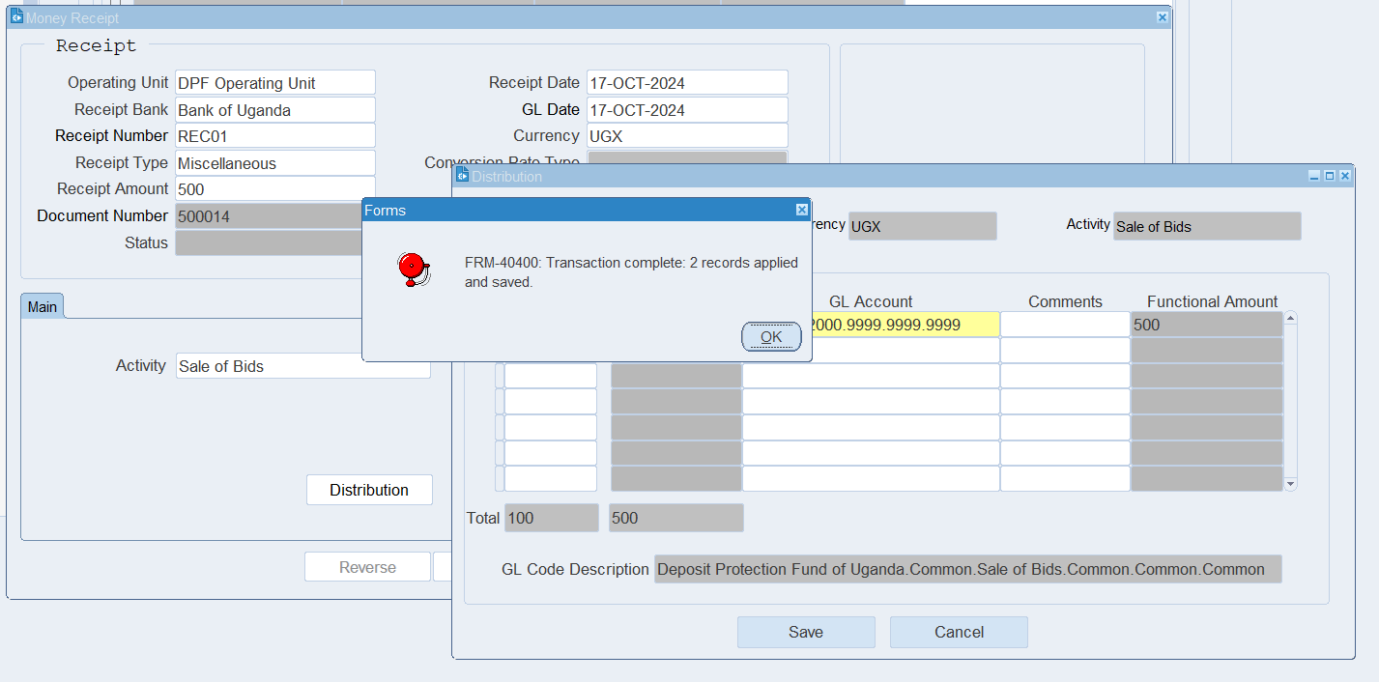

After save system will generate Accounting
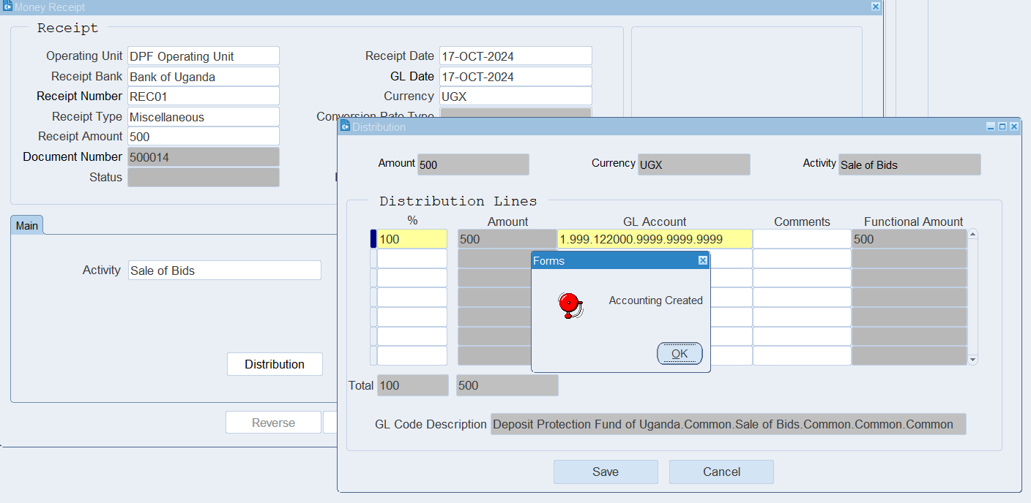

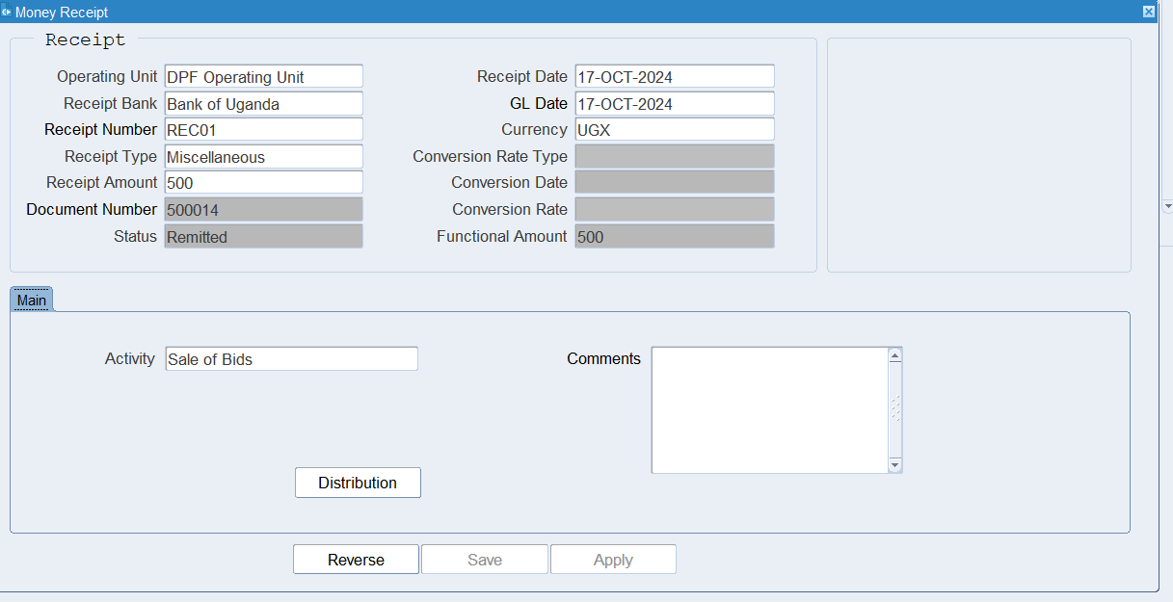
Miscellaneous Money Receipt Created.

XX END XX

