White Paper User Manual For –

White Paper User Manual For –
Payroll Management

Module – Human Resource

Author : Sourav Suman
Creation Date : 18-Oct-2024
Last Updated : 18-Oct-2024
Version : 1.0

Overview:
Payroll refers to the process by which an organization calculates and distributes compensation to its employees for their work. It involves several key components:
- Salary and Wages: Determining how much employees will be paid based on their employment agreements, hours worked, or commission structures.
- Deductions: Calculating various deductions, including taxes (federal, state, local), social security, health insurance, retirement contributions, and other withholdings.
- Payroll Processing: Compiling all relevant data (e.g., hours worked, overtime, leave taken) and running payroll on a regular schedule (weekly, biweekly, monthly).
- Distribution: Issuing payments to employees, which can be done via direct deposit, checks, or other methods.
- Record-Keeping: Maintaining accurate records of payroll transactions for compliance, audits, and reporting purposes.
- Reporting: Preparing and submitting necessary reports to government agencies regarding payroll taxes, employee earnings, and compliance with labor laws.
Effective payroll management is crucial for ensuring employees are paid accurately and on time, maintaining compliance with regulations, and managing financial records.

Why it is used?

Payroll is used for several important reasons:
- Compensation: Ensures that employees are paid accurately and on time for their work, which is essential for employee satisfaction and retention.
- Legal Compliance: Helps organizations comply with labor laws, tax regulations, and reporting requirements, reducing the risk of legal issues and penalties.
- Record Keeping: Maintains accurate records of employee earnings, deductions, and hours worked, which are necessary for audits and financial reporting.
- Financial Management: Supports budgeting and financial planning by tracking labor costs and forecasting future payroll expenses.
- Employee Benefits: Manages deductions for benefits like health insurance, retirement contributions, and other employee programs, ensuring that employees receive their entitlements.
- Tax Reporting: Facilitates accurate tax calculations and timely submissions of payroll taxes to government agencies, ensuring compliance with tax obligations.
- Employee Engagement: Timely and accurate payroll contributes to a positive workplace culture, fostering trust and engagement among employees.
In summary, payroll is a critical function that supports both organizational operations and employee welfare.

Where it used?
In essence, payroll is a fundamental function in any organization that employs workers, ensuring accurate compensation and compliance with financial regulations.
When it used?
Payroll is used at key times, including:
- Regular Pay Cycles: Processed weekly, biweekly, or monthly.
- Onboarding: Set up for new employees.
- Salary Reviews: Adjustments made annually or semi-annually.
- Employee Departures: Final paychecks for leaving employees.
- Bonuses: Special payroll runs for bonuses and incentives.
- Tax Reporting: Year-end reporting and documentation.
- Status Changes: Updates for promotions or changes in hours.
Overall, payroll ensures timely and accurate employee compensation throughout their employment.

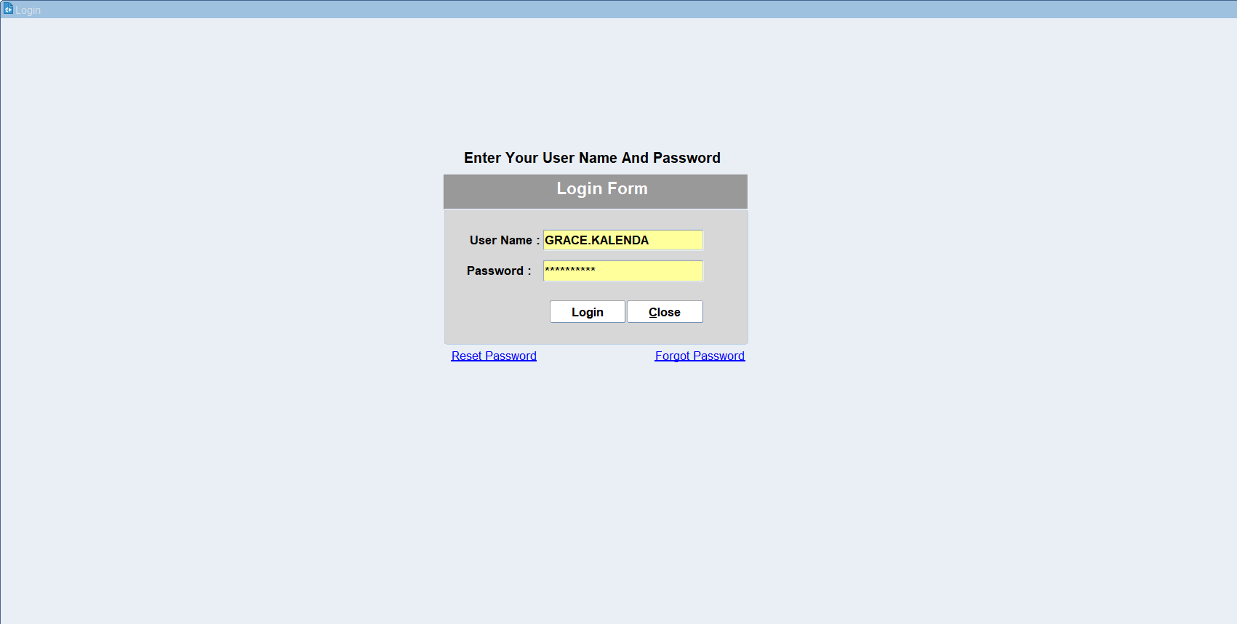
Put the Login details & click on login
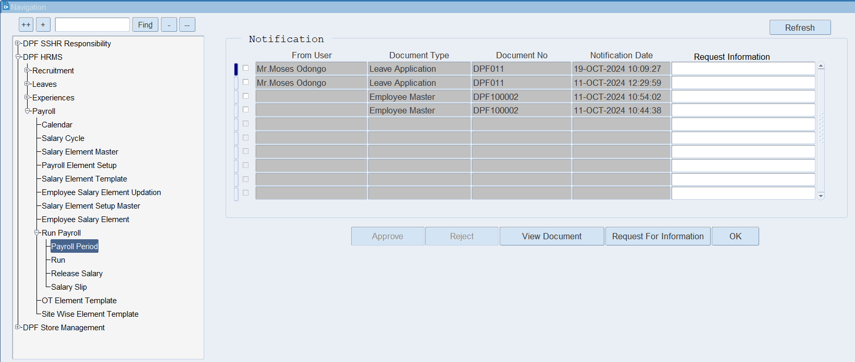
Click on Payroll Period

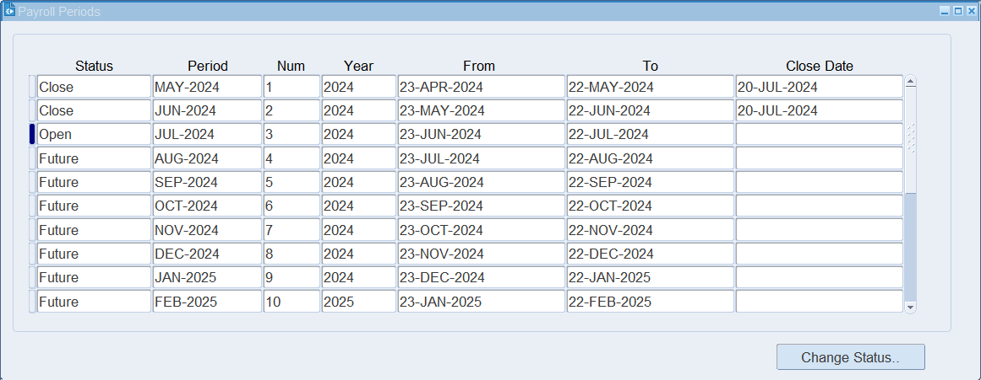
Select the previous period and Click on Change Status > Close the Period

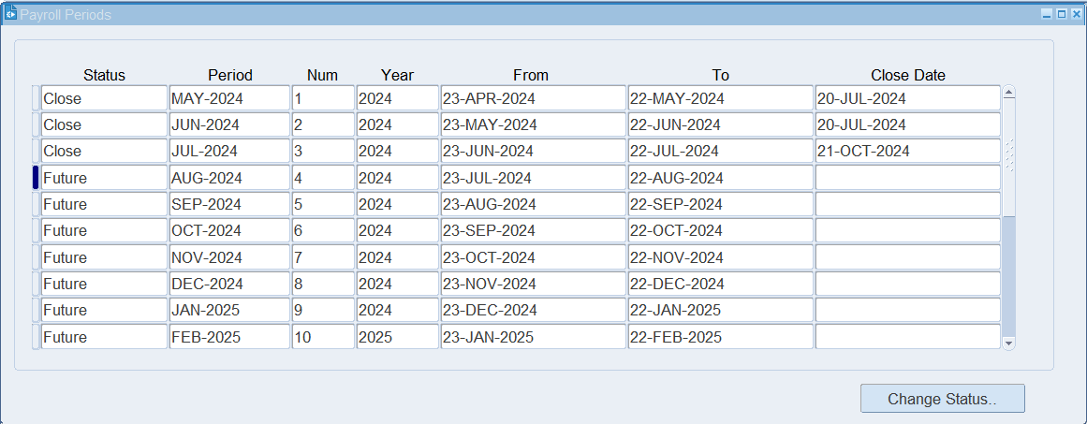
Select the Current period for which you want to run the payroll and click on change status
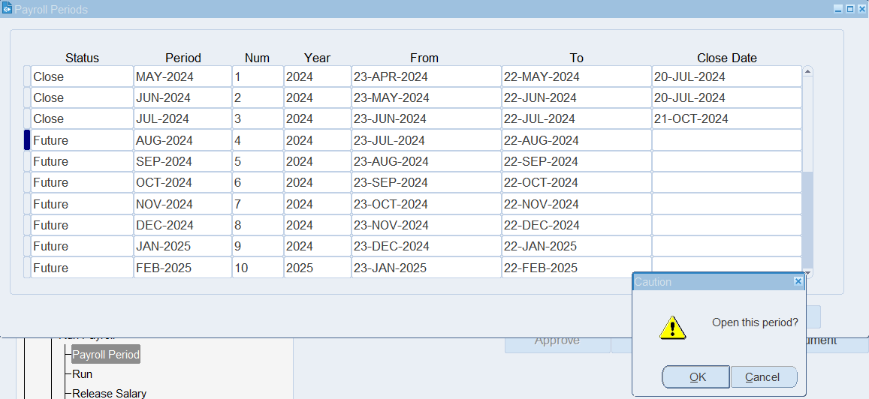
Open the period.

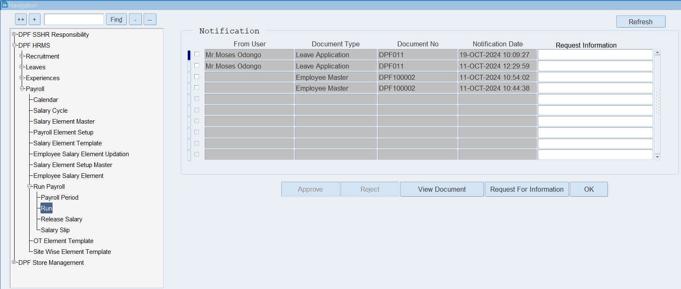
Click on Run.

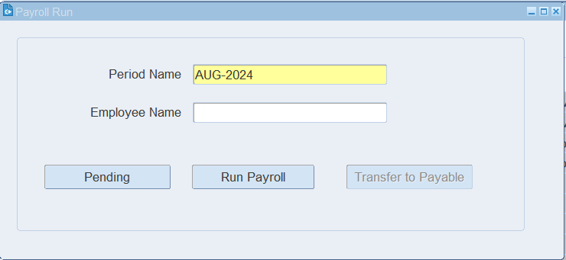
Select the period for you want to run the payroll and Click on Pending to check weather any task is pending for run the payroll
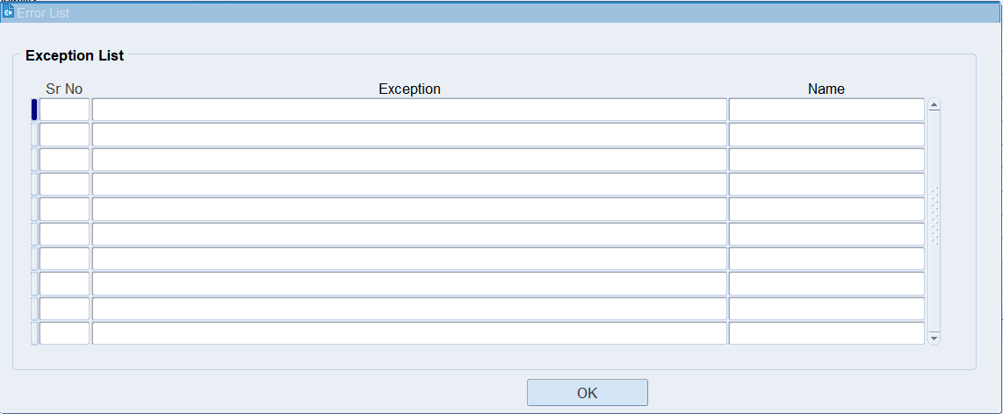
If any activity is pending then the system will show the pending activity in the Exception list. > Click on Ok.

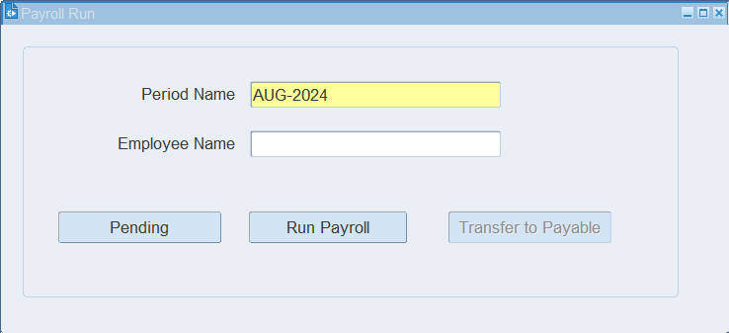
If there are no pending activities, you can go ahead and click the "Run Payroll" button to proceed. And Click on Transfer to Payable once the payroll is generated.

XX END XX

