White Paper User Manual For –

White Paper User Manual For –
Performance Management

Module – Human Resource

Author : Sourav Suman
Creation Date : 18-Oct-2024
Last Updated : 18-Oct-2024
Version : 1.0

Overview:
A performance management system (PMS) is a framework used by organizations to assess, monitor, and improve employee performance. It aligns individual performance with the organization's goals and facilitates ongoing feedback and development. Key components include:
- Goal Setting: Establishing clear, measurable objectives for employees that align with organizational goals.
- Continuous Feedback: Providing regular feedback to employees about their performance, rather than relying solely on annual reviews.
- Performance Appraisals: Conducting formal evaluations at set intervals to assess employee performance against established goals.
- Development Plans: Identifying areas for improvement and creating training or development plans to help employees grow.
- Documentation: Keeping records of performance discussions, feedback, and appraisals for accountability and future reference.
- Integration with Compensation: Linking performance outcomes to rewards, promotions, and salary adjustments to motivate employees.
A well-implemented performance management system enhances employee engagement, fosters a culture of accountability, and drives overall organizational success.

Why it is used?
A performance management system (PMS) is used for several important reasons:
- Alignment of Goals: Ensures that individual employee goals align with organizational objectives, promoting a unified direction.
- Performance Improvement: Helps identify strengths and areas for improvement, enabling targeted development and support.
- Continuous Feedback: Facilitates ongoing communication, allowing employees to receive timely feedback and adjust their performance accordingly.
- Employee Engagement: Engages employees by involving them in goal setting and providing recognition for their achievements.
- Talent Development: Supports career growth through personalized development plans and training opportunities.
- Accountability: Establishes clear expectations and accountability for performance, helping to drive results.
- Informed Decision-Making: Provides data and insights that inform promotions, compensation, and succession planning.
- Organizational Culture: Fosters a culture of performance and continuous improvement, enhancing overall organizational effectiveness.
Overall, a PMS helps create a motivated workforce and drives better business outcomes.

When it used?
A performance management system (PMS) is used throughout various stages of the employee lifecycle and organizational processes, including:
- Onboarding: Introduced during employee onboarding to set expectations and goals from the start.
- Goal Setting Periods: Typically, at the beginning of performance cycles (annually or quarterly) to establish objectives.
- Regular Check-Ins: Ongoing throughout the year for continuous feedback and coaching, often in monthly or quarterly meetings.
- Performance Appraisal Cycles: Used during formal evaluations, which may occur annually or biannually, to assess progress against goals.
- Training and Development Planning: During development discussions to identify skill gaps and training needs.
- Promotions and Compensation Reviews: Applied when making decisions about promotions, raises, or bonuses based on performance.
- Succession Planning: Used to identify and develop potential leaders within the organization.
In summary, a PMS is a continuous process that supports employee development and organizational goals at various key moments throughout the year.

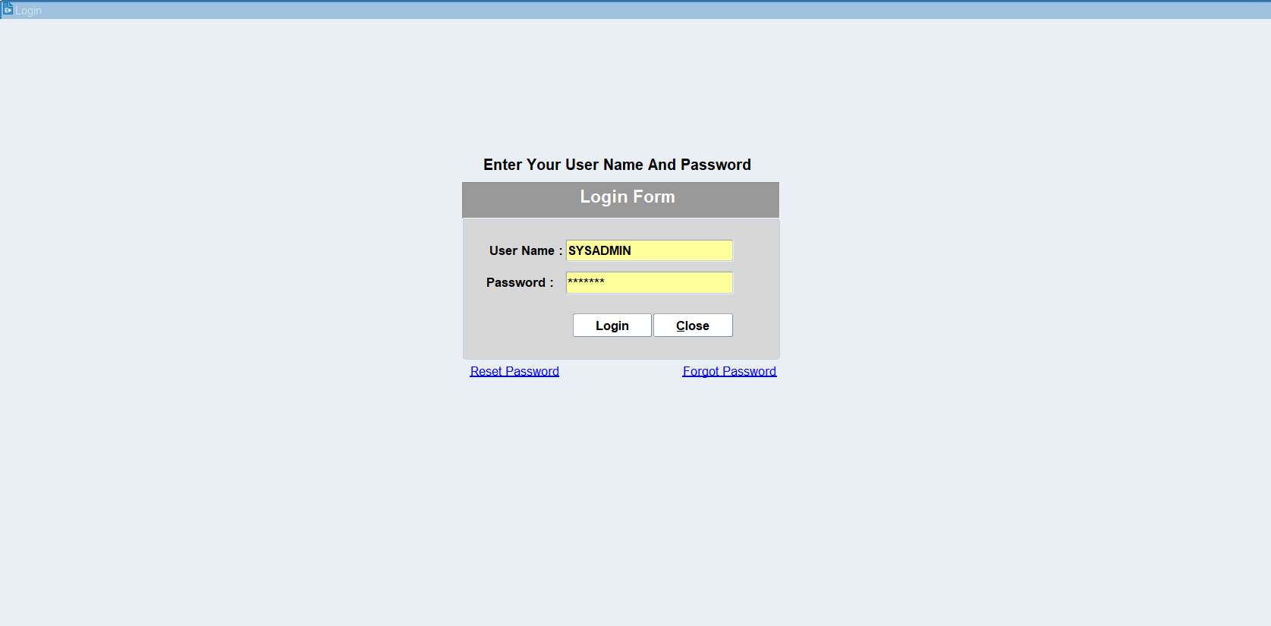
Put the login details and login

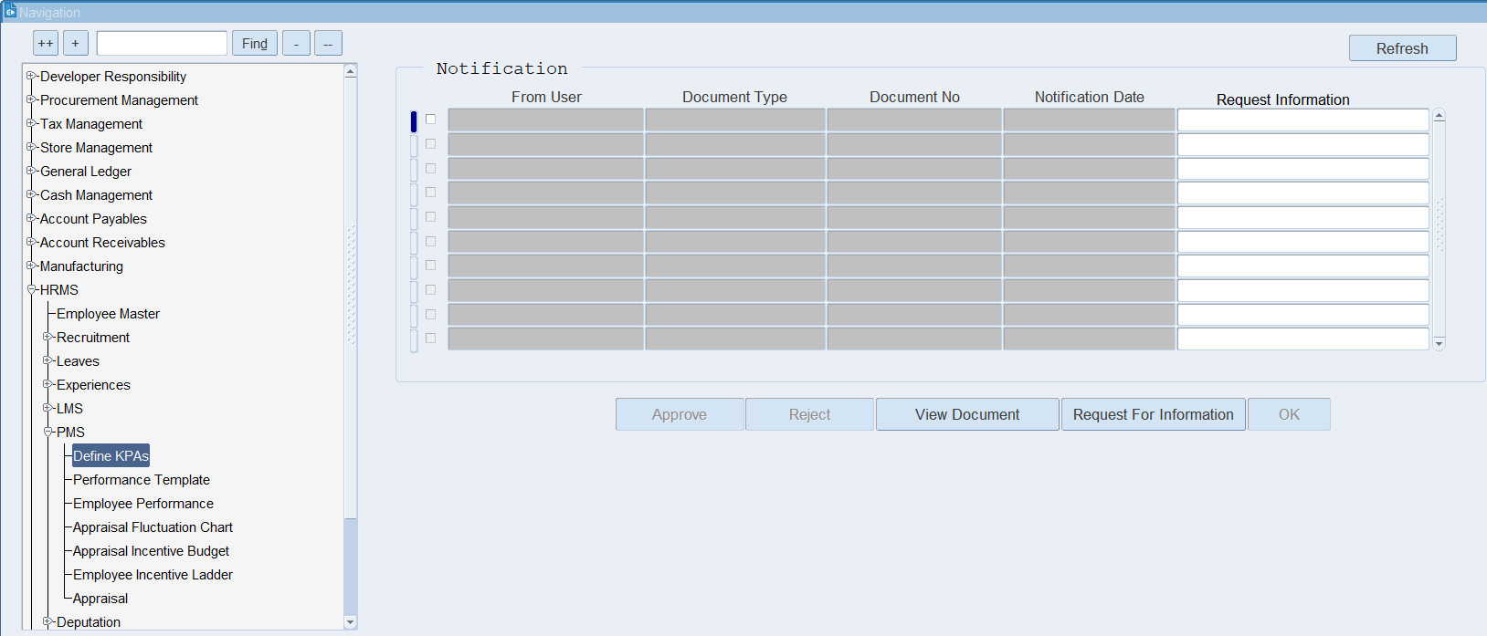
Click on Define KPA’s

KPA (Key Performance Area)
KPA stands for Key Performance Area. It refers to specific areas or aspects of performance that are crucial for the success of an organization or a project. KPAs help in assessing how well individuals, teams, or the organization as a whole are achieving their objectives.
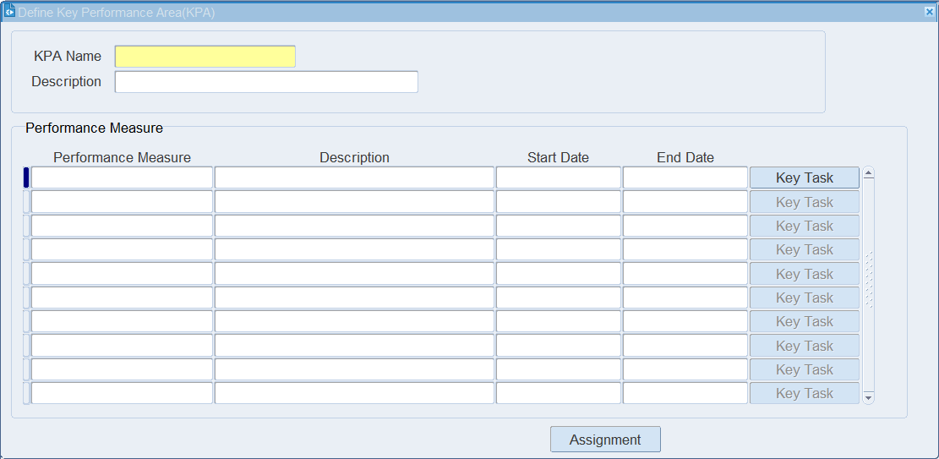
Put the KPA Name & Description.

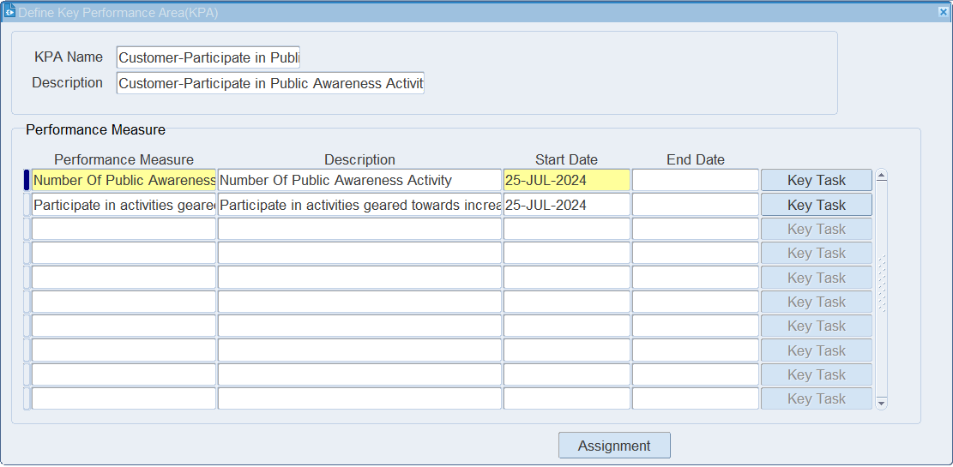
Put the Performance Measure manually as per requirement & put the start date.
Click on Key Task.

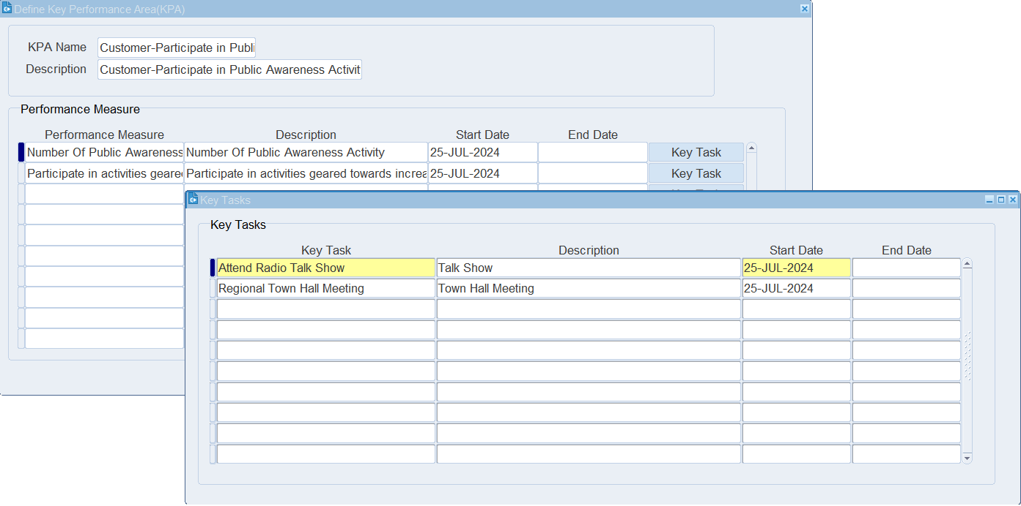
Put the Key Task names.

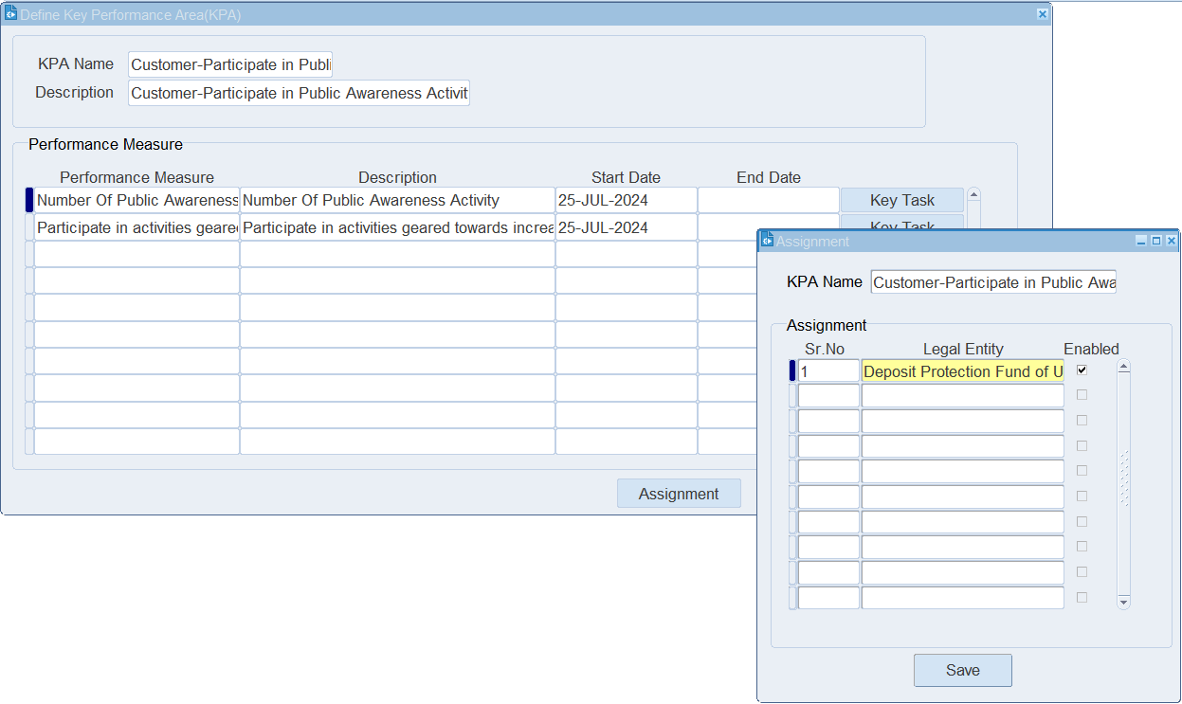
Click on Assignment. Then put the Legal Entity. Click on save.

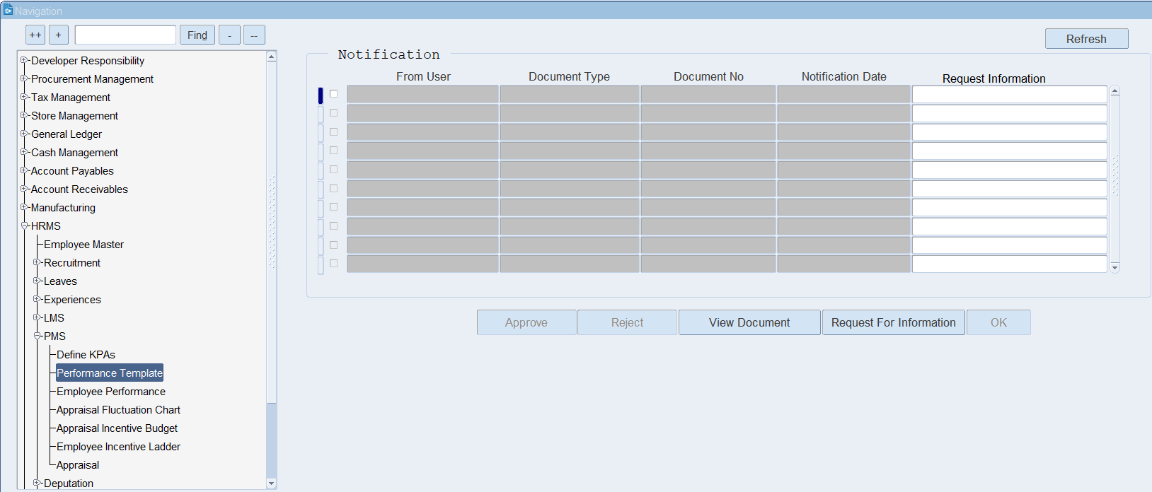
Click on Performance Template.
What is a performance template?
A performance template is a structured document used to evaluate and track performance metrics in an organization. It standardizes assessments for various purposes, such as employee reviews, project management, and business performance.

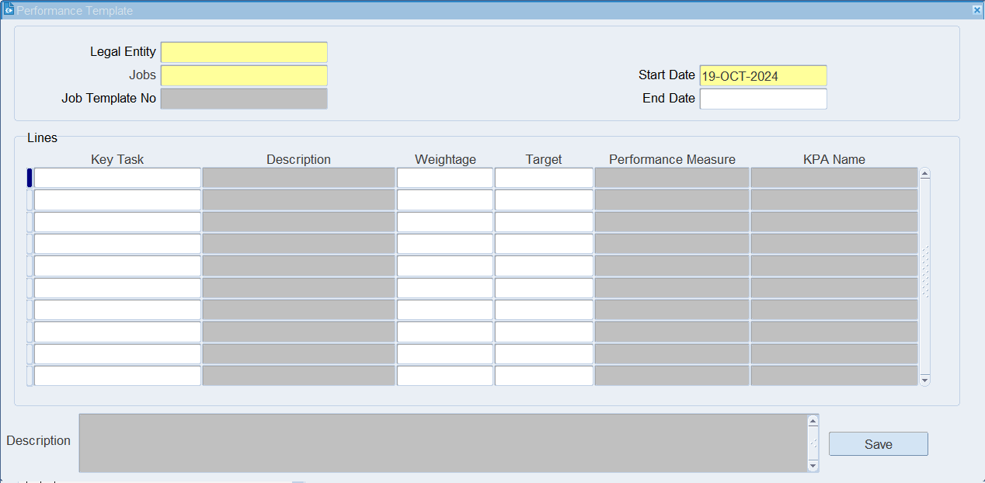
Put the mandatory details like Legal Entity and Jobs.

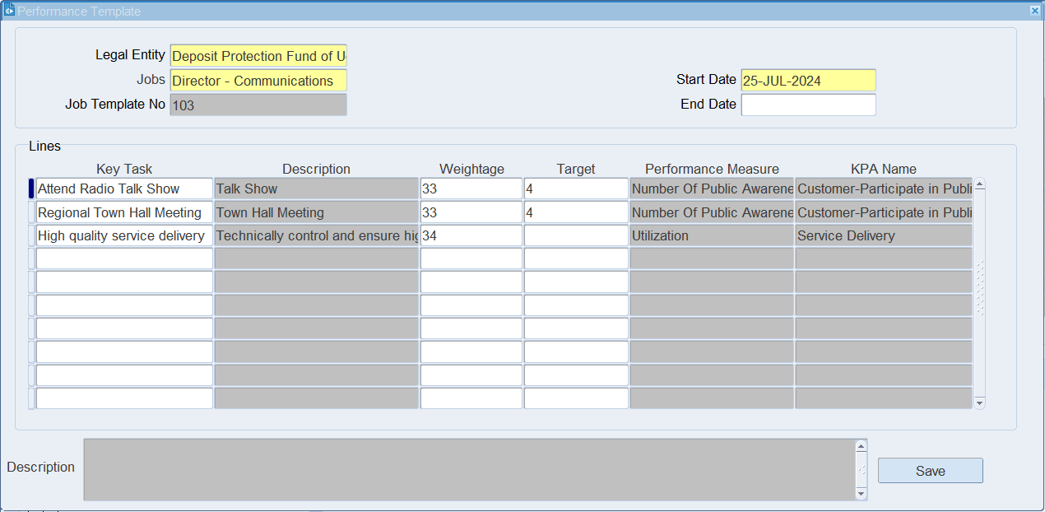
Put the target & click on save.

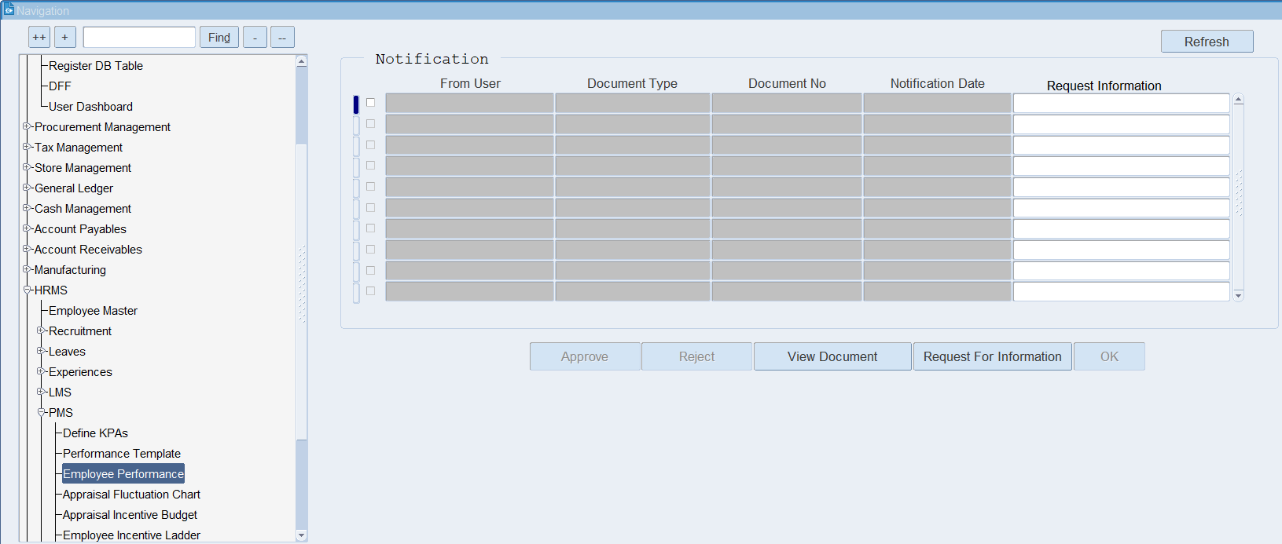
Click on Employee Performance.

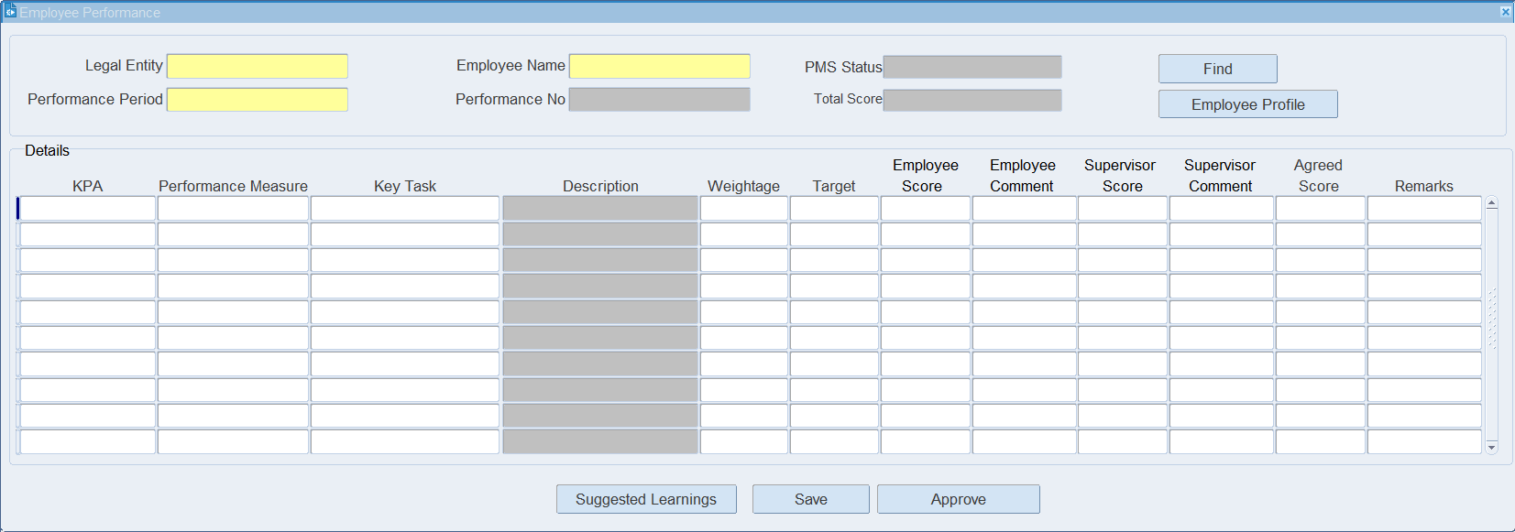
Put the mandatory information like Legal Entity, Employee Name & Performance period.
Click on find.
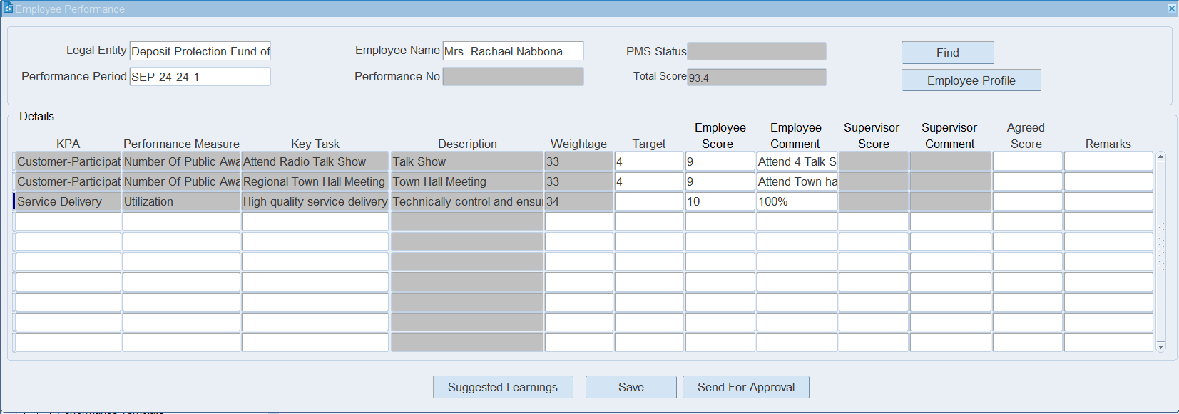
Here, put the Target & Employee score.
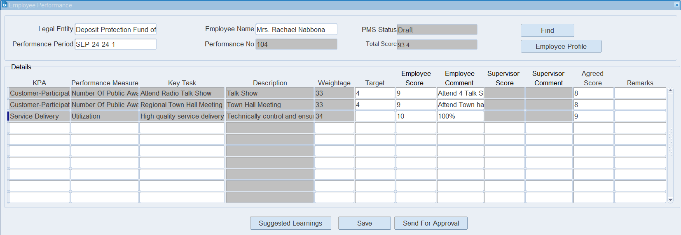
Click on Send for approval to the supervisor for review and approval.

XX END XX

