White Paper User manual For –
Posting of Journal Voucher

Module – General Ledger

Author : Ajinkya Patil
Creation Date : 03-Sep-2024
Last Updated : 03-Sep-2024
Version : 1.0

To explain a general voucher using the 5 W’s—Who, What, When, Where, and Why—here’s a breakdown:

- Who:

  - Who issues it? Vouchers are typically issued by businesses, organizations, or financial institutions. They can also be provided by governments or other entities.
  - Who uses it? The voucher is usually given to a customer, employee, or recipient as a form of credit or discount.

- What:

  - What is a voucher? A voucher is a document or digital code that represents a value or credit, which can be redeemed for goods, services, or discounts. It acts as a form of payment or incentive.

- When:

  - When is it issued? Vouchers can be issued at various times, such as during promotions, as rewards, or as part of a financial transaction. They might also be issued periodically or as part of specific programs.
  - When can it be used? The timing of voucher use depends on its validity period, which can be immediate or have a set expiration date.

- Where:

  - Where can it be redeemed? Vouchers are typically redeemable at specified locations or online stores, depending on the issuing entity's policies. Some vouchers might be valid only at particular retailers or service providers.

- Why:
  - Why is it issued? Vouchers are issued to encourage purchases, reward customers, promote brand loyalty, or facilitate transactions. They can also be used to provide financial assistance or incentives.

Navigation – General Ledger > Journals > Post
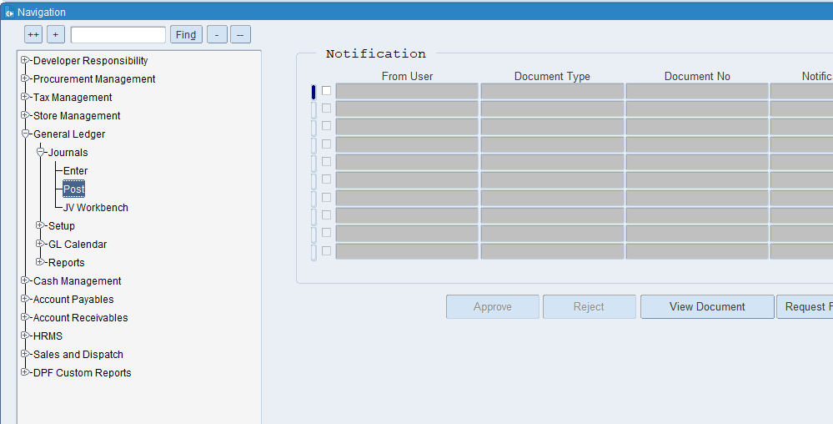

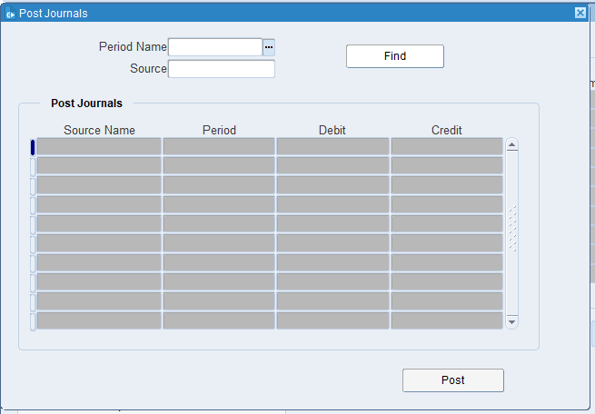
Put the period name & Source

What is a Source name?
In accounting, the source name might refer to the document or record from which a transaction originates. For example, invoices, receipts, or purchase orders are source documents that provide evidence for entries in the accounting system

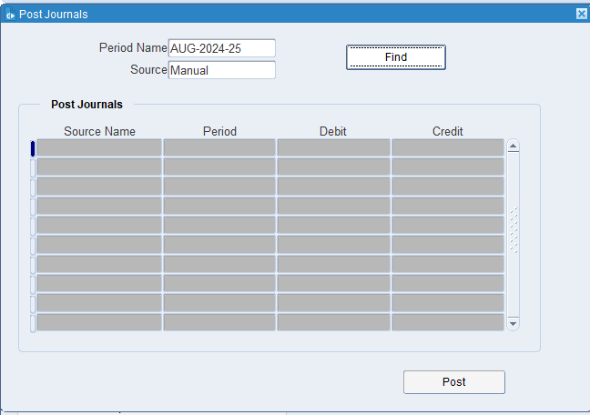
Click on Find
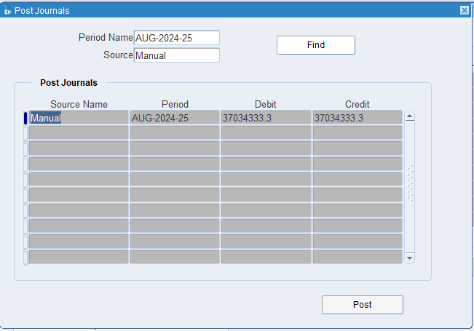
Click on Post.

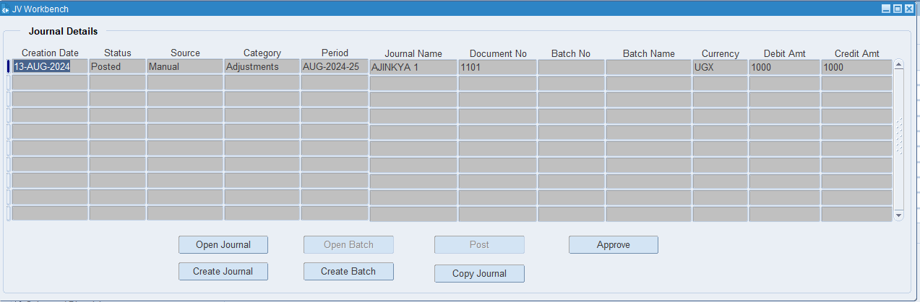
The JV has been successfully posted.

XX END XX

