White Paper User Manual For –
Prepayment Unapply With Foreign Currency

Module – Account Payables

Author : Ajinkya Patil
Creation Date : 23-Sep-2024
Last Updated : 23-Sep-2024
Version : 1.0

To understand prepayment using the 5 W's (Who, What, When, Where, Why), here’s a comprehensive breakdown:

1. Who
- Who Makes the Prepayment: The prepayment is typically made by a buyer or customer who is paying in advance for goods or services.
- Who Receives the Prepayment: The prepayment is received by a seller, service provider, or landlord who will provide the goods or services at a later date.

2. What
- What Is Prepayment: Prepayment is the act of paying for goods or services before they are actually delivered or provided. It can be a full or partial payment made before the service period begins or before the goods are supplied.
- What It Includes: This may include advance payments for products, deposits for reservations, subscription fees, or rent paid in advance.

3. When
- When Is It Done: Prepayment is made at the time of booking, ordering, or signing a contract, typically before the delivery date or service provision date. It is done according to the terms agreed upon between the buyer and the seller.
- When It’s Recognized: In accounting terms, prepayments are recognized as assets initially and then expensed over time as the service is received or the goods are delivered.

4. Where
- Where Is It Used: Prepayment is used in various scenarios, including:
  - Retail: For reserving products or services.
  - Real Estate: For paying rent or deposits on rental properties.
  - Travel and Hospitality: For booking flights, hotels, or event tickets.
  - Subscriptions: For paying for ongoing services like magazines, software, or memberships.
- Where Is It Recorded: In financial records, prepayments are typically recorded as prepaid expenses or prepaid assets on the balance sheet until the service or goods are delivered.

5. Why
- Why Is It Done: Prepayments are made for several reasons:
  - To Secure Goods or Services: Ensures availability or reservation of products or services.
  - To Benefit from Discounts: Some providers offer discounts or better terms for advance payments.
  - To Manage Cash Flow: Helps in budgeting and planning by spreading out payments.
  - To Mitigate Risk: Reduces the risk of non-payment or cancellation by securing funds upfront.

Navigation – Account Payables > Invoice

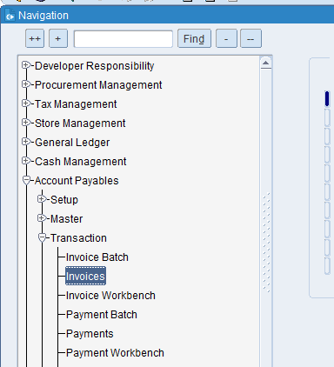

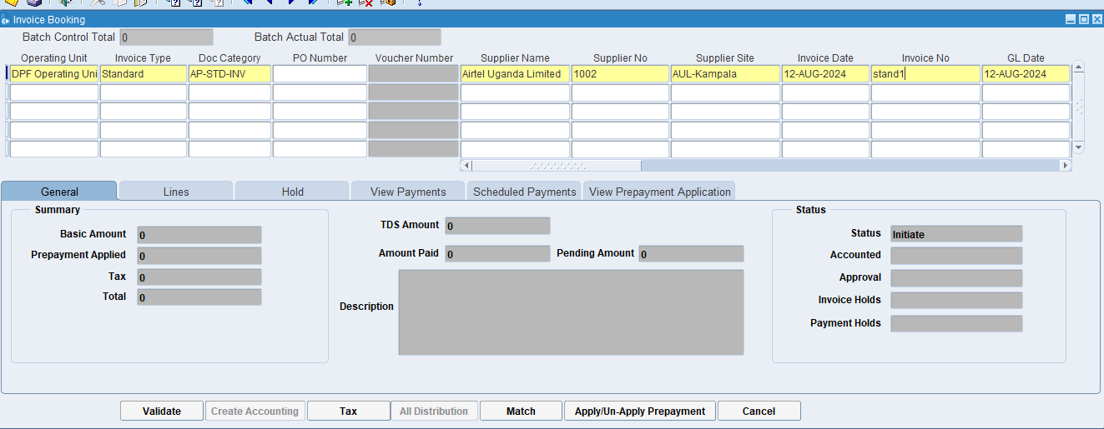
Put the Doc Category, Invoice type, supplier’s name & Invoice number.

What is Document Category?
This is a classification assigned to an invoice to indicate its type or purpose. It helps the ERP system to apply specific rules, workflows, and processing steps based on the category. Examples might include "Sales Invoice," "Purchase Invoice," "Credit Note," or "Debit Note."

What is Supplier's name?
It identifies the party that has supplied the goods or services, ensuring that there is clarity on who the invoice is coming from. This helps in maintaining accurate records and resolving any discrepancies related to the supplier.

What is a supplier site?
The supplier site provides detailed information about where a supplier operates, ships from, or where services are delivered. This helps in managing logistics, shipping, and procurement processes efficiently.

What is the Invoice Number?
The invoice number uniquely identifies each invoice, making it easy to reference and track. It helps in distinguishing one invoice from another, which is essential for organization and clarity in financial records.

What is GL Date?
The GL date indicates the specific date on which a transaction is recorded in the General Ledger. This date determines the accounting period in which the transaction will be included for financial reporting and analysis

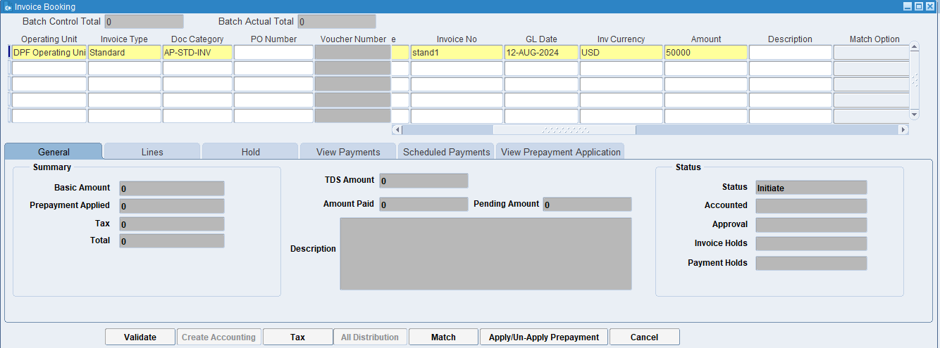
Put the amount

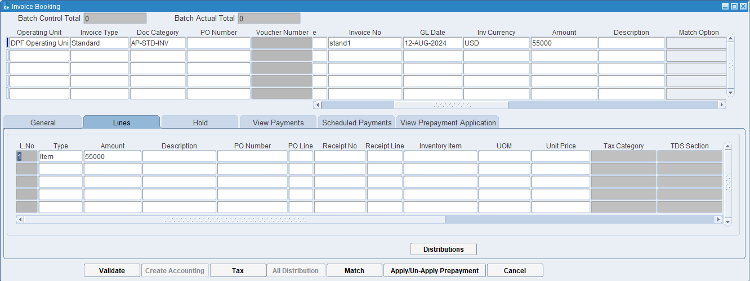
Click on the Lines then click on distributions.

What is Lines?
In the context of an invoice, lines refer to the individual entries or rows on the invoice that detail each specific item or service being billed. Each line typically includes a description, quantity, unit price, and total amount for the particular item or service.

What is Distributions?
In the context of invoicing and accounting, distributions refer to the process of allocating the costs of an invoice to different accounts, cost center, or departments within an organization. This ensures that expenses are recorded accurately in the financial records and helps in proper budgeting and financial analysis.

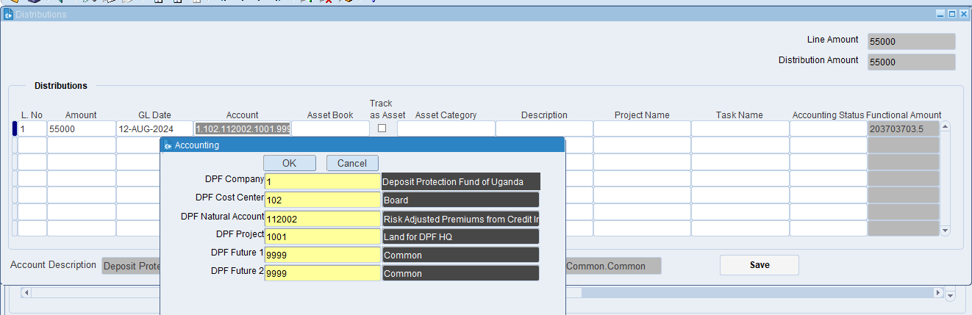
Put the required information in Account then click on ok

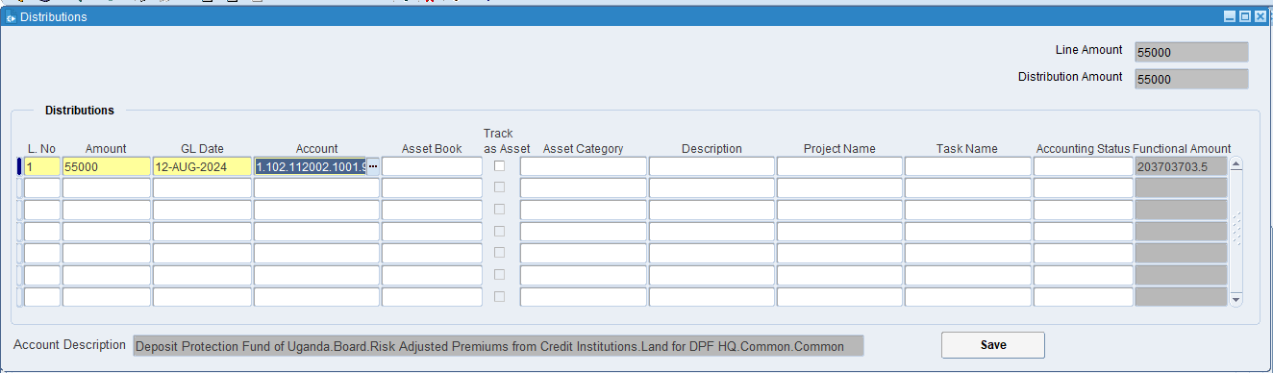
Click on save

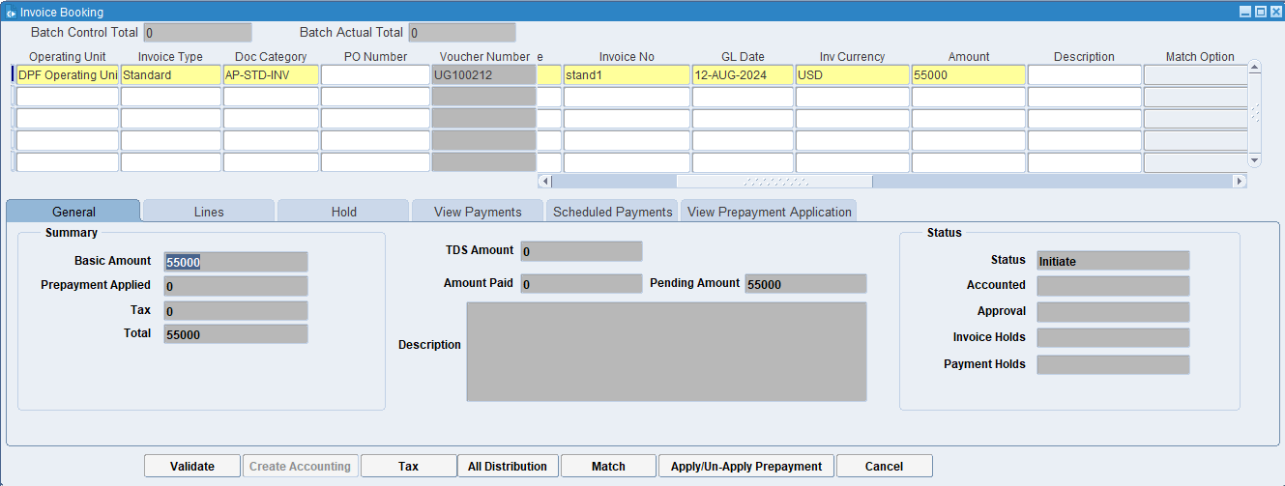
Click On Validate

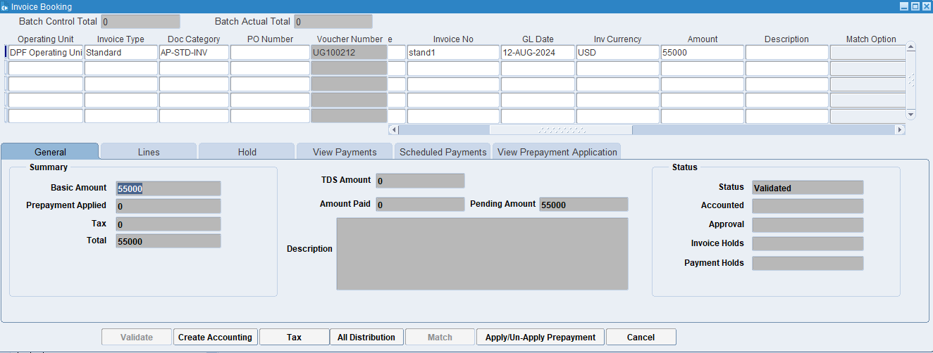
Click on Apply/Un-apply Prepayment

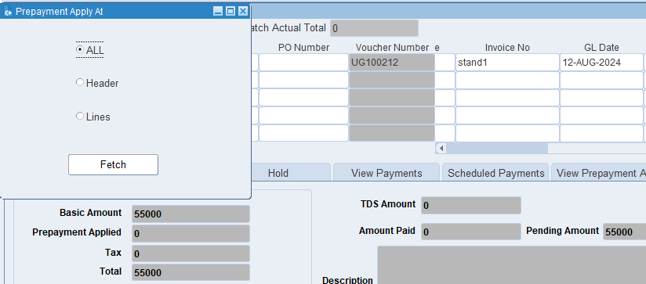
Click on fetch

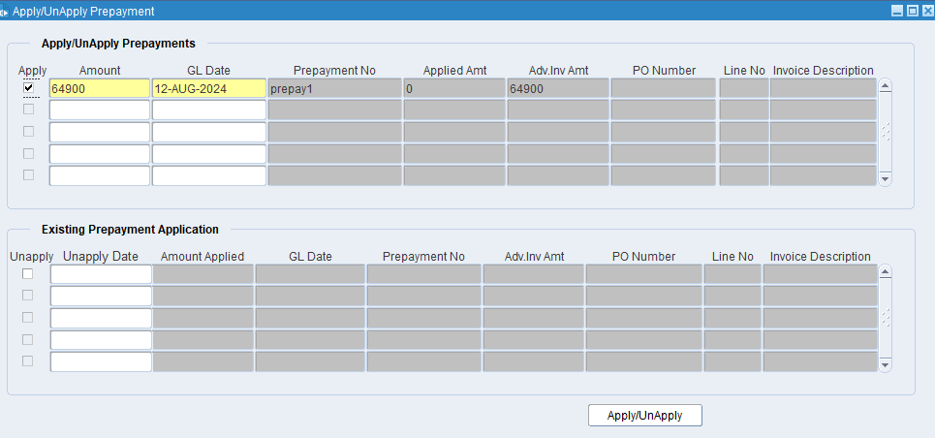
Tick on Apply then click on Apply

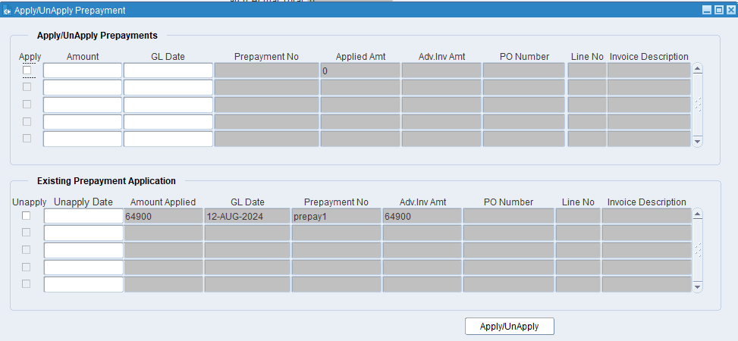
Now Prepayment has been applied.

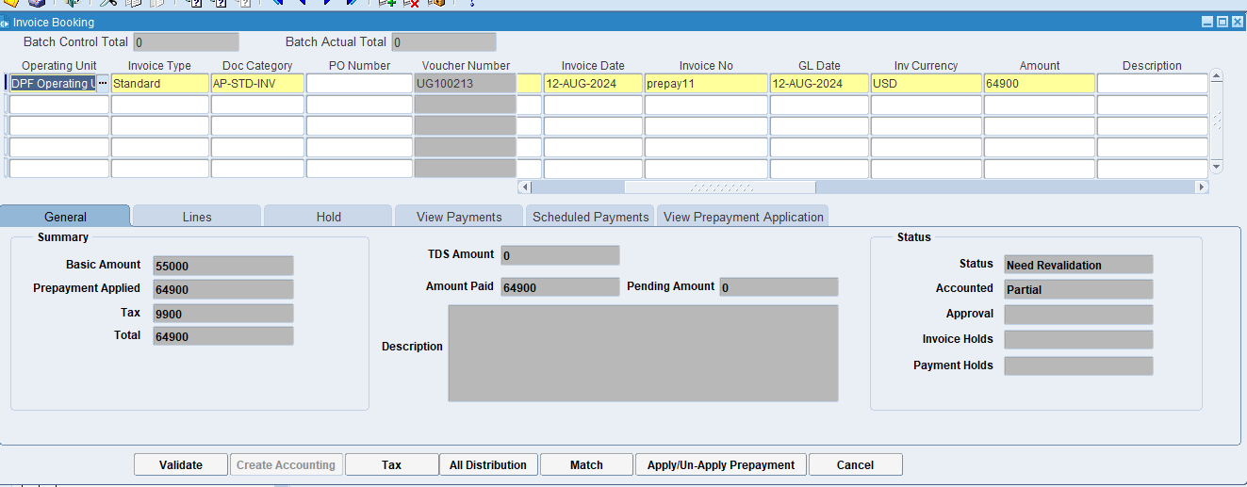
Now prepayment has been applied. Now status is in Need Revalidation.

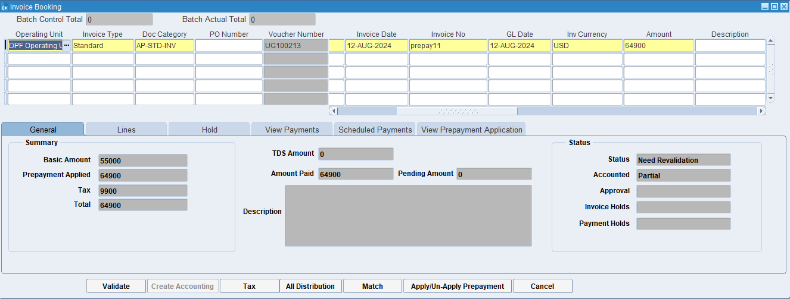
Click on Validate

Now we Un-apply the prepayment
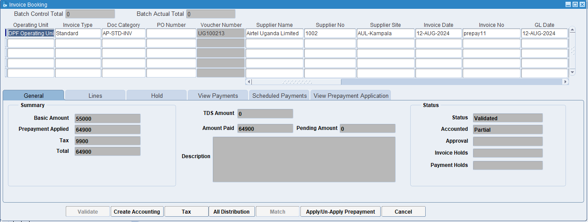
Click on Apply/Un-apply prepayment
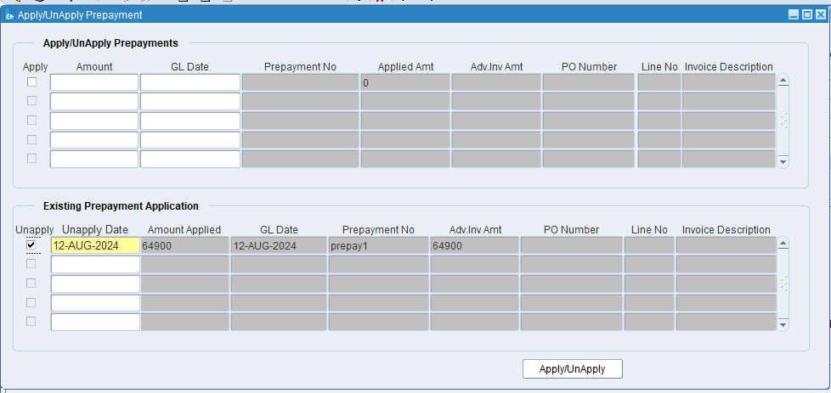
Tick on Unapply then click on Apply/Unapply

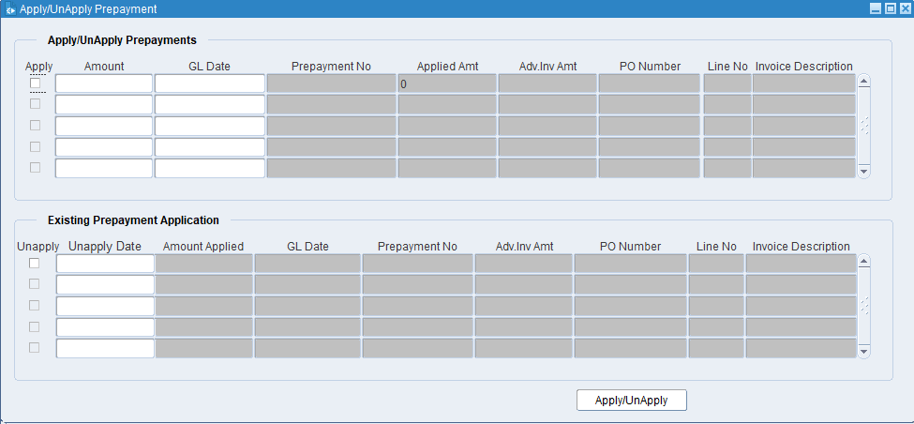
Prepayment Unapplied.

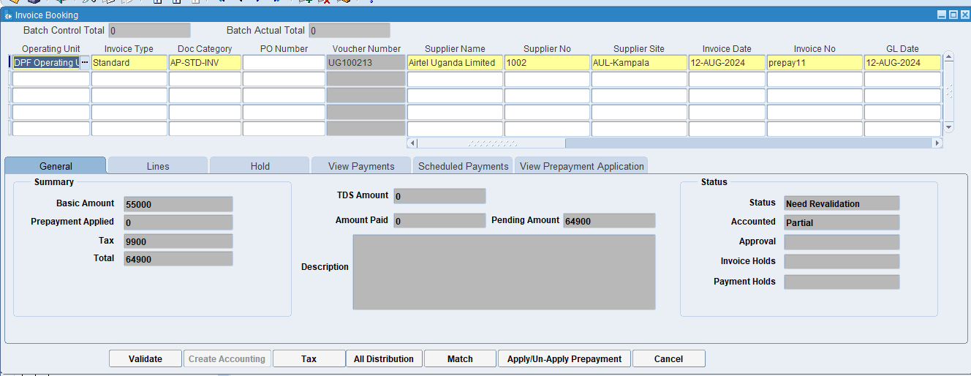
Click on Validate the click on Create Accounting.

XX END XX

