White Paper User manual For –
Manual Recurring Invoice

Module – Account Payables

Author : Ajinkya Patil
Creation Date : 20-Sep-2024
Last Updated : 20-Sep-2024
Version : 1.0

What is a Recurring Invoice?
A recurring invoice is an invoice that is automatically generated and sent at regular intervals (e.g., monthly, quarterly). It is used for ongoing services or subscriptions, ensuring consistent revenue for the seller and consistent billing for the buyer.

When does it occur?
The invoice is issued according to a pre-set schedule. For example, if the agreement is for monthly services, the recurring invoice will be generated and sent at the same time each month.

Where is it used?
Recurring invoices can be used in various settings including business-to-business (B2B) transactions, business-to-consumer (B2C) transactions, and subscription-based services. They can be managed and issued through various platforms like accounting software, billing systems, or manual methods.

Who is involved?
The seller or service provider who issues the invoice.
The buyer or client who receives and pays the invoice.
Often, there may be a billing department or accounts team managing the process.

Why use recurring invoices?
- Efficiency: Automates the billing process, saving time and reducing administrative effort.
- Consistency: Ensures that payments are received on a regular schedule.
- Cash Flow: Helps maintain steady cash flow for businesses by ensuring regular income.
- Convenience: Provides convenience for clients by automating their payment schedules and avoiding the need to remember to make payments manually.

Navigation – Account Payables > Transaction > Recurring Invoices
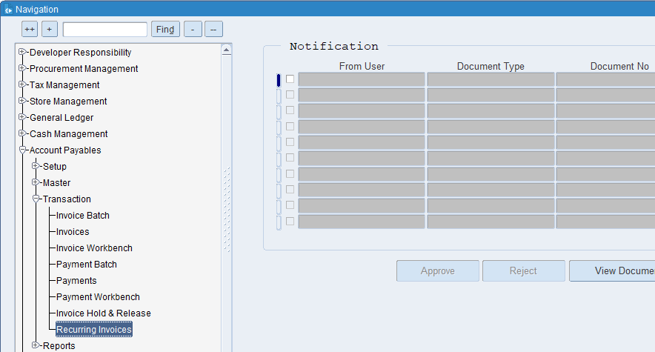

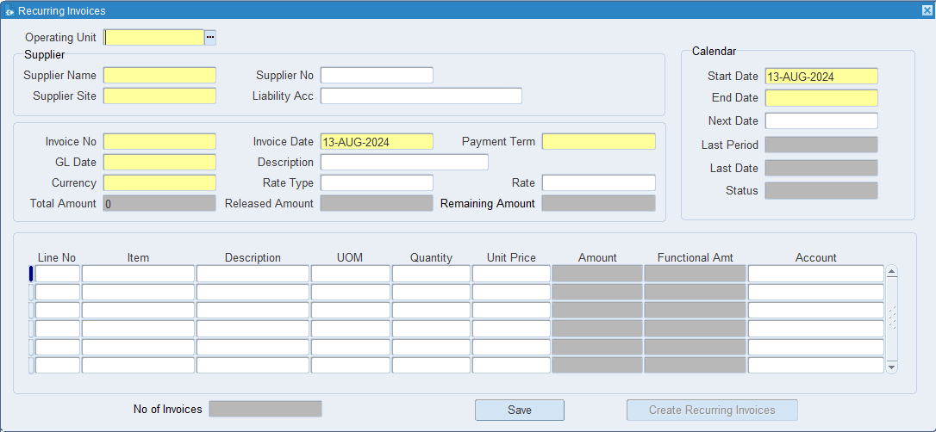
Put the all Information

What is an Operating Unit?
An operating unit is a segment of an organization that is responsible for carrying out specific business activities or operations. These units are typically organized based on functions, products, services, or geographic locations.

What is Supplier's name?
It identifies the party that has supplied the goods or services, ensuring that there is clarity on who the invoice is coming from. This helps in maintaining accurate records and resolving any discrepancies related to the supplier.

What is a supplier site?
The supplier site provides detailed information about where a supplier operates, ships from, or where services are delivered. This helps in managing logistics, shipping, and procurement processes efficiently.

What is the Invoice Number?
The invoice number uniquely identifies each invoice, making it easy to reference and track. It helps in distinguishing one invoice from another, which is essential for organization and clarity in financial records.

What is GL Date?
The GL date indicates the specific date on which a transaction is recorded in the General Ledger. This date determines the accounting period in which the transaction will be included for financial reporting and analysis.

What is a Payment term?
A "payment term" is a set of conditions agreed upon by a buyer and seller that outlines how and when payment for goods or services is to be made. These terms are crucial for managing cash flow, financial planning, and maintaining good business relationships

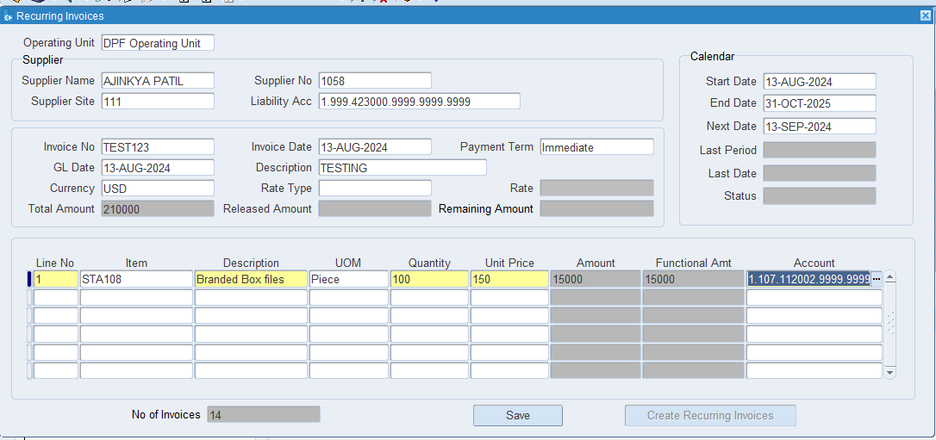
Click on Save.
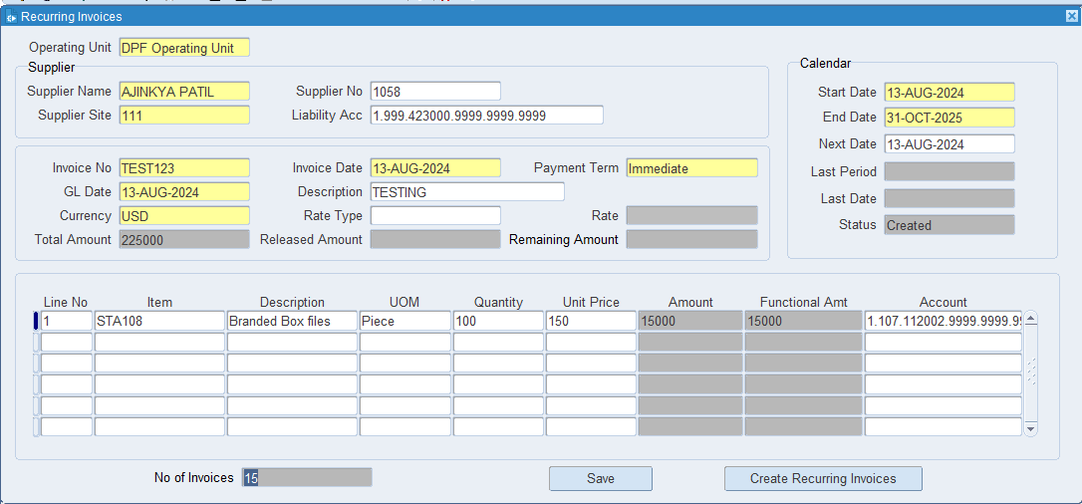

Click on Create Recurring Invoices.

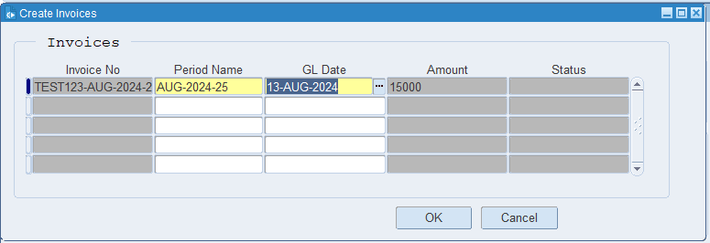

Put the Period name & GL Date. Click on Ok
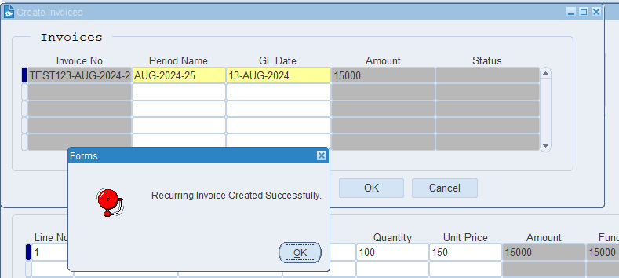

The Recurring Invoice has been created.

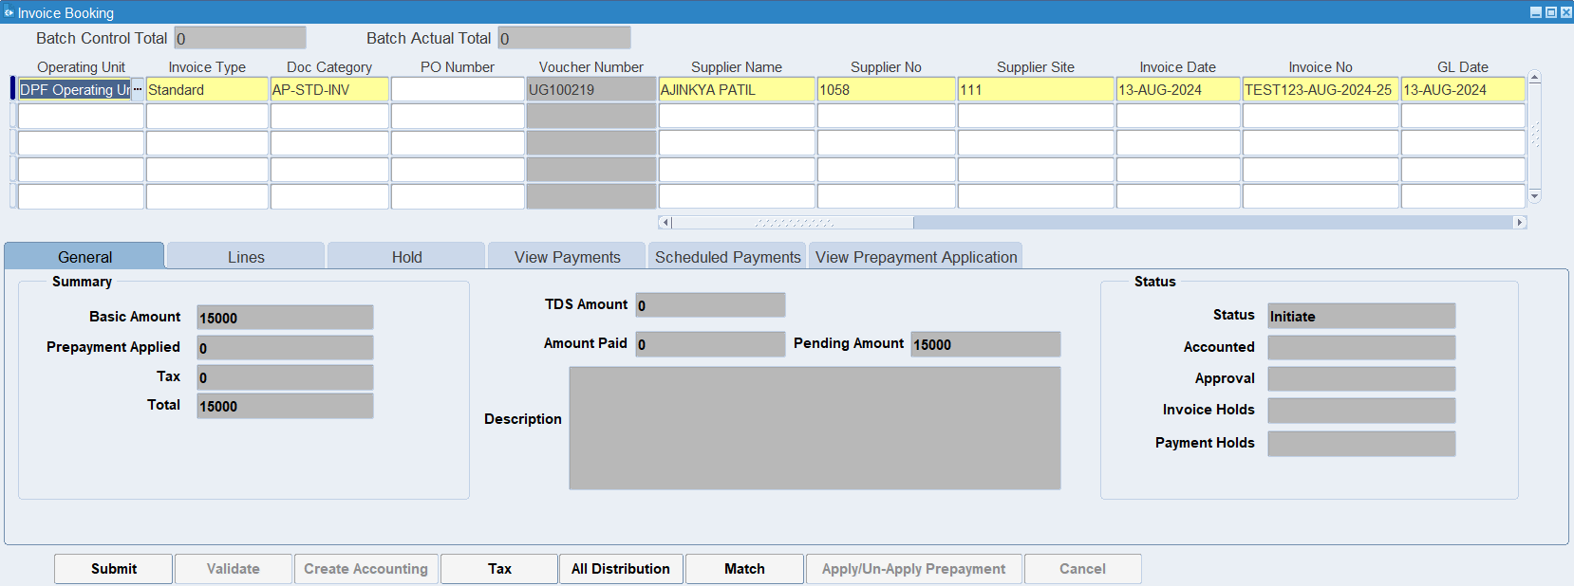

XX END XX

