White Paper User Manual For –
Responsibility Creation

Module – Developer Responsibility

Author : Sourav Suman
Creation Date : 18-Nov-2024
Last Updated : 18-Nov-2024
Version : 1.0

Login From the User Credential to whom the functionality is Provided.
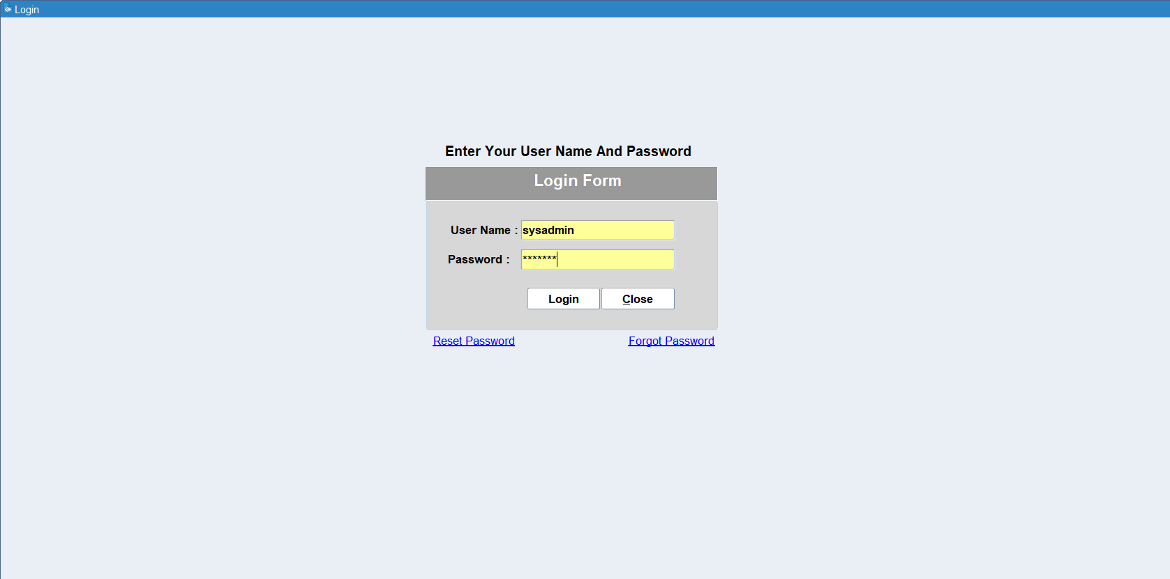

Navigation: Developer Responsibility > Responsibility
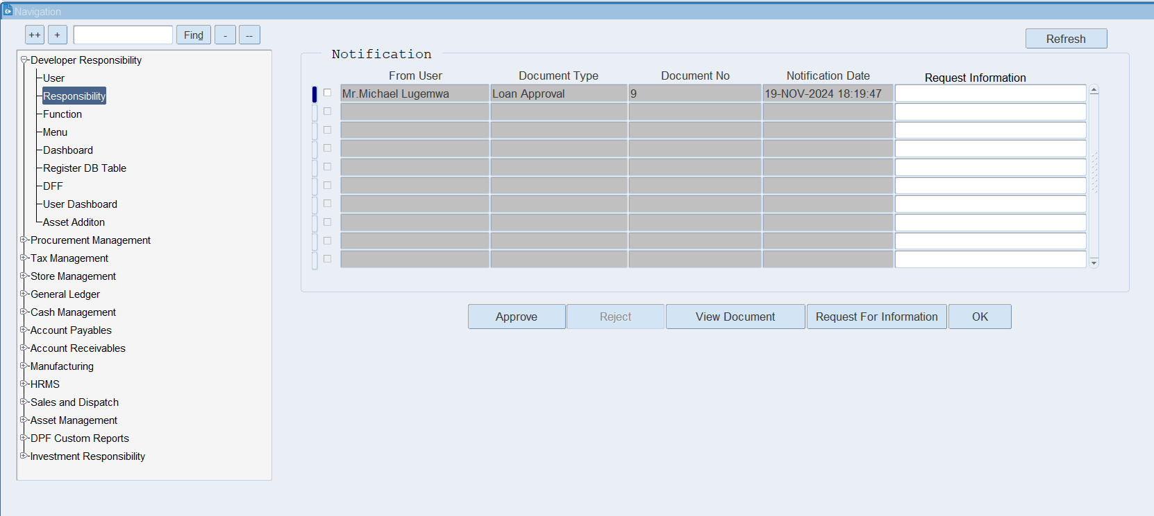

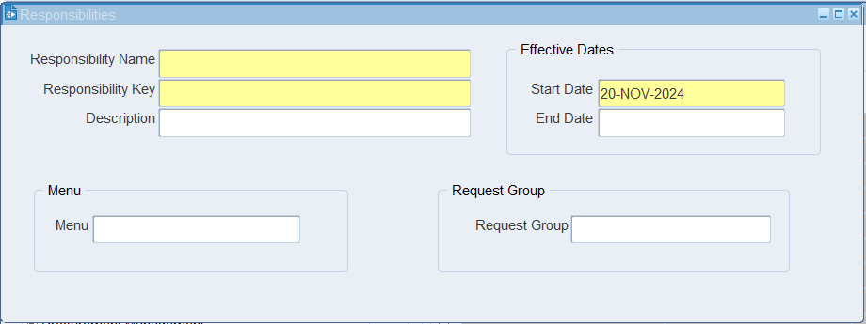
Enter the Mandatory field, Select start date and select the menu for the responsibility.

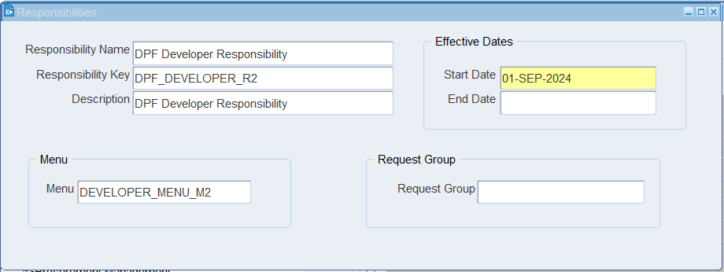
To assign the menu to the responsibility, click on Menu field, open the list of values, and select the Menu you want to assign to the responsibility.

XX END XX

