White Paper User Manual For –
Run Depreciation Process

Module – Fixed Asset

Author : Niraj Chaurasia
Creation Date : 20-Jan-2025
Last Updated : 20-Jan-2025
Version : 1.0

Login from the User Credential to whom the functionality is provided
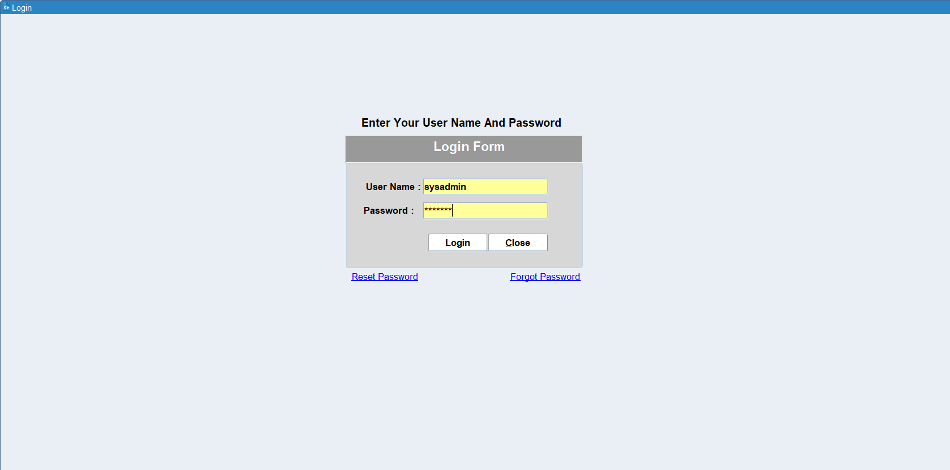

Navigation: Asset Management > Run Depreciation
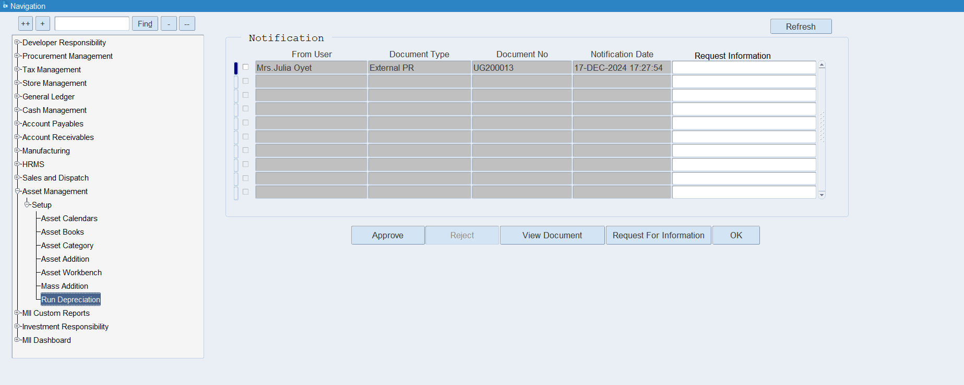

After double click Depreciation form will be open as shown below
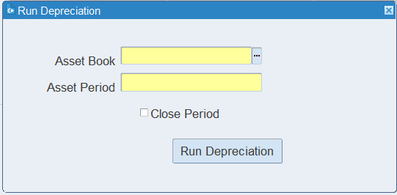
Choose the depreciation book for which you want to run and Asset Period should be open period those auto comes after clicking LOV
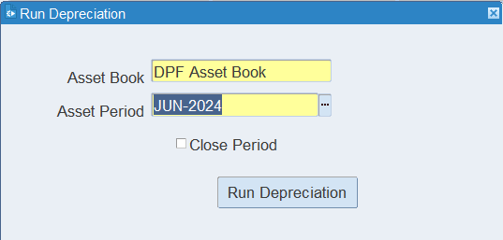
Click on Run Depreciation button
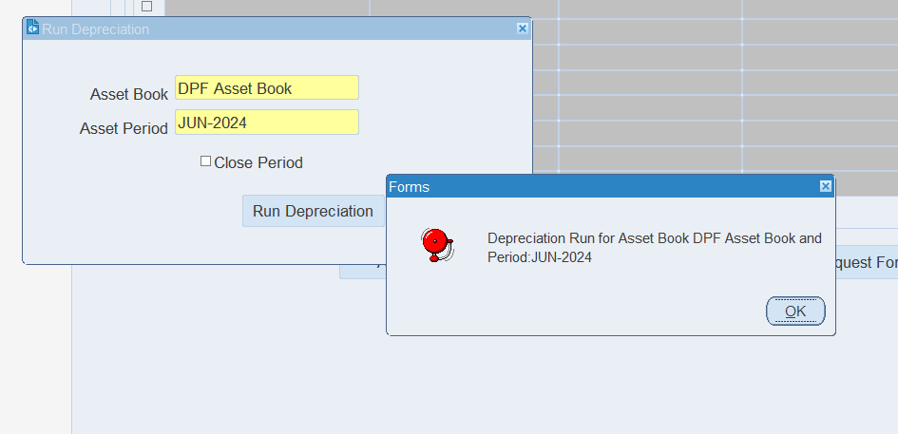
System will run Depreciation process for JUN-2024 Period
Go to Asset Workbench form for viewing depreciation details
Navigation: Asset Management > Asset Workbench
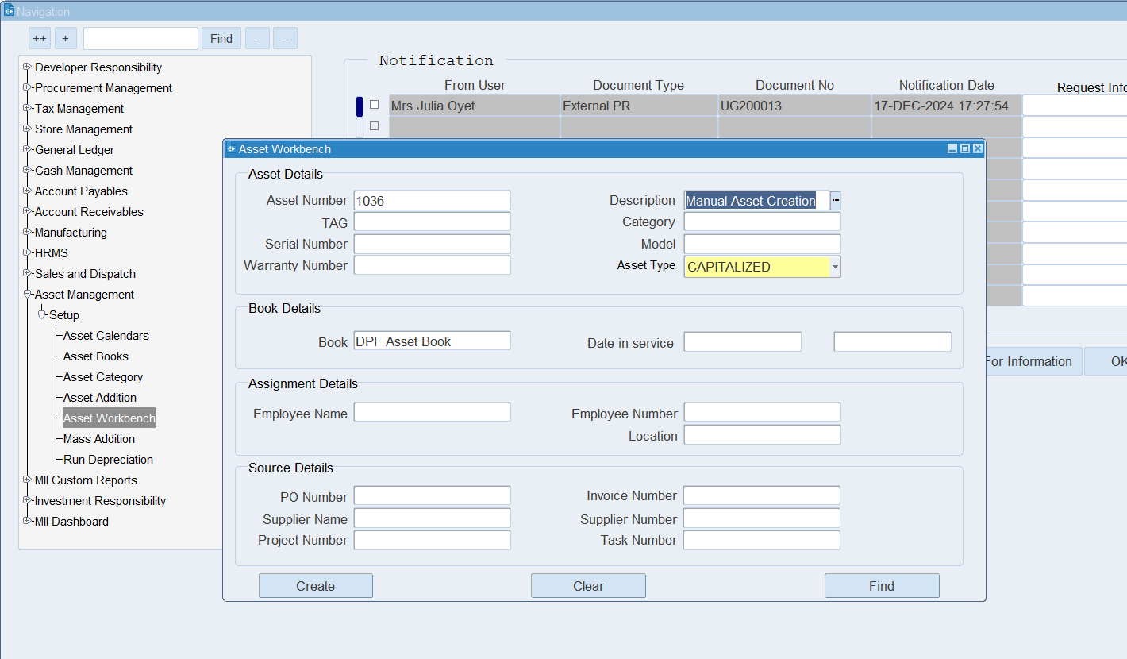

Enter Asset Number and Click find button
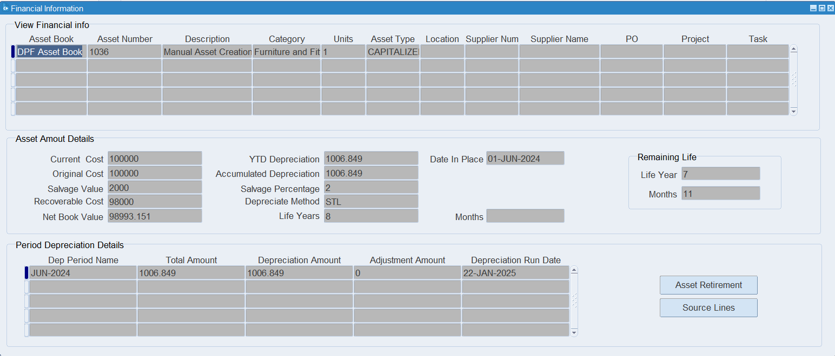
Depreciation details shown in line level.
For Accounting
Go to General Ledger Responsibility
Navigation: General Ledger > Journals > JV Workbench
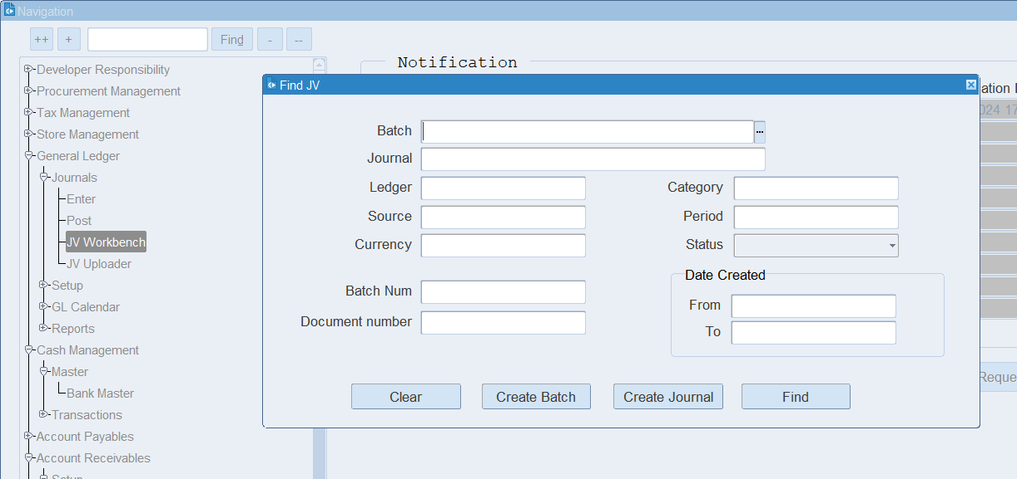
Enter Asset Number in Document Number Field
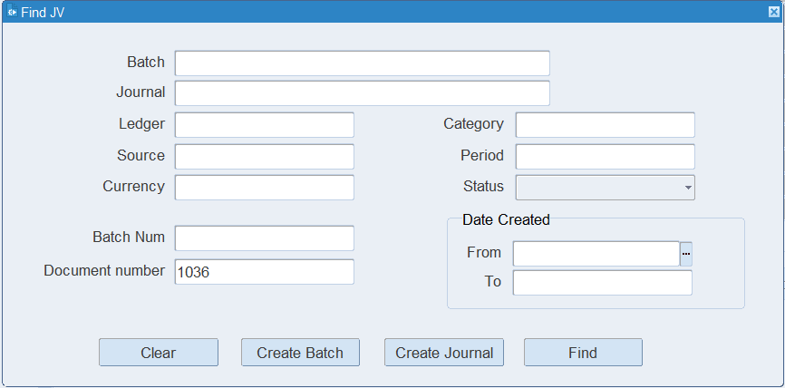
Click Find Button
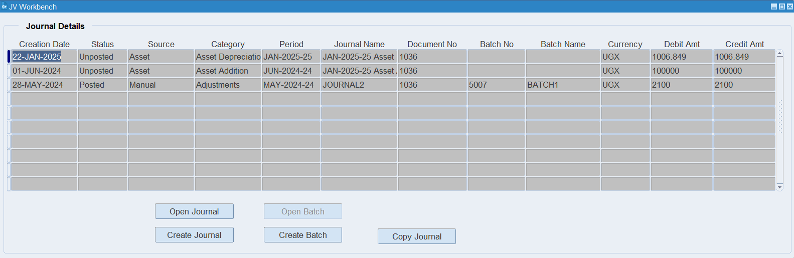
Click Open Journal Button for view Accounting
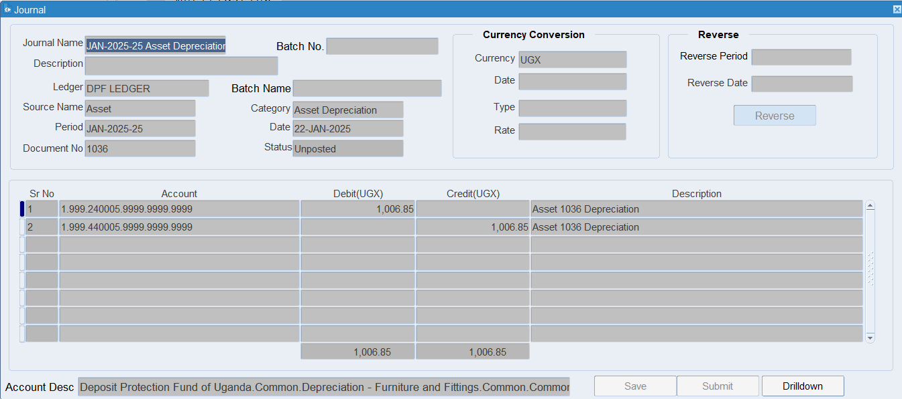

XX END XX

