White Paper User manual For –
Standard Money Receipt and Invoice Application Process

Module – Account Receivables

Author : Ajinkya Patil
Creation Date : 09-Sep-2024
Last Updated : 09-Sep-2024
Version : 1.0

A Money Receipt in Accounts Receivable (AR) can be understood using the 5 W's:

- Who?
- Issuing Party: The seller or service provider is responsible for issuing the receipt. It can be a business, organization, or individual receiving payment.
- Receiving Party: The customer or client making the payment.

- What?
- Definition: A money receipt is a formal document that acknowledges the receipt of payment. It typically includes details such as the amount paid, the date of payment, and a reference to the related invoice or transaction.
- Components: A typical receipt may include:
  - Receipt number
  - Date of transaction
  - Payer's information
  - Description of goods/services
  - Amount paid
  - Payment method (cash, credit card, etc.)
  - Seller’s signature or stamp

- When?
- Timing: The receipt is issued immediately upon receiving payment, whether it's a cash transaction, credit card payment, or an online payment. This instant documentation helps both parties keep track of the transaction.

- Where?
- Context of Use: Money receipts are utilized in various business settings, including retail, services, and B2B transactions. They can be provided in physical form (printed) or electronically (PDF or digital receipts) depending on the business's operational methods.

- Why?
- Importance:
  - Proof of Payment: It serves as legal proof that a payment has been made, protecting both the buyer and seller in case of disputes.
  - Record-Keeping: Helps both parties maintain accurate financial records for accounting purposes.
  - Tax Compliance: Receipts are essential for tax reporting and can be used as evidence in audits.
  - Customer Trust: Providing a receipt enhances transparency and builds trust with customers, ensuring they feel confident in the transaction.

Navigation – Account Receivables – Transaction – Money Receipt

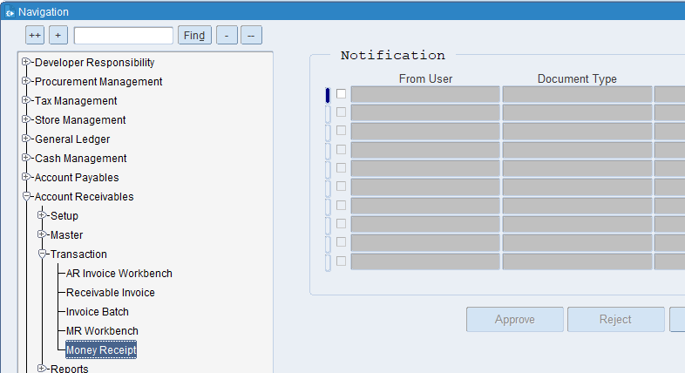

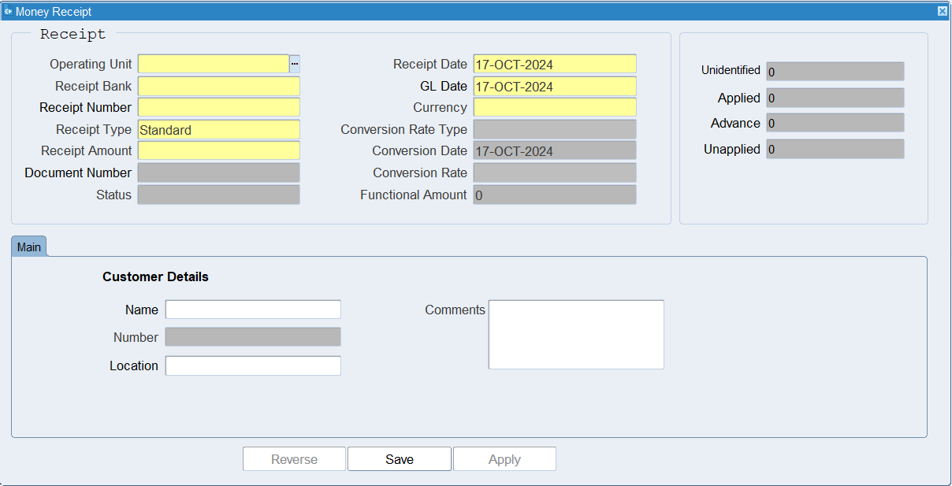

What is an Operating Unit?
An operating unit is a distinct segment or division within a company that manages a specific part of the company's operations. It can be thought of as a self-contained unit responsible for its own set of activities, resources, and objectives.

What is GL Date?
The GL date indicates the specific date on which a transaction is recorded in the General Ledger. This date determines the accounting period in which the transaction will be included for financial reporting and analysis.

What is Invoice Currency?
Invoice currency specifies the type of currency used to calculate and display the amounts due on an invoice. This could be the currency of the supplier, the customer, or a mutually agreed-upon currency.

What is Type?
The classification or category assigned to an Money receipt that indicates the nature of the invoice or the type of transaction it represents.

What is the Document Number?
A unique numerical or alphanumeric code assigned to an AR invoice to distinguish it from other invoices and provide a reference point for tracking and managing.

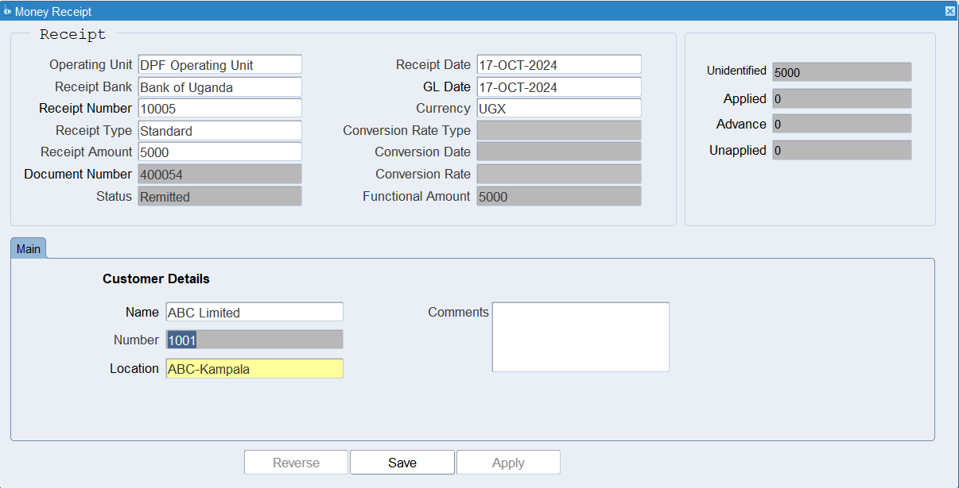
Put all the required details
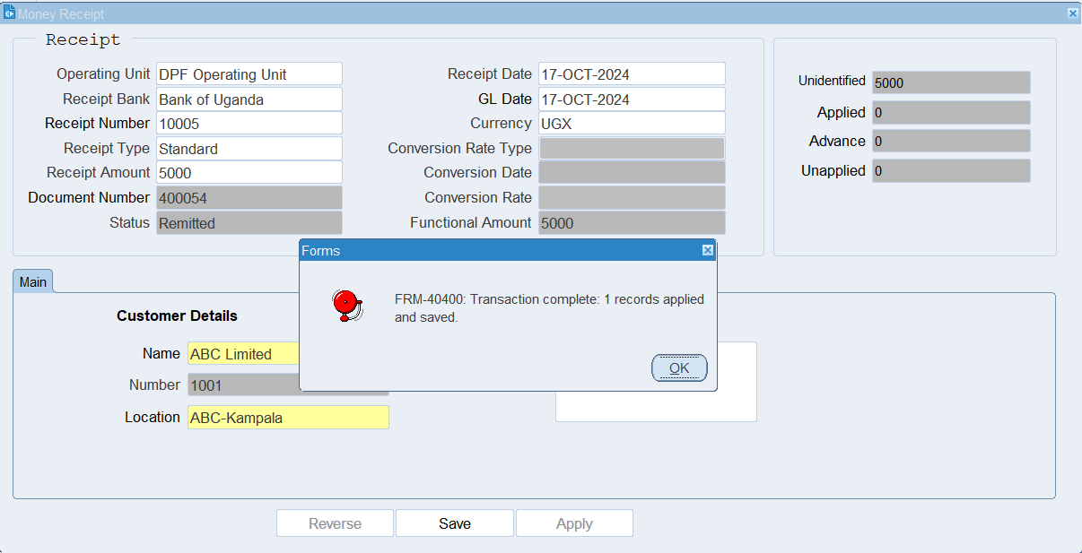
Click on Save

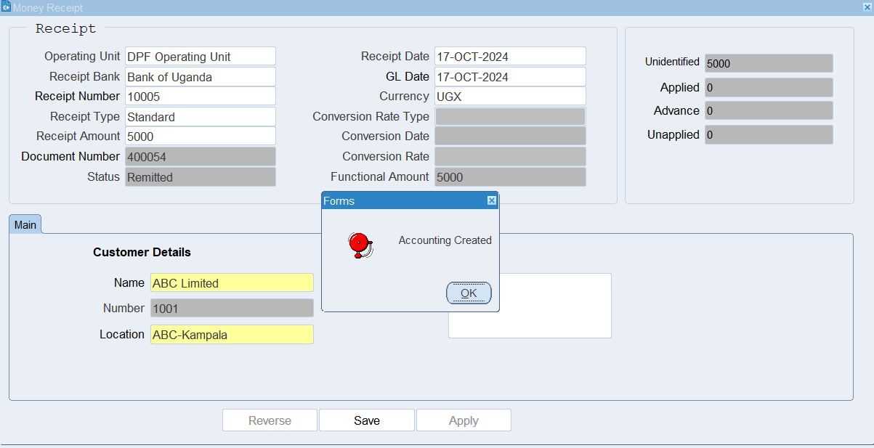

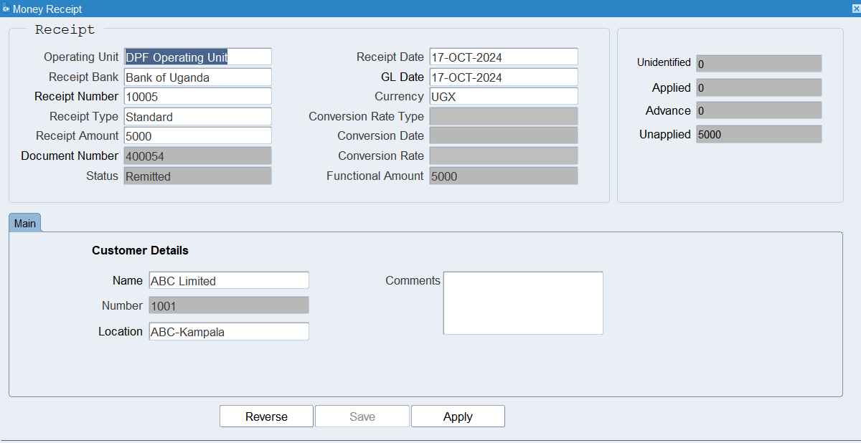
Money Receipt Created.

Now Money Receipt application with AR Invoice
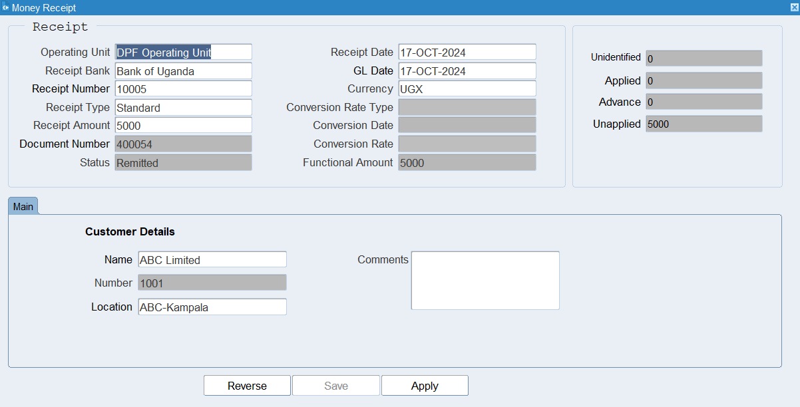
Click Apply Button

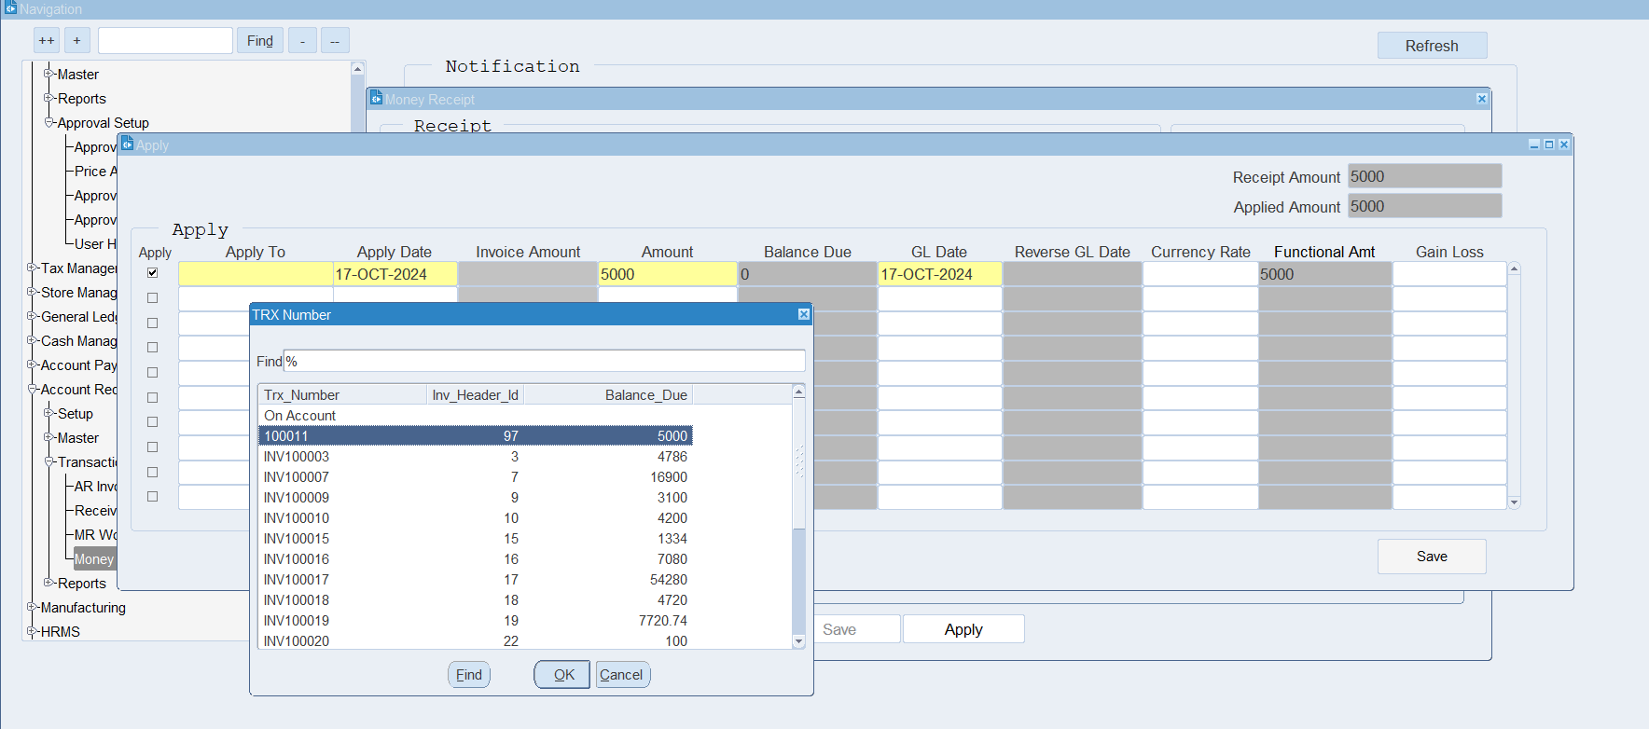

Select Invoice

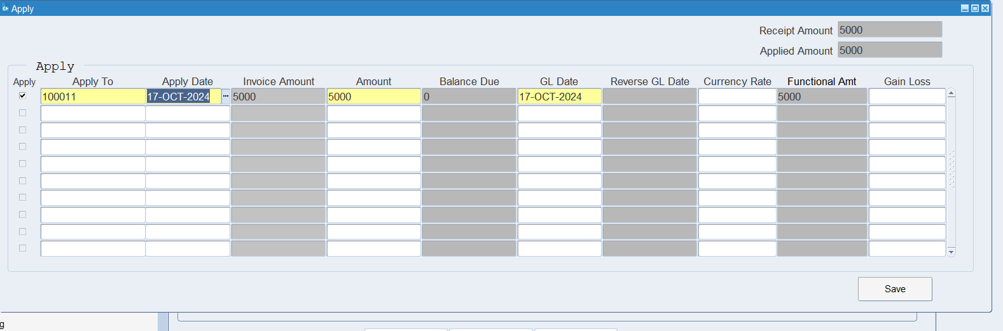

Save

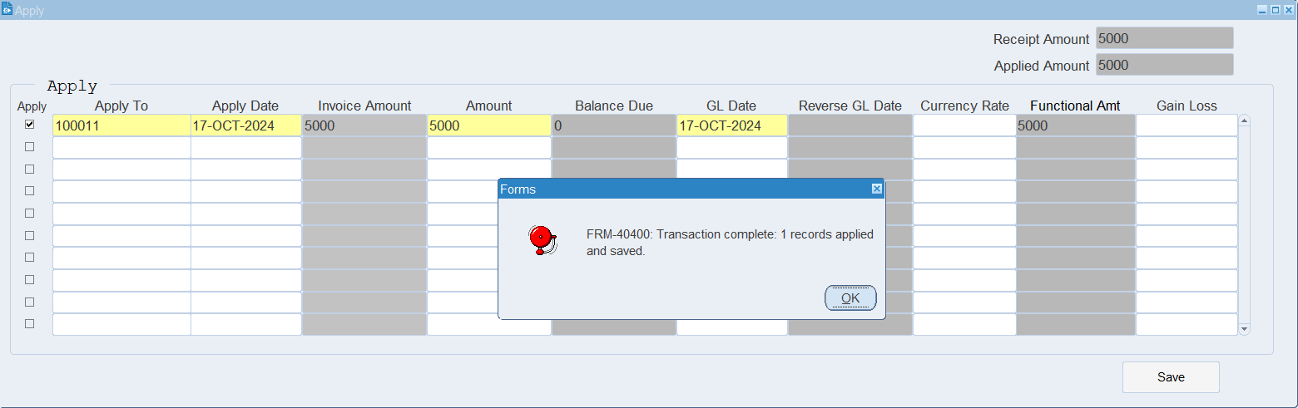

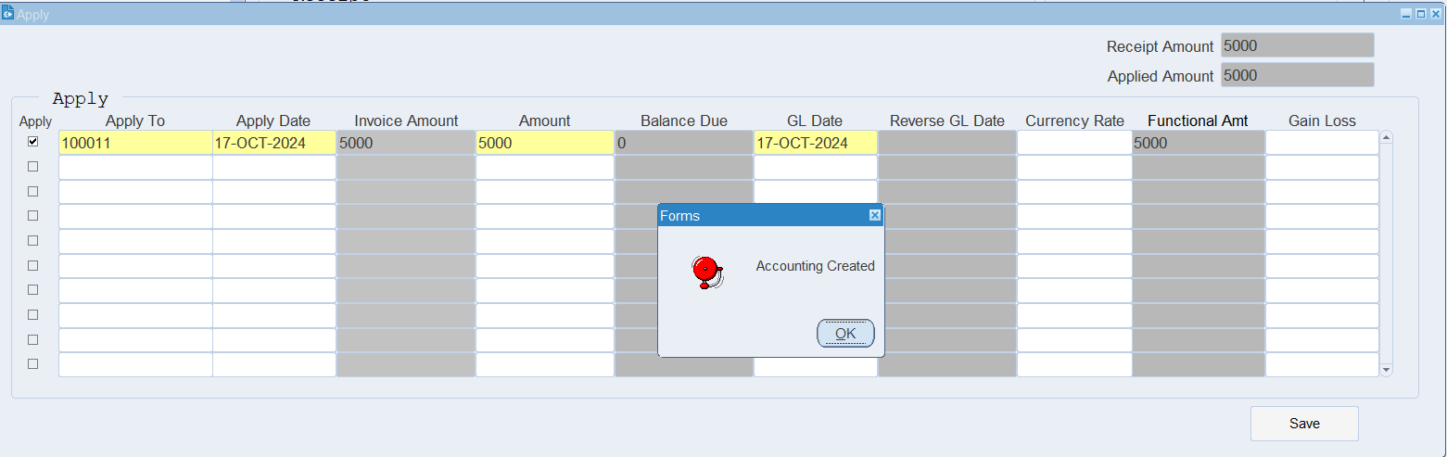
After save system will generate Accounting

Now amount is applied
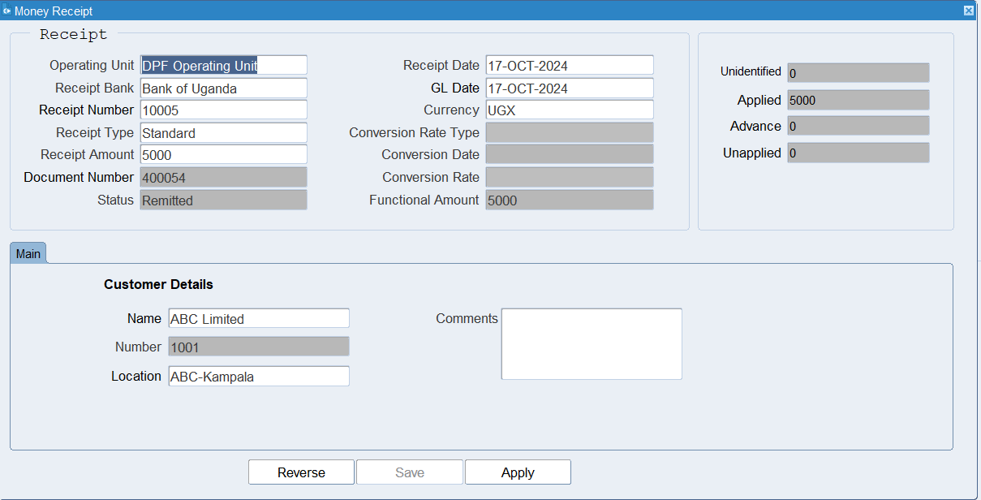

XX END XX

