White Paper User Manual For –
MII Lookup Value Updation

Module – Store Management

Author : Sourav Suman
Creation Date : 18-Nov-2024
Last Updated : 18-Nov-2024
Version : 1.0

Login From the User Credential to whom the functionality is Provided.
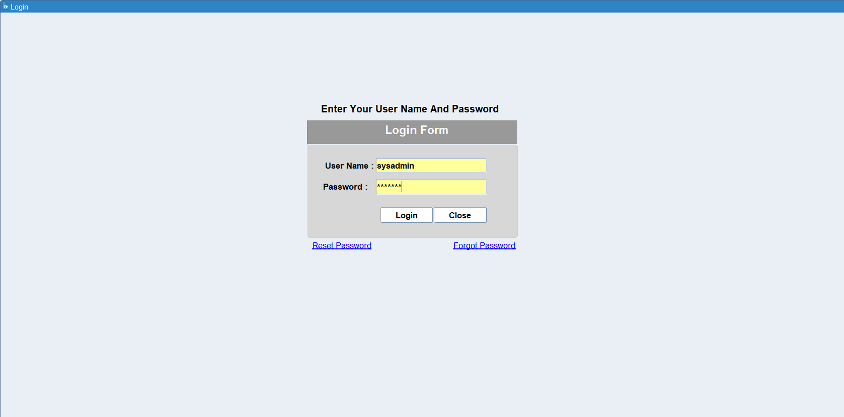

Navigation: Store Management > Setup > MII Lookup
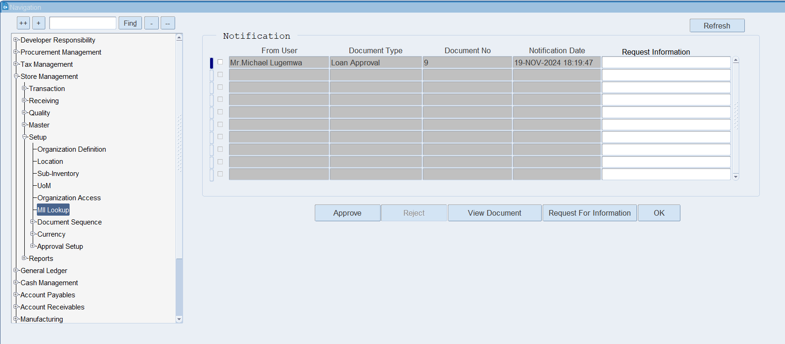

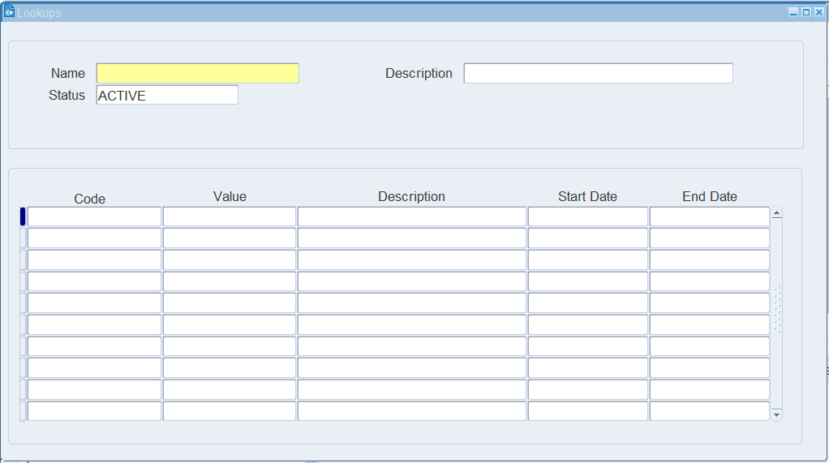
Lookups form will be Open like as shown above.
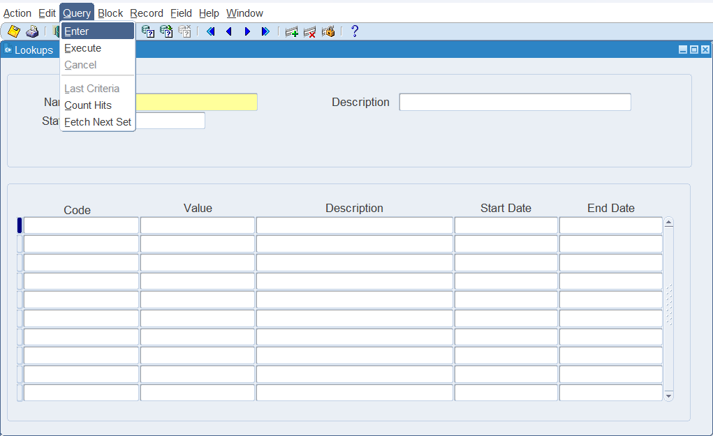
To Query lookup Click on Query on Menu Option after that click on Enter. Then the form will open in Query Mode.

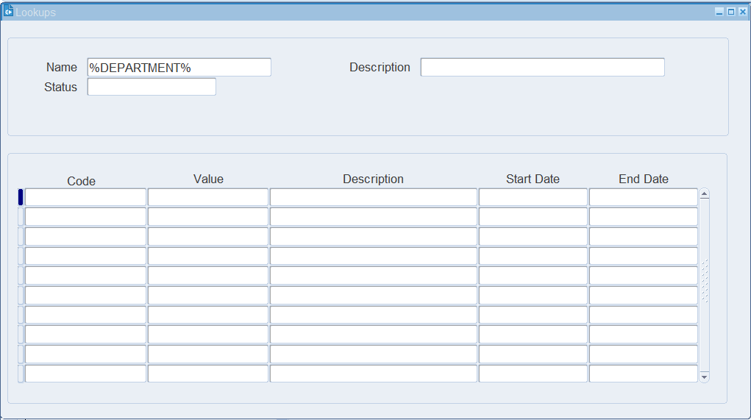
When the form will open in query mode then enter the lookup name in which you want to perform changes such as addition or cessation of the lookup value.

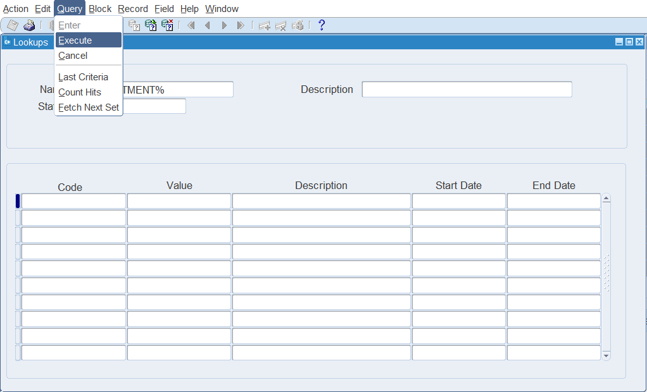
Again click on Query and after that click on Execute.

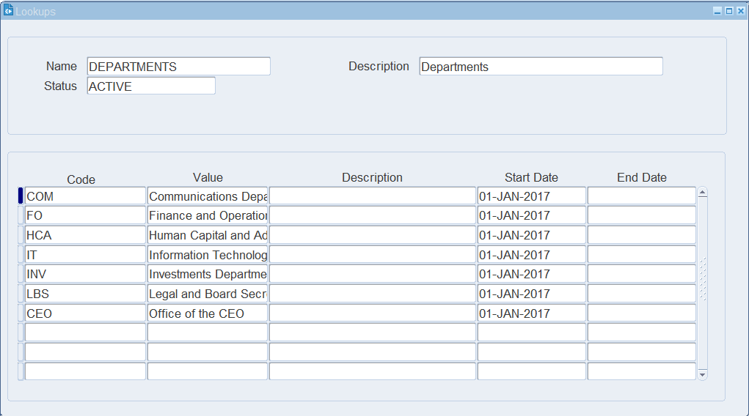
After click on Execute the system will show you the value of the desired search form. If you want to remove some department in that case you need to put end date to the value.

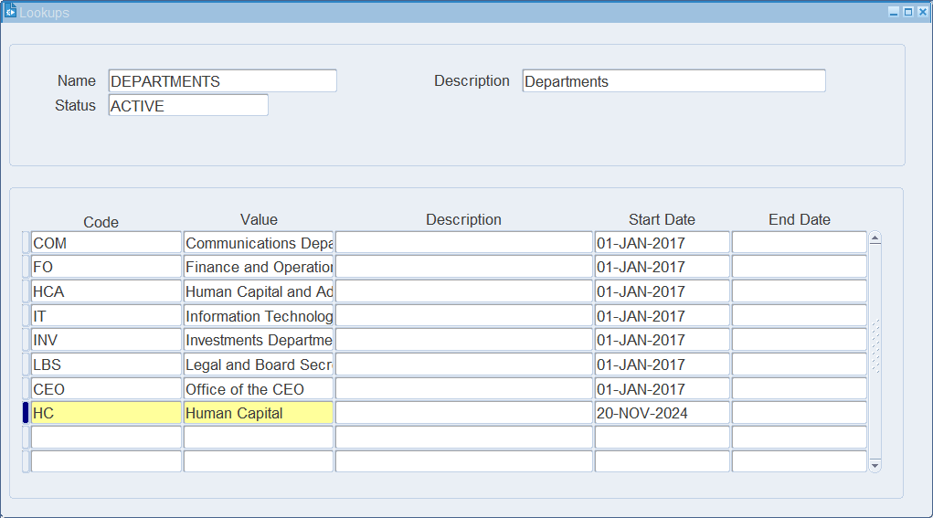
Enter the Code and Its value as these field are mandatory along with start date. Save the Transaction.

XX END XX

