White Paper User Manual For –
User Creation

Module – Developer Responsibility

Author : Sourav Suman
Creation Date : 18-Nov-2024
Last Updated : 18-Nov-2024
Version : 1.0

Login From User Credential whom the developer responsibility is Provided.
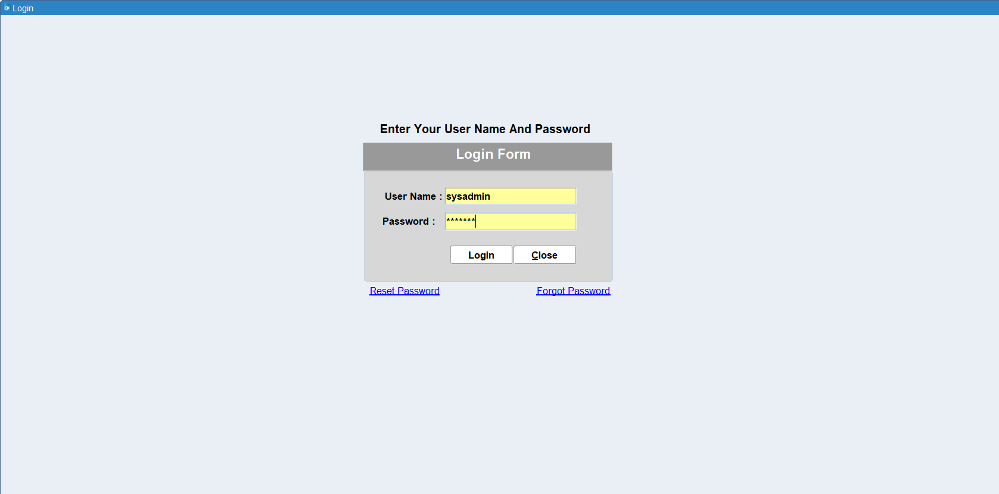

Navigation: Developer Responsibility > User
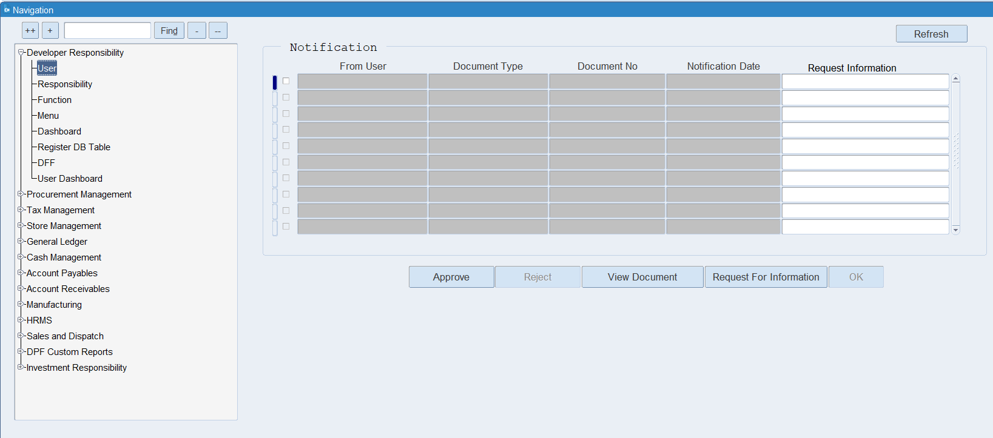

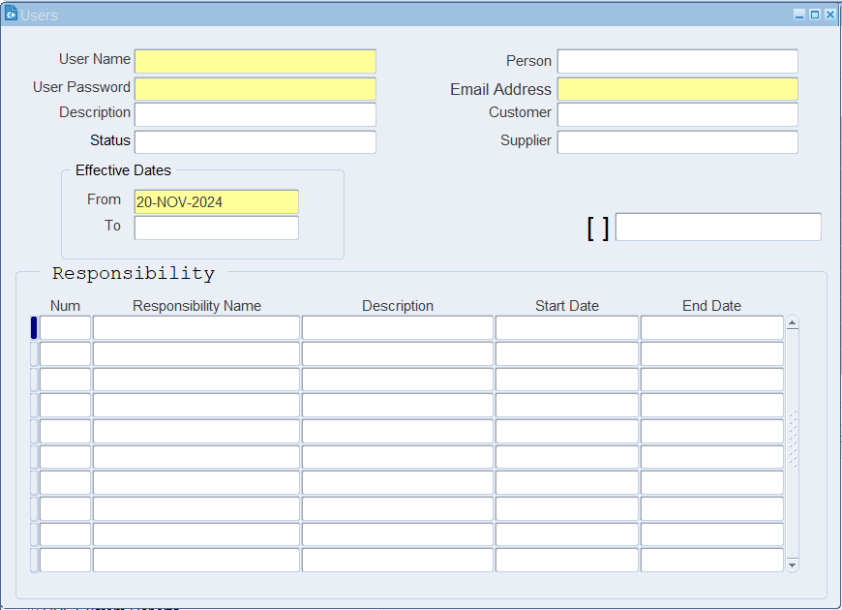

To Enter new user Fill the mandatory field and tag an Employee by using Person Field Where all the Employee name is available in List of value, You need to select one of them.

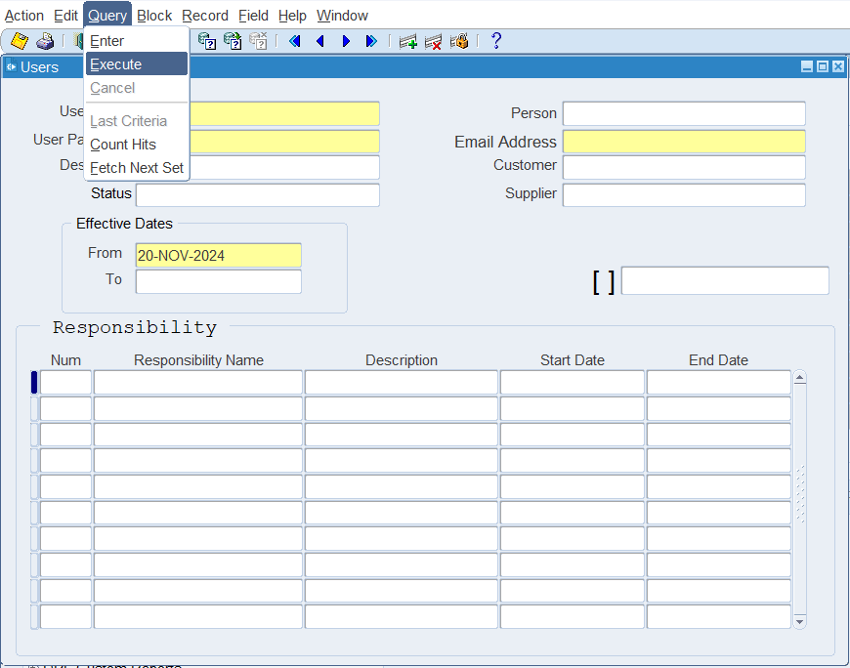

To query and existing employee click on Query Button in the menu bar > Click on Execute
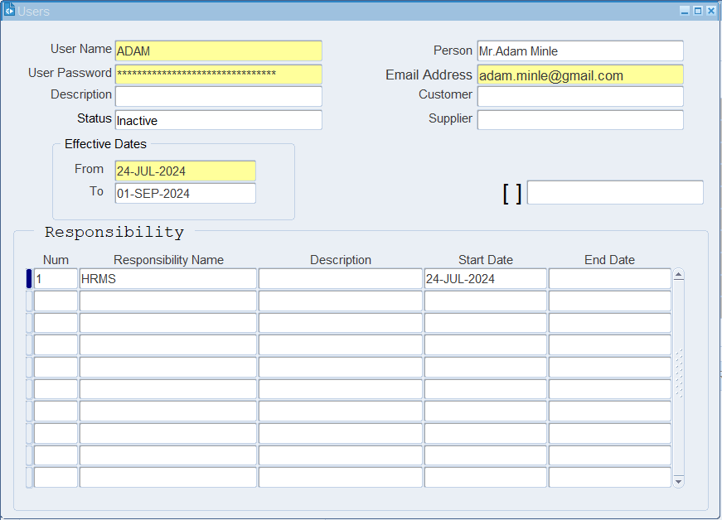

User details are available as shown in the above image.
For a new user, you need to select the responsibility from the list of values which is shown as below.
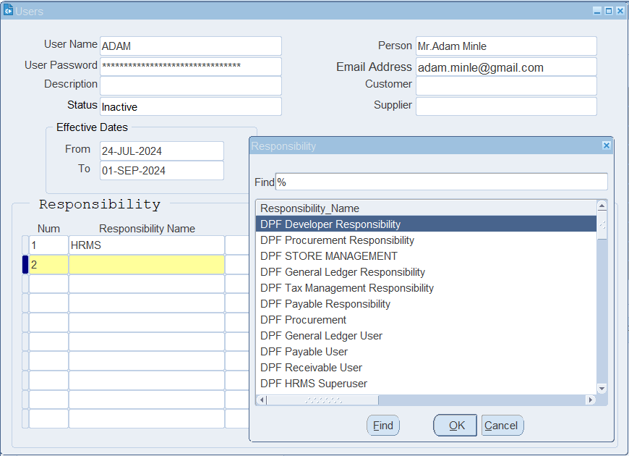
To add a new responsibility, click on the Responsibility Name field > open the list of values > and select the responsibility you want to assign to the user.

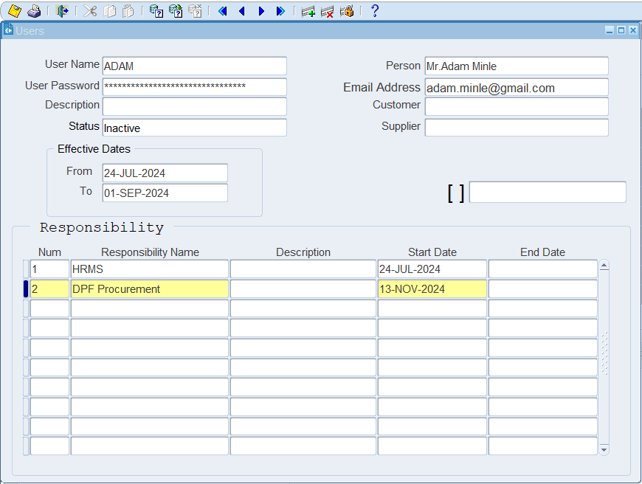
Select start date from when the responsibility is available for the user.
Enter the End date if you want to revoke the responsibility from the user Login.

XX END XX

