White Paper User manual For –
Vendor Creation

Module – Account Payables

Author : Ajinkya Patil
Creation Date : 24-Sep-2024
Last Updated : 24-Sep-2024
Version : 1.0

In business and finance, the term "vendor master" refers to a centralised repository or database that contains detailed information about the vendors or suppliers a company does business with. This database is crucial for managing vendor relationships and ensuring smooth procurement processes. Here’s what it typically includes:

- Basic Information: Name, address, contact details, and legal information.

- Bank Details: Information required for payments, such as bank account numbers and routing details.

- Tax Information: Tax identification numbers or other regulatory compliance details.

- Payment Terms: Agreed-upon terms for payment, such as net 30 days, discounts for early payment, etc.

Navigation – Account Payables > Master > Supplier Master

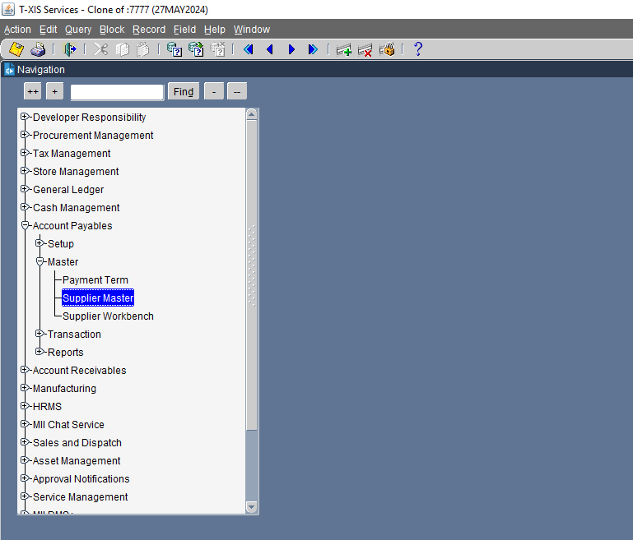

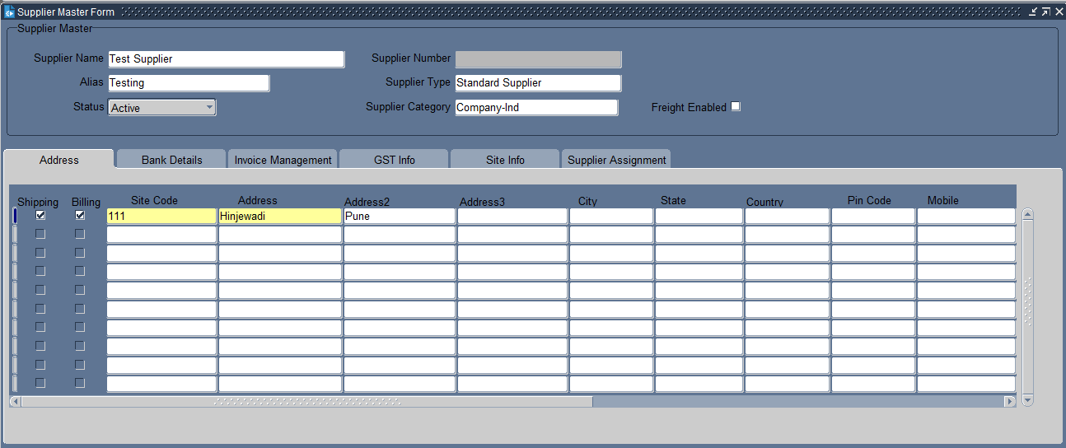
Put the Supplier name, site name & address.

What is Supplier's name?
It identifies the party that has supplied the goods or services, ensuring that there is clarity on who the invoice is coming from. This helps in maintaining accurate records and resolving any discrepancies related to the supplier.

What is a supplier site?
The supplier site provides detailed information about where a supplier operates, ships from, or where services are delivered. This helps in managing logistics, shipping, and procurement processes efficiently.

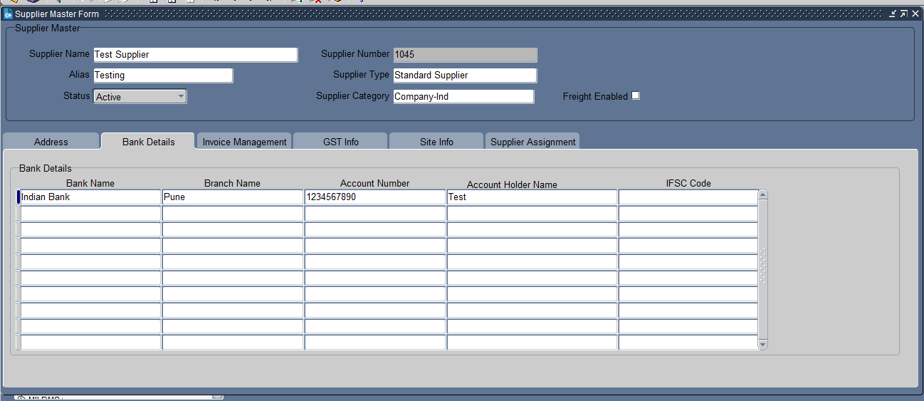
Put the bank details

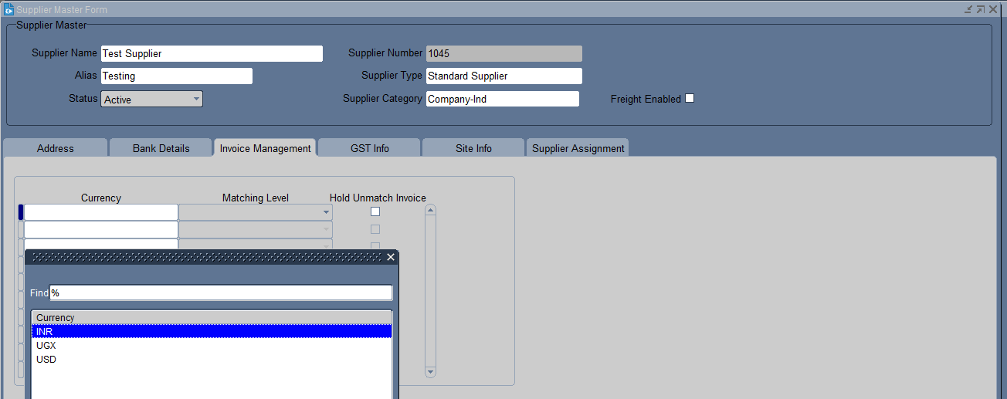
Select the currency as per requirement.

What is Currency?
Currency specifies the type of currency used to calculate and display the amounts due on an invoice. This could be the currency of the supplier, the customer, or a mutually agreed-upon currency.

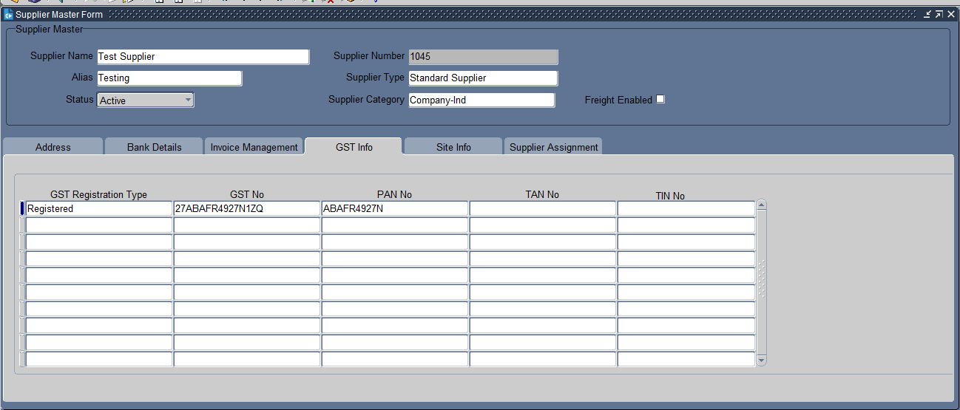
Put the Registration Details like TAN Number, TIN Number etc

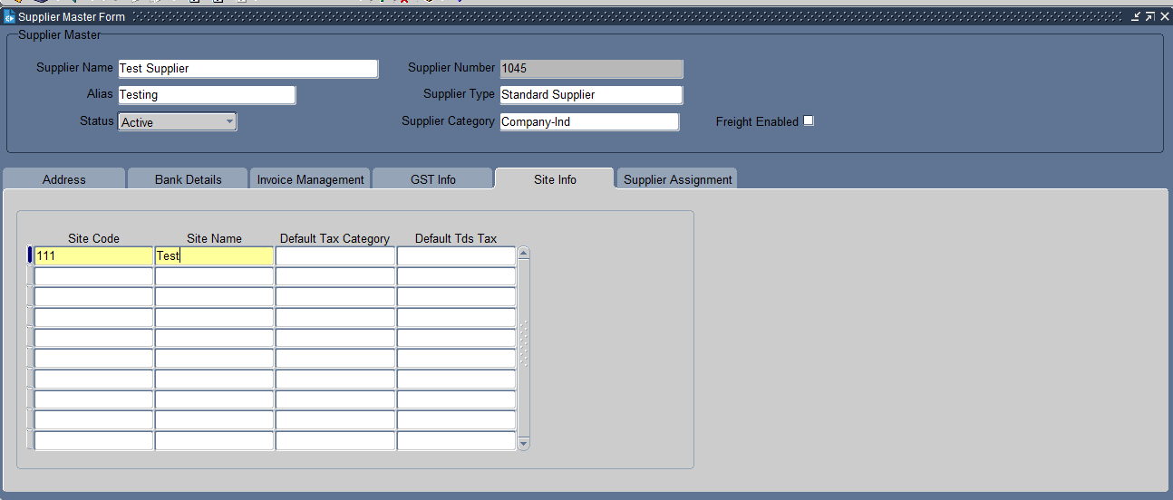
Put the site code & Site Name

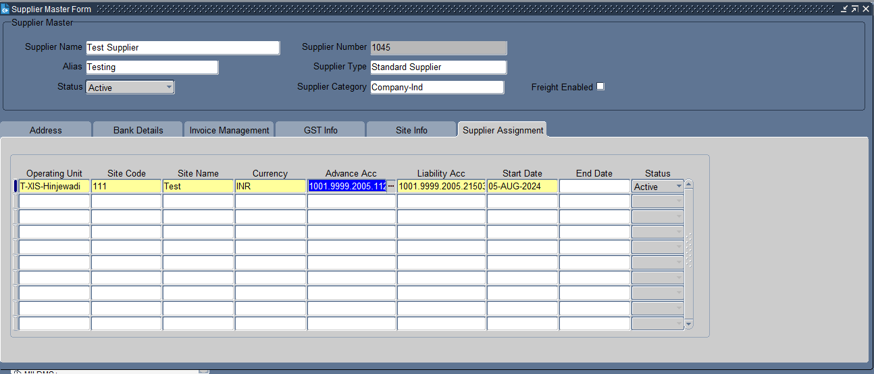
Put the Supplier assignment details

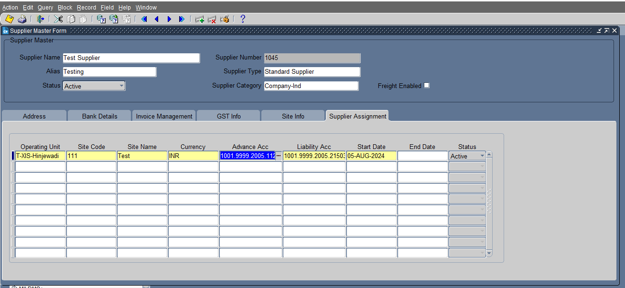
Click on Save
The supplier has been created.

XX END XX

